Early Assistance Meeting Number: EA26105
Project Name: Magnify Sanctuary and Admin Bldg
Project Location: 4130 Old Ranch Rd
Project Parcel No: 6223000053
Project Description: Request to build a new 11,560sf sanctuary and administrative PEMB building for religious based services on an existing lot with an existing residence (church parsonage). It is the intent of the property owner to continue the use of the parsonage with the new sanctuary building. Property utilities include a well, a septic system, and there is existing power. Facility would require new driveway access.
Meeting Date: Wed, September 23, 2026 @ 1 pm

El Paso County Planning & Community Development Planning Checklist

Request – Map Provided by Applicant
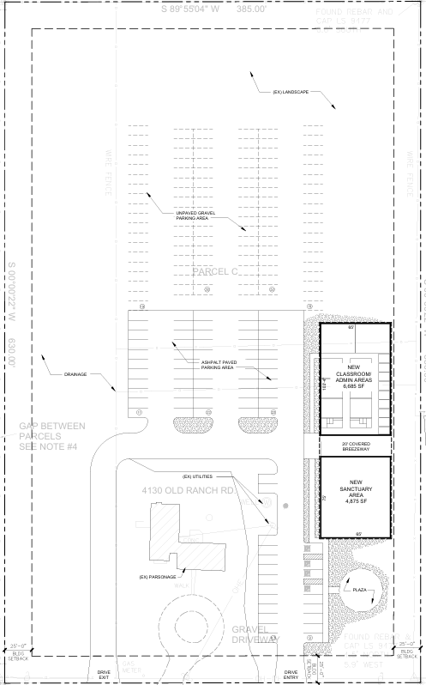

Zoning
Existing Zone(s)
Zone |  | Name
RR-5 |  | Residential Rural – 5 acres

Zone Map
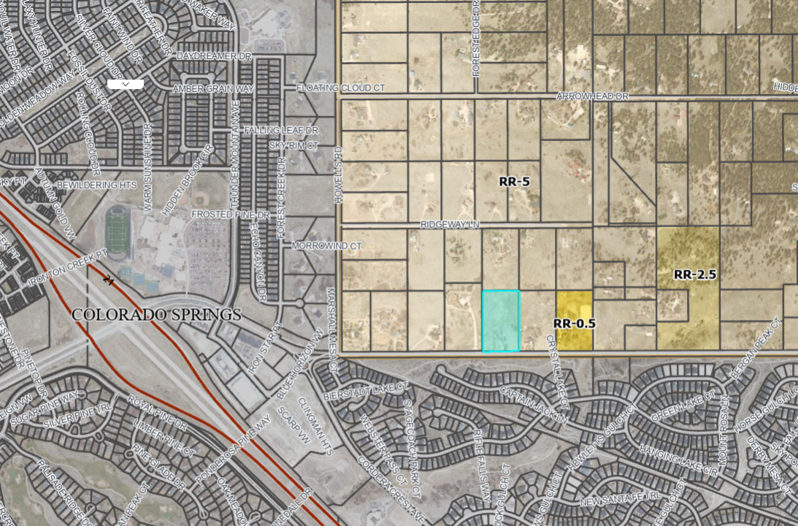

Zoning Analysis
Section 1.15 in the LDC defines Religious Institution as follows:

Religious Institution — An establishment primarily for the conduct of religious activities, limited to sanctuary, educational classrooms, daycare, committee and office work, a single parsonage/rectory, or religious camp.

Pursuant to Table 5-1 in the Land Development Code, the use is allowed in the zone.

Table 5-1. – Principal Uses
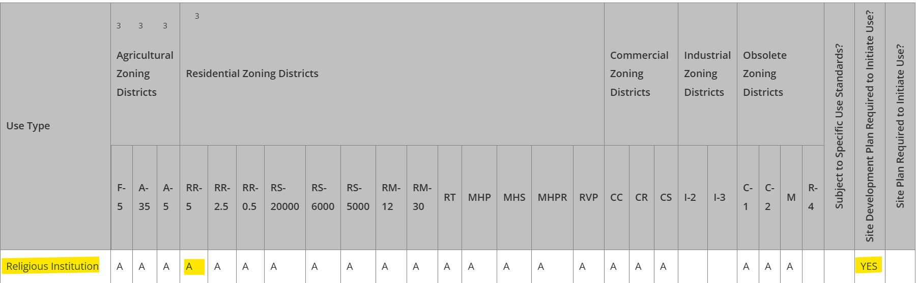

Application Type(s) Hearing: Required/ Optional/ No
Site Development Plan | No
Required Application Materials – Available checklists / Forms for each item
Application/Petition Form
Elevation Plans
Floor Plans (24" x 36")
Landscape Plan drawings
Letter of Intent
Lighting Plan
Road Impact Fee Acknowledgement
Site Development Plan
Erosion and Stormwater Quality Control Permit (ESQCP)
Financial Assurance Estimate (FAE) Form
Grading & Erosion Control (GEC) Checklist
Grading & Erosion Control (GEC) Plan
PCM - MHFD Detention Calcs or SDI Form
PCM - Notice of Intent to Construct a Non-Juris. Water Impoundment Structure (proof of submittal)
PCM Applicability Form
PCM Operations & Maintenance (O&M) Manual
Stormwater Management Plan (SWMP)
Stormwater Management Plan (SWMP) Checklist
Geotechnical Report
Drainage Report - Final
Traffic Impact Study
PCM Maintenance Agreement (MS WORD version required - attachments included)

Zoning District Requirements (density, lot size, lot design standards, building setbacks)
Table 5-4. Density and Dimensional Standards for Agricultural, Residential and Special Purpose Districts
 | RR-5 Zone
Minimum Lot Size | 5 acres ²
Width at Front setback line | 200 ft
Minimum Front Setback | 25 ft ³
Minimum Rear Setback | 25 ft ³
Minimum Side Setback | 25 ft ³
Maximum Lot Coverage | 25%
Maximum Height | 30 feet

Max lot coverage – applies to structures.
² In the event that the land to be partitioned, platted, sold or zoned abuts a section line County road, the minimum lot area for lots abutting the road shall be 4.
³ Agricultural stands shall be setback a minimum of 35 feet from all property lines.75 acres and minimum lot width shall be 165 ft.

Assessor Map of Unplatted parcel
Current unplatted legal lot
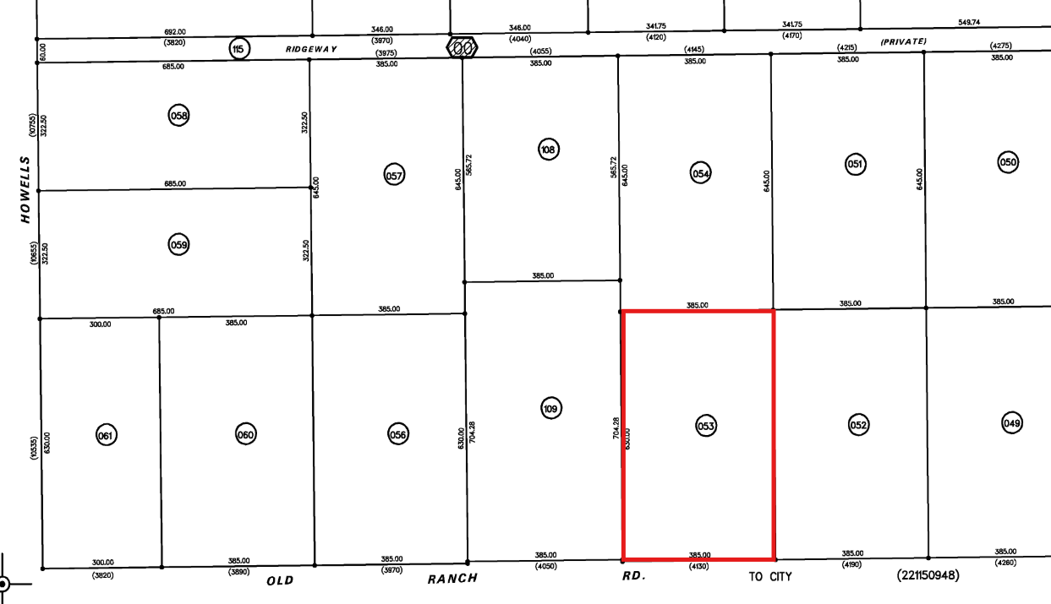

Parcel was legally created in 1958, prior to Subdivision standards being established in 1972. Parcel will not need to be Subdivided prior to Site Development Plan.

Road Impact Fees:
Due at time of building permit/Site Development Plan approval
The owner agrees on behalf of him/herself and any developer or builder successors and assignees that Subdivider and/or said successors and assigns shall be required to pay traffic impact fees in accordance with the El Paso County Road Impact Fee Program Resolution (Resolution No. 25-337), or any amendments thereto, at or prior to the time of building permit submittals. The fee obligation, if not paid at approval/building permit, shall be documented on all sales documents and on plat notes to ensure that a title search would find the fee obligation before sale of the property

**You will schedule a preconstruction meeting with our inspections team AFTER your approval of the Site Development Plan.

Contact: bradwalters@elpasoco.com

Processing Issues and Options
Old Ranch Rd is owned by City of Colorado Springs. Engineering staff to discuss this issue in their checklist. (See comments from City in “Intergovernmental” section of this checklist)

Relevant Current/Past History:
- 1956: Single Family Dwelling built
- 1958: Parcel created
- 2006: Pole Barn added
- 2026: EA request for religious institution

Design and Landscaping

Site Design/Layout (Lot pattern, circulation/road design, open space, preservation of natural features, compatibility internally and with adjacent land uses)
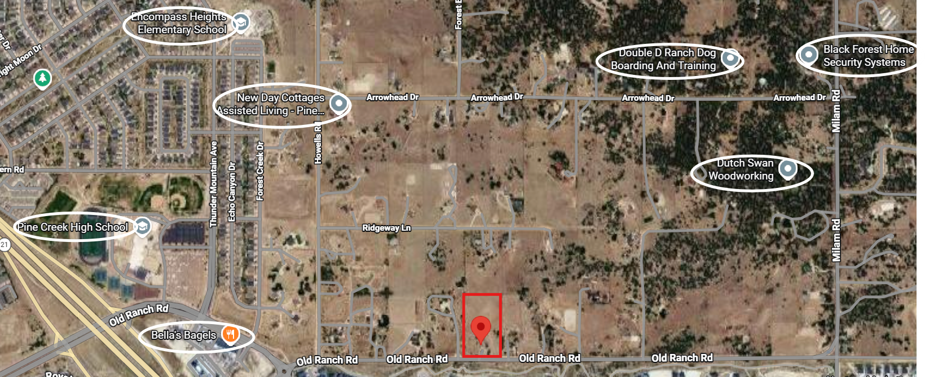

Mix of home businesses and commercial businesses as well as residential and educational uses in the surrounding area.

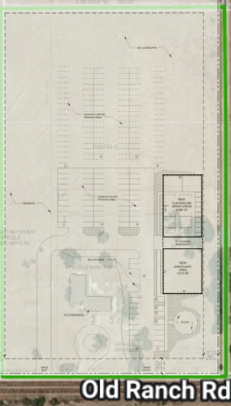

Overlay of proposed plans and existing parcel layout

Landscaping
☐ | Expressway, Principal arterial area depth – 25’-Trees required 1 per 20’
☐ | Urban interchange/Intersection area depth – 25’- N/A
☒ | Minor arterial area depth 20’ – Trees required 1 per 25’ (Old Ranch Rd)
☐ | Non-arterial area depth 10’ – Trees required 1 per 30’
☒ | Parking lot landscaping required
☐ | Buffer between non-residential and residential districts separated by a non-arterial road or public alley  ☐ Zone Boundary Buffer

6.2.2. Landscape Requirements
- Applies to All Land Uses. The requirements of this Section shall apply to all uses. PUD's may have their requirements modified subject to the individual PUD.

(B) Roadway Landscaping Requirements. Roadway landscaping areas are required. A roadway landscaping area is located along the lot, parcel or tract frontage between the road right-of-way, easement, or tract boundary lines and any building or use.

(C) Parking Lot Landscape Requirements.
- Required Trees.
A tree of a type suitable for parking lots shall be provided for every 15 parking spaces in parking lots with 15 or more parking spaces. The required trees may be clustered and shall be located in a manner which will divide and break up expanses of paving and long rows of parking and create a canopy effect over the parking lot. See Landscaping and Planting Manual for island details.

(5) Required Parking Lot Screening. Parking lots shall be screened from view from adjacent roads and properties with differing land uses. The minimum height of the screening shall be 3 feet and may be accomplished by using berms and plantings. A minimum of ⅔ of the road frontage or common lot, parcel, or tract boundary, not counting intersecting driveways, shall be provided with the required screening. The maximum spacing of plants to achieve an acceptable screen and the maximum acceptable grades for screening areas, such as grass berms and plantings beds, should be consistent with the Landscaping and Planting Manual.

Decorative walls or fences may be approved if the Director finds that:
• The wall or fence avoids a blank and monotonous appearance by architectural articulation and the planting of vines, shrubs, or trees.
• The total use of berms or plantings is not physically feasible; or
• The wall or fence attractively compliments the use of berms or plantings.
(4) Authority of Director to Approve Substitute Landscape Designs. The PCD Director may approve landscaping that does not meet the specific requirements of this Section provided the proposed landscaping meets the purpose of this Section, promotes the concepts contained in the Landscaping and Planting Manual, and provides an equivalent benefit to the community and environment as would otherwise be achieved by meeting the specific requirements of this Section. This authority shall not allow the PCD Director to eliminate the requirement for landscaping or to diminish the total landscaped area required by this Section.

Signage:
Sign permit applications are self-initiated at https://epcdevplanreview.com/

- Agricultural, Forestry, and Residential Zoning Districts.

Parking Requirements:
Table 6-2. Minimum Parking Requirements by Use
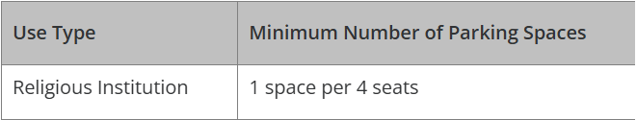
Professional Offices | 1 space per 200 square feet

Once you calculate the number of spaces required, see Table 6-3. Disabled Parking Space Requirements, to determine number of required ADA spaces.

Lighting:
6.2.3. Lighting
(d) Maximum Levels. Maximum on-site lighting levels shall not exceed 10 foot candles, except for loading and unloading platforms where the maximum lighting level shall be 20 foot candles.
(e) Measurement at Property Boundaries. Light levels measured at the property line of the development site adjacent to residential property or public right of way shall not exceed 0.1 foot candles as a direct result of the on-site lighting.
Photometric Plan ReqRequired | ☒

Site Characteristics\ Constraints\ Environmental Standards:
No slope
No Preble’s Mouse
No Floodplain
Wildlife Impact Level – 1 (Low)
Wildland Urban Interface – Moderate Intensity

Districts
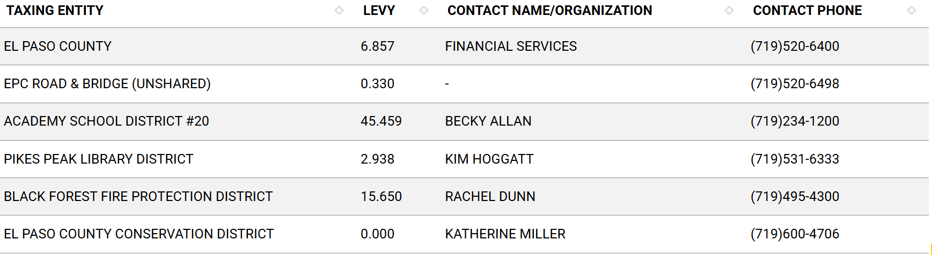

Road Impact Fees:
Paid at building permit. (See Engineering checklist)

Proposed source of water |  |  | Proposed method of wastewater disposal
☒ | Central System |  | ☒ | Central System
District Name: |  | Well | District Name: |  | Septic

Water/Wastewater:
Will need to contact Division of Water Resources to determine well sufficiency for proposed use.
- Existing well permit info:
- Permit #25389, Domestic Well 1965 (original)
- Permit #37811, Domestic Well 1969 (permit to deepen well)
- These are the records I was able to pull from DWR, they may have additional records or interpretation of the records.
Will need to contact El Paso County Health to determine septic sufficiency for proposed use.

Fire District:
Black Forest Fire Protection District

https://www.bffire.org/

Fire District Design Concerns/Emergency Services Issues:
Due to the parcel being in the Moderate Intensity area of the Wildland Urban Interface, the fire district may request a Wildland Fire and Hazard Mitigation Plan which will be added to the list of the submittal documents requested with this Site Development Plan.

Commissioner District: 1 – Holly Williams

Parks and trails:
Parks has not commented on the meeting request as of this date but will be invited to review the submitted documents and provide comments during the project review cycle.

Annexations/Intergovernmental/ Jurisdictional Access issues:
1- The city will need the applicant to dedicated 10' of ROW and 5 feet easement along Old Ranch Road.
2- Limit the site proposed access points to a maximum of 16 feet wide.
3- Is the site includes a school? if yes, what grades, operation hours, and student population?
4-The developer will need to construct an eastbound left turn lane at the proposed site entrance. The length of turn lane will need to be addressed in a traffic impact study.
Zaker Alazzeh, P.E.
Traffic Engineering Manager/Deputy City Traffic Engineer
City of Colorado Springs
(719) 385-5468
Zaker.Alazzeh@coloradosprings.gov
EDRD shares the same comments as the Traffic Team:
- The City will require the applicant to dedicate 10 feet of ROW and a 5-foot easement along Old Ranch Road.
- Limit the proposed site access points to a maximum width of 16 feet.
- Does the site include a school? If so, please provide the grades served, operating hours, and student population.
- The developer will be required to construct an eastbound left-turn lane at the proposed site entrance. The required turn-lane length must be addressed in a traffic impact study.
Reviewed by Hao Vo, P.E.
hao.vo@coloradosprings.gov

Next Steps
- After this meeting, you will have access to the notes presented in this meeting as well as a recording of this meeting at this link…EA26105
- You will be sent a submittal request for the list of documents required for the Site Development Plan. The request will come from “EPCDev” so check your junk/spam folder if you do not see it in your inbox.
- You may upload documents one at a time as you procure them, but you will only hit Submit once all documents are uploaded
- My supervisor will “triage” your documents and give them a cursory review to determine if they are acceptable. If they are not, he will return a request to resubmit them with a comment regarding why they were rejected. If they are accepted you will receive a payment request.
- Once you make the payment, the initial review cycle of 14 days will commence
- In that 14 days, County Staff and other outside agencies will be invited to review your documents and make comments
- One the 14th day, you will receive all comments as well as a resubmittal request for the documents we would like to see revised
- You will then be on your own timeline to resubmit the revised documents
- Once you resubmit, a 2nd review cycle will commence, which could be 7 to 14 days depending on the scope of the revisions requested.
- This cycle will repeat until all comments are addressed
- We will stamp your plans approved and provide necessary signatures on Engineer documents and upload them to the EDARP file under “Approved Documents”
- You will use the stamped approved plans to submit with your building permit application at Pikes Peak Regional Building.
- You will need to set up a Pre-Con meeting with Brad Walters inspections team (bradwalters@elpasoco.com)

Helpful Links

Planning Website: https://planningdevelopment.elpasoco.com/

El Paso County Master Plan: https://planningdevelopment.elpasoco.com/#1510603950097-f5d985dc-35b2
Water Master Plan: https://planningdevelopment.elpasoco.com/#1515613078151-9a697e85-b1a7
Parks Master Plan: https://parks.elpasoco.com/parks-and-recreation/park-planning/
Mineral Extraction Master Plan: https://planningdevelopment.elpasoco.com/#1515613078151-9a697e85-b1a7

Forms and Templates: https://planningdevelopment.elpasoco.com/forms-and-affidavits/

Applications and Checklists: https://planningdevelopment.elpasoco.com/applications-and-checklists/

Land Development Code: https://library.municode.com/co/el_paso_county/codes/land_development_code

EDARP: https://epcdevplanreview.com/

Public GIS: https://experience.arcgis.com/experience/94cea8ccda3d4806a3fd500d2b5a4433?draft=true

Wrap Up
-If subdivision is proposed, recording fees, park and school fees and road impact fees may apply.

-Fees are subject to change. The fees at the time of application apply.

-Road Impact Fees
Please see the following website for information on the EPC Road Impact Fee Project. https://publicworks.elpasoco.com/road-impact-fees/ to include fee schedule.
As of December 15, 2016, per Resolution 16-454, on and after January 1, 2020, property in the unincorporated area of the county that receives a Land Use Approval either in a public hearing or administratively, is subject to the payment of Road Impact Fees. After December 31, 2024, in accordance with BoCC Resolution 24-377 the fee is paid for new residential and non-residential uses and structures and expansions of non-residential uses and structures. Road Impact fees are typically paid at time of building permit. If no building permit is being obtained for a particular Land Use application, then Road Impact Fees must be paid at the time of Site Development Plan or Special Use approval. If there are questions about EPC Road Impact program or fees, please contact DPW Development Review Services and the Engineer of the Day.

- Engineering Criteria Manual (ECM) Deviations.
The fee for any additional ECM deviation requests (more than two per land use application) - $1483.00 each per current Fee Schedule. Please note ECM deviation requests may result in additional processing and project review time. ECM Deviations should be submitted prior to the initial Site Development Plan or Final Plat submittal to preclude changes having to be made to engineering plans and documents if the deviation is not approved. Submission of an ECM deviation request does not imply or guarantee that the deviation will be approved. An ECM Deviation form must be submitted to include complete exhibits and justification excluding cost with supporting engineering criteria. If there are questions about ECM Deviation requests, please contact DPW Development Review Services and the Engineer of the Day.

-The fee for any additional waiver/deviation requests (more than two) - $550.00 each. Please note that requests for waivers and/or deviations may result in additional processing/review delay.

-All items requested must accompany the submittal for it to be complete, prior to payment request or the submittal will not be complete and ready for review agencies.

-A temporary use permit shall be applied for and approved for any staging area associated with development, such as a sales office, construction trailer, or contractor's equipment yard, prior to scheduling of the pre-construction meeting with El Paso County Planning and Community Development. If a Planned Unit Development is proposed, the temporary staging area should be shown on the development guideline and phasing plan.

-All prospective timelines for review are subject to departmental staffing and workload.

-Early Assistance is valid for 12 months from submittal of the EA application. If a project submittal is not received within 12 months, a new EA meeting may be required. An audio/video copy of the meeting is available in EDARP within the EA folder.

- Applications scheduled for public hearings may be heard as a regular item at the request of staff or a hearing body member.

- Any comments or commitments made by any member of the County Staff during this early assistance meeting are only preliminary in nature and should not be relied upon by the applicant. All prospective applicants should be informed that formal comments cannot be made by staff until after the application is submitted.

