Early Assistance Meeting Number: EA2656
Project Name: Peyton Hwy 310 EA
Project Location: Jones RD and Peyton Hwy
Project Parcel Nos. 3300000217
Project Description: Enclosed is our application for an early assistance meeting regarding our 310-acre project on North Peyton Highway. We’re very familiar with the process of splitting large tracts into 35+ acre parcels, but this would be our first project sub-35-acres.
We’ve had a preliminary water study completed with a local water engineer (enclosed), and believe we have sufficient water to divide this tract into sub-35-acre parcels.
The drawing I included is just a rough idea, pending feedback from you all.
We’d like to split this into as many 5-acre tracts as possible, but we’re open to other options. We understand this will require road building off of E Garrett and Jones Rd, and the specifications of those roads are one of the topics I’d like to discuss at the meeting.
There is a flood zone running through a portion of the property. In those areas, we’d have a few larger tracts that allow for plenty of buildable land outside of the flood zone.
We’re hoping to get a clearer idea of what is/isn’t feasible at the early assistance meeting, given the water, entry points, flood zone, and county requirements.
Thank you for your time,
Dan Haberkost
719.428.2516
Meeting Date:

El Paso County Planning & Community Development Planning Checklist

Request – Map Provided by Applicant
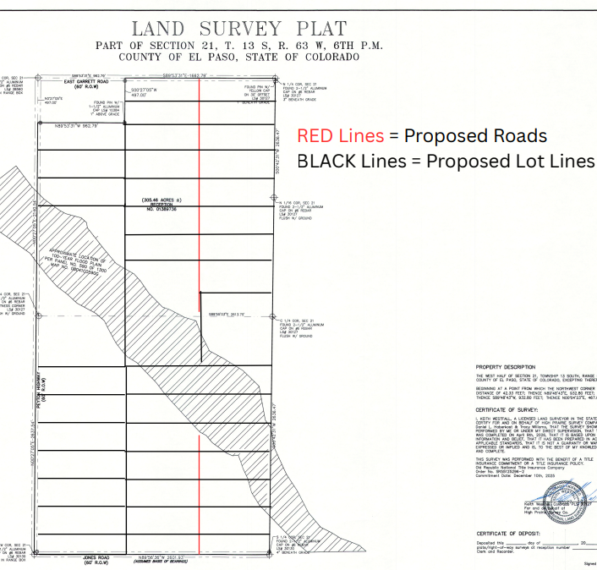
Lots not to be divided by floodplain; 2 access points required

Zoning
Existing Zone(s)
Zone |  | Name
A35 |  | Agricultural

Proposed Zone(s)
Zone |  | Name
A-5 or RR-5 |  | Agricultural/ Residential Rural

Zone Map (existing conditions of approval)
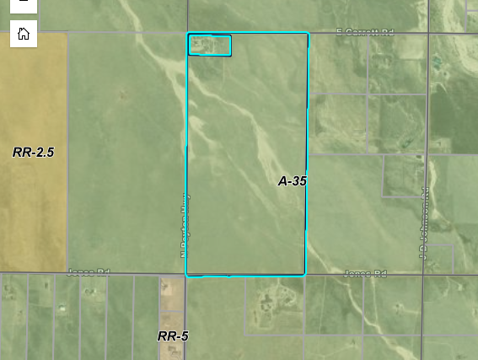
Crossing channel requires more engineering

Zoning Analysis
(C)A-5, Agricultural District. The A-5 zoning district is a 5 acre district primarily intended to conserve agricultural resources and ranching operations and accommodate limited residential use.

(A)RR-5, Residential Rural District. The RR-5 zoning district is a 5 acre district intended to accommodate low-density, rural, single-family residential development.
(B)RR-2.5, Residential Rural District. The RR-2.5 zoning district is a 2.5 acre district intended to accommodate low-density, rural, single family residential development.

(b)Standard Drainage Easement Widths and Locations. Drainage easements may be coincident with the required utility easements unless requested otherwise by the review engineer. The standard drainage easements for urban and rural lots shall be provided as follows
(ii)Rural Density
• Front Lot Lines: 10 feet

• Side Lot Lines: 10 feet

• Rear Lot Lines: 10 feet
(B)Utilities Standards.
(1)Utilities Located Underground. Utility facilities shall be located underground throughout the division of land except in situations or locations where undue hardship result from compliance with this requirement and the overriding intent of this Code has been demonstrated to the satisfaction of the PCD Director. Transformers, switching boxes, pedestals and other necessary facilities may be placed aboveground.
(2)Extended to Each Lot or Building Site. Utilities shall be extended to each lot, tract or building site.
(3)Utilities Located in Rights-of-Way or Easements. Utility lines, including appurtenances, shall be placed either within rights-of-way or within the easements or tracts provided for the particular facilities in accordance with the approved utility service plan and the ECM. Utility easements shall be identified for water, sewer, gas, electric power, telephone, cable television, and drainage facilities on the plat.
Zoning District | Maximum  Density  (DU/ac) | Minimum Lot Size |  | Minimum Setbacks Principal(Accessory)^{14,3} |  |  | Maximum Lot Coverage | Maximum Height
Zoning District | Maximum  Density  (DU/ac) | Area¹ | Width (at front setback line) | Front | Rear | Side | Maximum Lot Coverage | Maximum Height
Forestry and Agriculture
F-5 |  | 5 acres ² | 200 ft | 25 ft ^{3,4} | 25 ft ^{3,4} | 25 ft ⁴ | 25% | 30 ft
A-35 |  | 35 acres | 500 ft | 25 ft ^{3,4,5} | 25 ft ^{3,4,5} | 25 ft ^{3,4,5} | None | 30 ft ⁶
A-5 |  | 5 acres ² | 200 ft | 25 ft ^{3,4} | 25 f ^{3,4} | 25 ft ^{3,4} | None | 30 ft
Rural Residential/Rural Suburban
RR-5 |  | 5 acres ² | 200 ft | 25 ft ³ | 25 ft ³ | 25 ft ³ | 25% | 30 ft
RR-2.5 |  | 2.5 acres | 200 ft | 25 ft ³ | 25 ft ³ | 15 ft ³ | None | 30 ft

Design Standards Highlights
8.4.3
Minimum Frontage for Division of Land.
A division of land shall have a minimum of 60 feet frontage on a public road.
(B)Lot Design. Lot design and layout shall conform to the following standards:
(1)Buildable Lots. Lots shall be buildable lots, unless specifically approved and restricted by plat note.
(2)Lot Area and Dimensions.
(a)Minimum Lot Dimensions in Zoning District. The minimum area and dimensions of lots shall conform to the requirements of the applicable zoning district.
(b)Adequate Buildable Area Required. Lots shall have sufficient buildable area to reasonably accommodate the allowed uses. Buildable areas shall be excluded from easements unless otherwise approved by the easement holder, and shall not encroach into natural hazard areas unless the natural hazards are mitigated as required by this Code.

(3)Unsuitable Building Areas. Areas within lots or tracts which reflect 1 or more of the following characteristics shall be deemed unsuitable for building and shall be identified as no build areas on the plat:
• Areas not suitable for location of water or sewage disposal systems as determined by State and County health regulations.

• Areas where slopes are greater than 30%.

• Areas of identified or designated geologic, soil, or natural hazards as identified in the geology and soils report or designated in the El Paso County hazard identification inventory; provided that the limitations cannot be overcome through the application of specialized engineering or mitigation.

• Areas within the 100-year floodplain as reflected on FEMA Flood Insurance Rate Map (FIRM), within proposed boundaries as reflected in LOMR/CLOMR, or as determined by a flood study as approved by the Floodplain Administrator.

• Areas within easements, without the permission or release from the beneficiary of the easement holder.

8.4.3
(f)Lots Using OWTS. (i)Lots Designed to Use an OWTS. Lots which will utilize an OWTS shall have a minimum area of 2.5 acres.(ii)Minimum Buildable Area for Lots Using an OWTS. A minimum of 1 acre of buildable area is required for lots proposed to utilize an OWTS.
(5)Division of Lots by Boundaries and Man-Made or Natural Features. (a)Roads or Other Lots. Lot shall not be divided by a road, alley, or another lot.(b)Municipal, County or Zoning District Boundary. Lots shall not be divided by a municipal or County boundary or zoning district boundary.(c)Special, Taxing, or School District Boundary. Lots shall not be divided by a special district, taxing district, or school district boundary, unless coordinated with the affected districts.(d)Lots Divided by Irrigation Ditch, Stream or Drainage Facility. Lots should not be divided by an irrigation ditch, stream, or drainage facility unless a bridge or crossing is built to provide vehicular or pedestrian access to both sides.(e)Lots Divided by Easements. Lots should not be divided by easements. Drainage easements which bisect a lot are only allowed where no reasonable alternative to the drainage solution exists.

8.4.4
(C)Public Roads Required. Divisions of land, lots, and tracts shall be served by public roads.(D)Dead-End Road Standards. (1)Maximum Number of Lots on Dead-End Road. The maximum number of lots fronting and taking access from a dead-end road is 25. A corner lot is not counted in the maximum number of lots on a dead-end road when the fire department determines that adequate emergency access is provided to the corner lot by an alternative road.(2)More than 25 Lots on a Dead-End Road. Where more than 25 lots would front and take access to a dead-end road, a second means of access shall be provided. The second access shall be either a public road or a road located within an easement specifically constructed for emergency access purposes.
In situations where a second access is planned but is not practicable to construct initially, a divided 4 lane road meeting the design and construction requirements of the ECM shall be considered a second means of access until the second access road is constructed. Provision for crossing the median of a 4 lane road by emergency vehicles shall be included in the design. Roads taking access from the 4 lane road shall be subject to the dead end and roadway termination standards of this Code and the ECM.

(3)Maximum Length of Dead-End Road. The maximum length of a dead-end road is governed by the ECM, and may be further limited in those areas subject to wildfire hazard in accordance with this Code.(E)Private Road Allowances. (1)Use of Private Roads Generally Limited. Private roads shall normally be confined to closed loops and dead-end roads not likely to be needed for the convenience and safety of the general public.(2)Private Roads Require Waiver. The use of private roads is limited and allowed only by waiver. In granting a waiver to allow private roads, the BoCC shall make written findings supporting the use of private roads and may require the owner to enter into a Private Road Maintenance Agreement or create covenants whereby the lot owners are required to maintain the private roads.(3)Private Roads to Meet County Standards. Generally, private roads shall be constructed and maintained to ECM standards except as may be otherwise determined in the waiver. Private road waivers may only include design standards for the following:
• Right-of-way width where suitable alternative provisions are made for pedestrian walkways and utilities;

• Design speed where it is unlikely the road will be needed for use by the general public;

• Standard section thickness minimums and pavement type where suitable and perpetual maintenance provisions are made;

• Maximum and minimum block lengths; and

• Maximum grade.

(4)Private Roads Determined to Comply with Access Requirements. In cases where private roads are approved, the private roads shall be deemed to comply with the access and frontage requirements of this Code as if the private roads were public roads.(5)Private Roads Posted. Private roads shall be posted and identified on the plat.

Application Type(s) Hearing: Required/ Optional/ No
Rezoning | YES
Preliminary Plan >25 lots | YES
Final Plat(s) | Depends on if H20 at Preliminary Plan

The Preliminary Plan will depict all the lots and include phased plat filing lines if applicable. Multiple plats may be filed to break up the subdivision improvements, roads/utilities, etc. All roads and improvements are collateralized at Plat recording, which is why it may be beneficial to break the Plats into smaller filings on the Preliminary Plan.

Approval Criteria:
5.3.5. Map Amendment (Rezoning)

(A)Purpose. The purpose of zoning is to locate particular land uses where they are most appropriate, considering public utilities, road access, and the established development pattern. In addition to categorizing land by uses such as residential, commercial, and industrial, the LDC also specifies such details as building setback lines, the height and bulk of buildings, the size and location of open spaces, and the intensity to which the land may be developed. The zoning of parcels of land generally conforms to and promotes the County's Master Plan. Zoning protects the rights of property owners while promoting the general welfare of the community. By dividing land into categories according to use, and setting regulations for these categories, zoning governs private land use and segregates incompatible uses.
Generally, rezoning is justifiable under one of the following circumstances:

• When the requested rezoning is in general conformance or consistency with the County's Master Plan;

• If inconsistent with the Master Plan, a material change in the character of the area since the date of the current zoning is demonstrated;

• When there was an error or oversight in the original zoning of the property; or

• The zone change is necessary for the general health, safety, or welfare of the community.

(B)Criteria for Approval. In approving a Map Amendment, the following findings shall be made:
• The application is in general conformance with the El Paso County Master Plan including applicable Small Area Plans or there has been a substantial change in the character of the neighborhood since the land was last zoned;

• The rezoning is in compliance with all applicable statutory provisions, including but not limited to C.R.S. § 30-28-111 § 30-28-113, and § 30-28-116;

• The proposed land use or zone district is compatible with the existing and permitted land uses and zone districts in all directions; and

• The site is suitable for the intended use, including the ability to meet the standards as described in Chapter 5 of the Land Development Code, for the intended zone district.

(2)Preliminary Plan.
(a)Description of Preliminary Plan. The preliminary plan is generally the second step of the approval process for a large or complex division of land or the first step in the process for simpler divisions of land. The preliminary plan process will review the feasibility and design characteristics of the proposed division of land based on the standards in this Code. The preliminary plan process will also evaluate preliminary engineering design.
The purpose of the preliminary plan is to provide an in-depth analysis of the proposed division of land including a refinement of the design considering the geologic hazards, environmentally sensitive areas, source of required services, vehicular and pedestrian circulation, and relationship to surrounding land uses. The preliminary plan and reports shall meet the statutory requirements as contained in C.R.S. § 30-28-133, as amended. During this step public hearings will be held before the Planning Commission and the BoCC.

(b)Applicability. The preliminary plan applies to all subdivisions except those that can be classified as minor subdivisions.(c)Concurrent Review of Preliminary and Final Plat. The preliminary plan may be submitted concurrently with the final plat if the proposed division of land and development of the lots does not require extensive engineering. The PCD Director shall determine whether a particular subdivision may combine processes. The preliminary plan may also be submitted in conjunction with a PUD rezoning application and serve as the development plan, as long as all applicable requirements for both applications are met.(d)Preliminary Plan Approval Required. Preliminary plan approval or conditional approval is required in order to proceed to the final plat.

(e)Criteria for Approval. In approving a preliminary plan, the BoCC shall find that:
• The proposed subdivision is in general conformance with the goals, objectives, and policies of the Master Plan;

• The subdivision is consistent with the purposes of this Code;

• The subdivision is in conformance with the subdivision design standards and any approved sketch plan;

• A sufficient water supply has been acquired in terms of quantity, quality, and dependability for the type of subdivision proposed, as determined in accordance with the standards set forth in the water supply standards [C.R.S. § 30-28-133(6)(a)] and the requirements of Chapter 8 of this Code (this finding may not be deferred to final plat if the applicant intends to seek administrative final plat approval);

• A public sewage disposal system has been established and, if other methods of sewage disposal are proposed, the system complies with state and local laws and regulations, [C.R.S. § 30-28-133(6) (b)] and the requirements of Chapter 8 of this Code;

• All areas of the proposed subdivision, which may involve soil or topographical conditions presenting hazards or requiring special precautions, have been identified and the proposed subdivision is compatible with such conditions. [C.R.S. § 30-28-133(6)(c)];

• Adequate drainage improvements complying with State law [C.R.S. § 30-28-133(3)(c)(VIII)] and the requirements of this Code and the ECM are provided by the design;

• The location and design of the public improvements proposed in connection with the subdivision are adequate to serve the needs and mitigate the effects of the development;

• Legal and physical access is or will be provided to all parcels by public rights-of-way or recorded easement, acceptable to the County in compliance with this Code and the ECM;

• The proposed subdivision has established an adequate level of compatibility by (1) incorporating natural physical features into the design and providing sufficient open spaces considering the type and intensity of the subdivision; (2) incorporating site planning techniques to foster the implementation of the County's plans, and encourage a land use pattern to support a balanced transportation system, including auto, bike and pedestrian traffic, public or mass transit if appropriate, and the cost effective delivery of other services consistent with adopted plans, policies and regulations of the County; (3) incorporating physical design features in the subdivision to provide a transition between the subdivision and adjacent land uses; (4) incorporating identified environmentally sensitive areas, including but not limited to, wetlands and wildlife corridors, into the design; and (5) incorporating public facilities or infrastructure, or provisions therefore, reasonably related to the proposed subdivision so the proposed subdivision will not negatively impact the levels of service of County services and facilities;

• Necessary services, including police and fire protection, recreation, utilities, open space and transportation system, are or will be available to serve the proposed subdivision;

• The subdivision provides evidence to show that the proposed methods for fire protection comply with Chapter 6 of this Code; and

• The proposed subdivision meets other applicable sections of Chapter 6 and 8 of this Code.

Final Plat.
(a)Description of Final Plat. The final plat is the last step in the approval process for a division of land. The final plat process will review the final engineering plans, the SIA, financial assurance, CC&Rs (if applicable), the plat, and any other documents, reports, or studies as necessary; and may also review issues such as building height, landscaping, and building envelopes which have been deferred.
The purpose of this Section is to detail the approval review and approval criteria for a final plat, engineering plans, SIA, and other legal requirements for platting a division of land. During this step, there may be public hearings before the Planning Commission and BoCC.

(d)Final Plat
a )Criteria for Approval. In approving a final plat, the approving authority shall find that:
• The subdivision is in conformance with the goals, objectives, and policies of the Master Plan;

• The subdivision is in substantial conformance with the approved preliminary plan;

• The subdivision is consistent with the subdivision design standards and regulations and meets all planning, engineering, and surveying requirements of the County for maps, data, surveys, analyses, studies, reports, plans, designs, documents, and other supporting materials;

• Either a sufficient water supply has been acquired in terms of quantity, quality, and dependability for the type of subdivision proposed, as determined in accordance with the standards set forth in the water supply standards [C.R.S. § 30-28-133(6)(a)] and the requirements of Chapter 8 of this Code, or, with respect to applications for administrative final plat approval, such finding was previously made by the BoCC at the time of preliminary plan approval;

• A public sewage disposal system has been established and, if other methods of sewage disposal are proposed, the system complies with State and local laws and regulations, [C.R.S. § 30-28-133(6)(b)] and the requirements of Chapter 8 of this Code;

• All areas of the proposed subdivision which may involve soil or topographical conditions presenting hazards or requiring special precautions have been identified and that the proposed subdivision is compatible with such conditions [C.R.S. § 30-28-133(6)(c)];

• Adequate drainage improvements are proposed that comply with State Statute [C.R.S. § 30-28-133(3)(c)(VIII)] and the requirements of this Code and the ECM;

• Legal and physical access is provided to all parcels by public rights-of-way or recorded easement, acceptable to the County in compliance with this Code and the ECM;

• Necessary services, including police and fire protection, recreation, utilities, and transportation systems, are or will be made available to serve the proposed subdivision;

• The final plans provide evidence to show that the proposed methods for fire protection comply with Chapter 6 of this Code;

• Off-site impacts were evaluated and related off-site improvements are roughly proportional and will mitigate the impacts of the subdivision in accordance with applicable requirements of Chapter 8;

• Adequate public facilities or infrastructure, or cash-in-lieu, for impacts reasonably related to the proposed subdivision have been constructed or are financially guaranteed through the SIA so the impacts of the subdivision will be adequately mitigated;

• The subdivision meets other applicable sections of Chapter 6 and 8; and

• The extraction of any known commercial mining deposit shall not be impeded by this subdivision [C.R.S. §§ 34-1-302(1), et seq.]

Processing Issues and Options
Rezoning encouraged to be concurrent with Preliminary Plan. Water to be found at Preliminary Plan then Final Plats administrative.
More than 25 lots require a Preliminary Plan to be processed.

Park and school fees due at Plat Recording.
Upper Black Creek Water Shed groundwater has to be reinfiltrated to basin.

Relevant Past History:
NA

Design and Landscaping- Rural / entry features

Site Design/Layout (Lot pattern, circulation/road design, open space, preservation of natural features, compatibility internally and with adjacent land uses)
Recommend roads are more circuitous and parallel to channel . Avoid crossing channel, but if elects to than perpendicular as roads cross flood plan- Assume no CLOMR is requested;

Landscaping- see updated landscape policies
☐ | Expressway, Principal arterial area depth – 25’-Trees required 1 per 20’
☐ | Urban interchange/Intersection area depth – 25’- N/A
☐ | Minor arterial area depth 20’ – Trees required 1 per 25’
☒ | Non-arterial area depth 10’ – Trees required 1 per 30’
☐ | Parking lot landscaping required
☐ | Buffer between non-residential and residential districts separated by a non-arterial road or public alley

Rural development- entry features; preserve riparian vegetation along channel/drainages. See Chapter 6 and the revised Landscape memo policies link below:

https://planningdevelopment.elpasoco.com/#1746738110740-12f27e97-215c

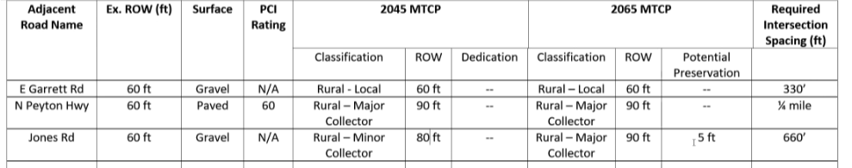

Signage:
Subdivision entry signage in easement or tract

Parking Requirements:
Must comply with residential standards

Lighting: NA
Photometric Plan Required | ☐

Site Characteristics\ Constraints\ Environmental Standards:
Rolling topography, floodplain; lots should incorporate floodplain at rear of lots in no build. Two sections naturally divided into north and south

☐ | 30% or greater slope | Topography:
☒ | CGS review required (separate fee to CGS) | Soils/geology: |  | 8.4.9 GEO report required by Professional; CGS review required- Receipt of payment to CGS required at EDARP
☒ | Floodplain | Floodplain comment: |  | 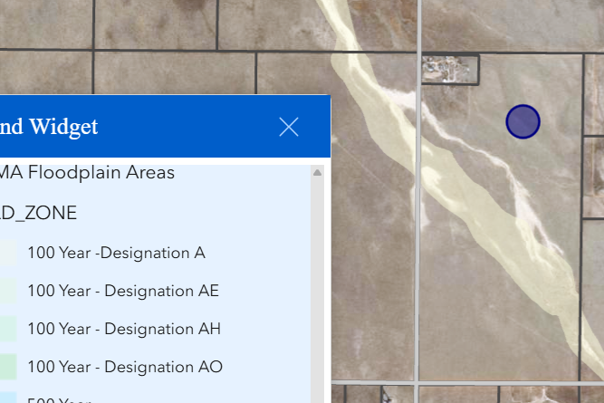 Place Floodplain in No Build Areas with rural lots if not in tracts.
☐ | Noise mitigation required | Noise comment:
☐ | Preble’s mouse

Air/Visual Quality:
No concerns If Chapter 8 is adhered to.

Districts

Taxing Entities
EL PASO COUNTY |  | 6.857 | FINANCIAL SERVICES | (719)520-6400
EPC ROAD & BRIDGE (UNSHARED) |  | 0.330 | - | (719)520-6498
ELLICOTT SCHOOL DISTRICT #22 |  | 29.284 | AMANDA KOBILAN | (719)683-2700
PIKES PEAK LIBRARY DISTRICT |  | 2.938 | KIM HOGGATT | (719)531-6333
ELLICOTT FIRE PROTECTION DISTRICT |  | 13.690 | MICHAEL HENLEY | (719)683-7211
UPPER BLK SQUIRREL CRK GROUND WATER DISTRICT |  | 1.082 | TRACY DORAN | (719)510-0780
ELLICOTT METRO DISTRICT |  | 0.000 | GEORGIA MCREA | (719)683-4190
EL PASO COUNTY CONSERVATION DISTRICT |  | 0.000 | KATHERINE MILLER | (719)600-4706

Proposed source of water |  |  | Proposed method of wastewater disposal
☐ | Central System |  | ☐ | Central System
District Name: |  | Well 8.4.7 Water Resource Report required | District Name: |  | OWTS 8.4.8 Waste Water Report Required
8.4.7
(v)Water Demands for Fire.
Proof shall be provided that water demands needed to satisfy fire demand, replacement of supplies reduced due to flooding, damaged or otherwise incapacitated systems can be met. This short term dependability is satisfied by such features as reservoirs, cisterns, standby wells and standby connections with other water supply or distribution systems.

7(d)Presumptive Use Values. In the absence of data on water use to the contrary or other minimum values established as acceptable by the State Engineer, the following presumptive values will be used to calculate the annual water demand:
• Residential inside use 0.26 acre feet per year for single family residences and 0.20 acre feet per year for each occupancy unit in multiple family residences other than single family. A duplex contains 2 occupancy units, a triplex contains 3 occupancy units, etc.;

• Residential and commercial landscaping use 0.0566 acre feet per 1,000 square feet of landscaping;

Water/wastewater comments
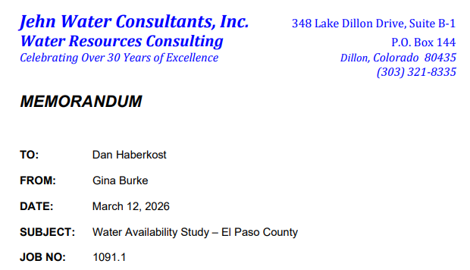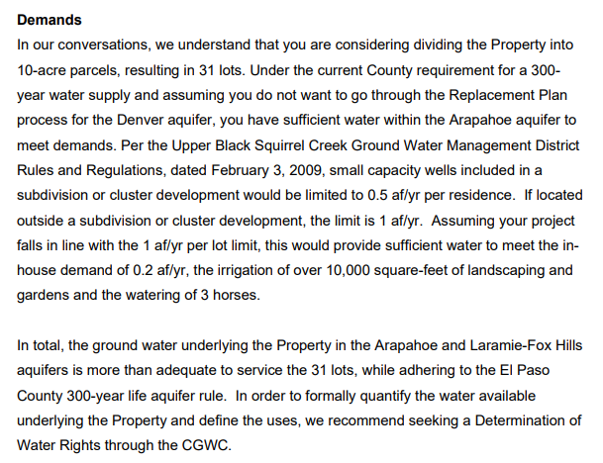

Fire District:
Ellicott Fire
See section 6.3.3. Fire Protection and Wildfire Mitigation
Report descriptions
(B)Reports and Commitments for Subdivisions.
(1)Fire Protection Report. A Fire Protection Report is required for any subdivision application and shall include the Fire Authority's capabilities, including existing and proposed equipment, facilities, services, response time to provide fire protection for the proposed subdivision, an analysis of compliance with the Fire Protection and Wildfire Mitigation Section of this Code, and an analysis of compliance with the applicable fire code.(2)Fire Protection Commitment. A written commitment to provide structural fire protection may be required for any proposed subdivision and the PCD Director may be requested for other development applications.
(3)Mitigation Costs Included in Construction Financial Assurance. If the Board of County Commissioners determines that wildfire mitigation issues are significant enough to require mitigation associated with development construction activities, the cost of the mitigation shall be included in the construction financial assurance. The Fire Authority may, at its discretion, choose to provide a recommendation to the Board of County Commissioners regarding whether the cost associated with performing wildfire mitigation is appropriate and should be secured and accounted for within the financial assurance estimate and associated collateral for the overall development.

(d)Areas without Central Water Systems. (i)Fire Cisterns.
• Fire Cisterns Required: Fire cisterns shall be provided in planned building areas which are not served by hydrants, unless the Fire Authority has recommended and the approval authority has approved an alternative fire protection water supply system. 30,000 gallons per Ellicott Fire Protection District

• Construction Standards: Construction of fire cisterns shall be in accordance with the approved plans and conform to the requirements of the NFPA standard on water supplies for suburban and rural fire fighting.

• Design Standards for Subdivisions with More than One Cistern: For subdivisions where more than one fire cistern is required, fire cisterns shall meet the requirements of the NFPA standards for water supplies for suburban and rural fire fighting. For this type of subdivision, fire cisterns shall be designed for the largest building allowed by zoning in the worst case hazard and construction class.

• Design Standards for Subdivisions with One Cistern: For subdivisions where only one fire cistern is required, the minimum capacity of the fire cistern shall meet the requirements of the NFPA standards on water supplies for suburban and rural fire fighting, or shall have a total capacity equal to 300 gallons for each acre within the subdivision plus 3,000 gallons per dwelling unit, whichever is greater.

• Cistern Turnaround: A dedicated turnaround shall be placed no more than 50 feet from a fire cistern, and the standpipe shall be within 8 feet of the nearest usable portion of the dedicated right-of-way or approved easement, unless otherwise recommended by the applicable Fire Authority and approved by the approval authority.

• Easements Required: Fire cistern easements shall be provided and dedicated to the appropriate fire department to afford accessibility of the cistern from a public road. Easements shall be of sufficient size to facilitate maintenance.

(ii)Dry Hydrants.
• Use of Dry Hydrants: Dry hydrants may be provided in combination with fire cisterns or other approved fire protection water supply systems. Plans for dry hydrants shall be submitted to the Fire Authority for recommendation and approved by the approval authority.

• Construction Standards: Construction and installation of dry hydrants shall be in accordance with the approved plans and conform to the requirements of the NFPA standards on water supplies for suburban and rural fire fighting.

• Accessible: Dry hydrants shall be located to be accessible under all weather conditions.

• Clearance: Dry hydrants shall have a minimum clearance of 20 feet on each side and be located a minimum of 100 feet from any structure. Highway or road traffic shall not be impaired during the use of the dry hydrant.

• Protected: Dry hydrants shall be protected from damage by vehicular and other perils, including freezing and damage from ice and other objects.

• Visible: Dry hydrant locations shall be made visible from the main roadway during emergencies by reflective marking and signage and shall be in conformance with the NFPA requirements. All identification signs shall be approved by the highway authority prior to installation if they are to be located on the right-of-way or are subject to State laws.

• Access to Hydrant: Vehicle access shall be designed and constructed to support the heaviest vehicle.

• Maintenance of Dry Hydrant: Dry hydrants shall be checked and maintained at least quarterly. Thorough surveys shall be conducted, to reveal any deterioration in the water supply situation in ponds, streams, or cisterns. Grass, brush, and other vegetation shall be kept trimmed and neat. Vegetation shall be cleared for a minimum 3 foot radius from around hydrants. The hydrant shall be painted as needed, with reflective material to maintain visibility during emergencies. The Fire Authority may make a recommendation regarding the ownership and maintenance responsibilities for the facilities per the NFPA 1142 Standards. The approval authority will approve the ownership and maintenance responsibilities for the facilities.

• Maps and Location/Detail Drawings: The Fire Authority and El Paso County Sherriff's Office shall maintain in a safe location, the maps and records of dry hydrant system locations, installation, tests, inspections, maintenance and repairs. When the property is not within a Fire Protection District it is the responsibility of the property owner and El Paso County Sherriff's Office to maintain in a safe location, the maps and records of dry hydrant system locations, installation, tests, inspections, maintenance and repairs.

• Easements Required: Dry hydrant easements shall be provided and dedicated to the appropriate fire department (or County where there is no fire department) to afford accessibility of the dry hydrant from a public road. Easements shall be of sufficient size to facilitate maintenance.

(iii)Water Supply Requirements. The owner of the cistern or dry hydrant is responsible for planning, developing, permitting, and continual provision of a sufficient water supply necessary to maintain the fire protection requirements of a cistern system, to the satisfaction of the approval authority with recommendation by the Fire Authority.(2)Roads. This Section shall apply to all roads providing access to a planned building area whether or not they are dedicated as public roads.(a)Roads Constructed to County Standards. All roads, including private roads and emergency vehicle access roads, shall be designed and constructed according to this Code and the ECM. Emergency vehicle access roads shall, at a minimum, be constructed to the County's gravel road standard if open to the public. Emergency vehicle access roads which are not open to public travel shall meet the non-road access standards(b)Roads within 150 Feet of Development. Roads or emergency vehicle lanes shall be provided within 150 feet of all development except single family residential development.(c)Two Access Routes Required. Access to a planned building area shall be provided by a minimum of 2 separate routes in accordance with the requirements of this Code and the ECM if the cul-de-sac exceeds the length allowed by the ECM.(d)Turnaround Required on Dead-End Roads. Every dead-end road more than 300 feet in length shall be provided with a roadway termination meeting ECM standards.(e)Road Grades in Wildland Fire Areas. Within wildland fire areas, road grades steeper than 10 percent may be permitted where the Fire Authority and ECM Administrator recommend that the mitigation measures are adequate and the approval authority approves the mitigation measure.

Wildland Fire and Hazard Mitigation Plan: May be Required posy July 2026- See 6.3.3 of Code. Discuss with Fire District; if submitted today will not be required.
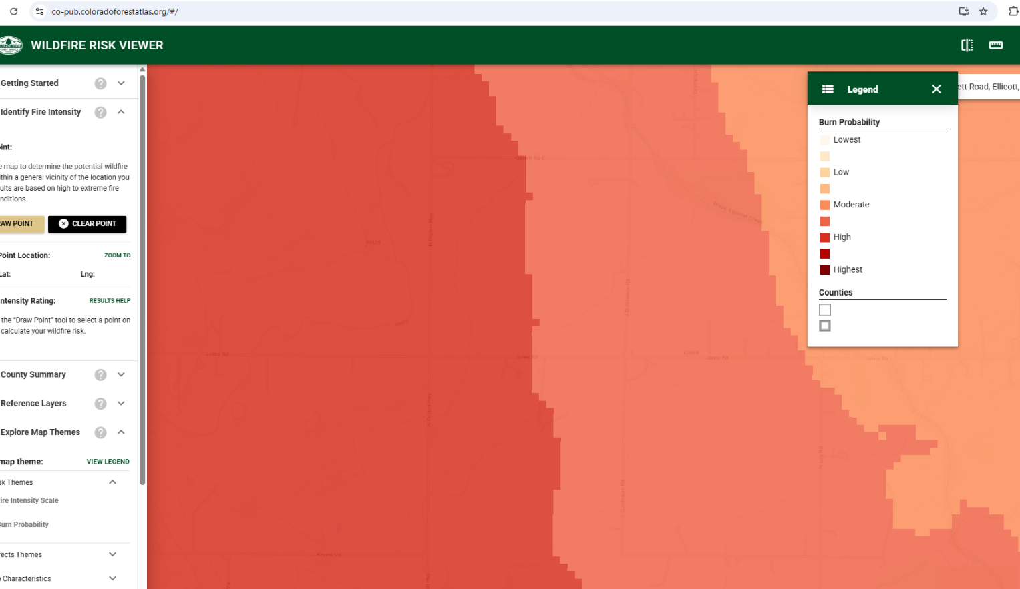

https://co-pub.coloradoforestatlas.org/#/

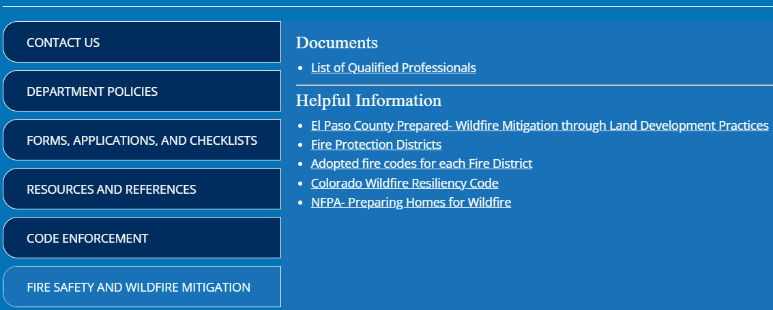

https://planningdevelopment.elpasoco.com/#1747935923000-7c355148-4705

Fire District/Emergency Services Issues: Cistern in Easement
All development requires water for fire protection and fire department access by both the County's Land Development Department and the adopted fire code for Ellicott Fire Protection District. If central water supply is not provided, then cisterns complying with NFPA 1142 are required. With the adoption and implementation of the Colorado Wildfire Resiliency Code hardened structure and mitigation are required for the level of wildfire hazard per the WRC map.


https://codes.iccsafe.org/content/IFC2021P1/appendix-d-fire-apparatus-access-roads

https://dfpc.colorado.gov/sections/wildfire-resiliency-code-board

Commissioner District: 2

Code Waivers:
None at this time
School Fees due at Plat Recording
Parks and trails: FEES due at Plat Recording
The 2022 El Paso County Parks Master Plan identifies impacts to a proposed trail within this property. The Judge Orr Primary Regional Trail is planned to run along along the southern border of the property near Jones Road. This creates a connection that allows the trail to travel west and east throughout the county.

Staff requests that a 25-foot trail easement be dedicated and clearly labeled as a County trail on the plat and along with an accompanying plat note. Additionally, we will want to ensure that the trail easement will not be within the ROW.

Additionally, for any grading proposed on the property, staff requests that it be conducted in a sustainable manner that supports the long-term viability of the trail corridor and avoids creating negative impacts.

Regional park fees will be assessed upon review of the forthcoming platting actions.

EPC Parks staff will attend this early assistance meeting.

Thank you!

Ashlyn Mathy
Parks Planner
Park Planning Division
El Paso County Parks Department
ashlynmathy@elpasoco.com

Annexations/Intergovernmental/ Jurisdictional Access issues:

Road Impact Fee Program (PID Inclusion):
Yes- PID possible

Your El Paso Master Plan

Placetype: Rural (adjacent to Large Lot Residential)
Character:
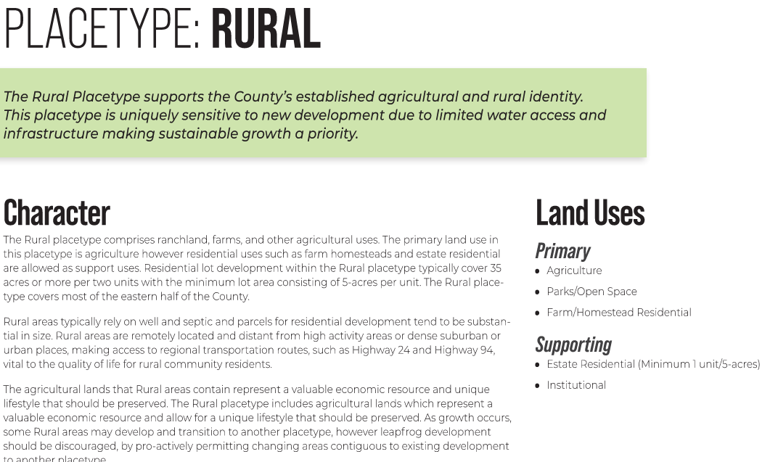
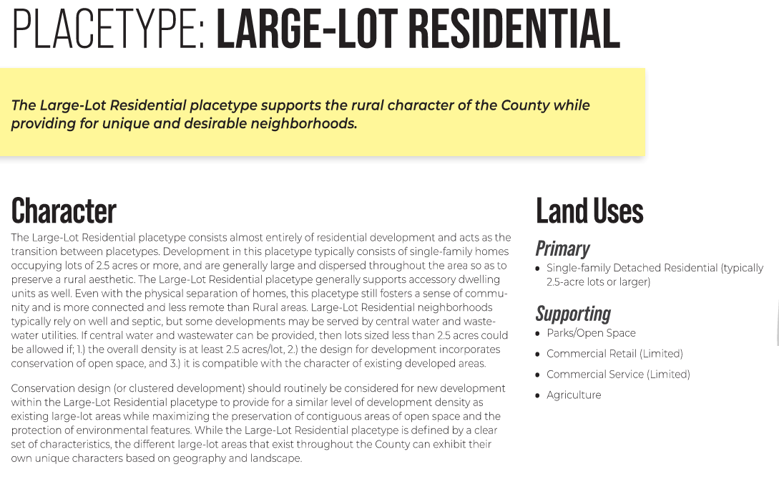
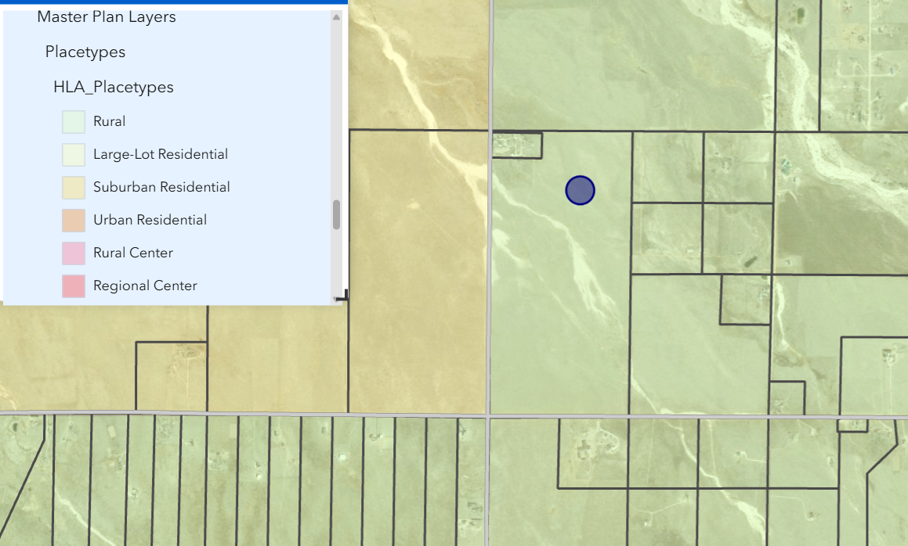

Recommended Land Uses:
- 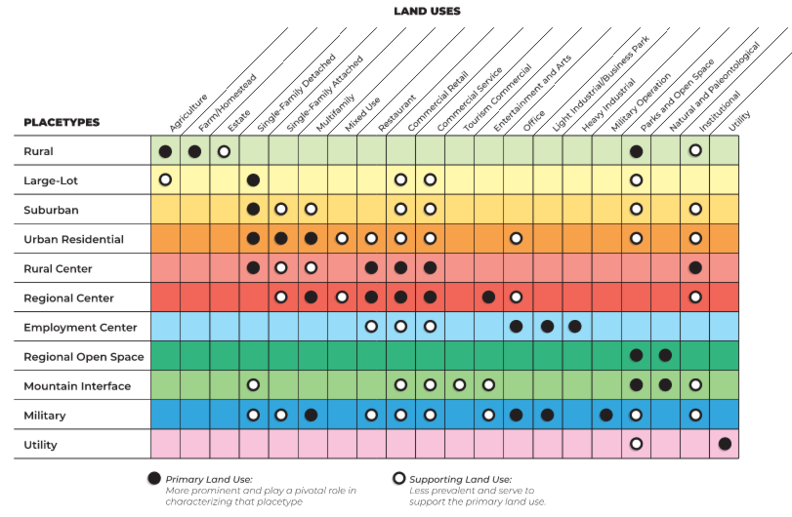

Goals, Objectives, Strategies:
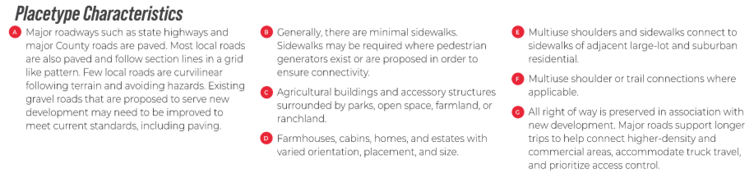

Area of Change Designation:
Description:
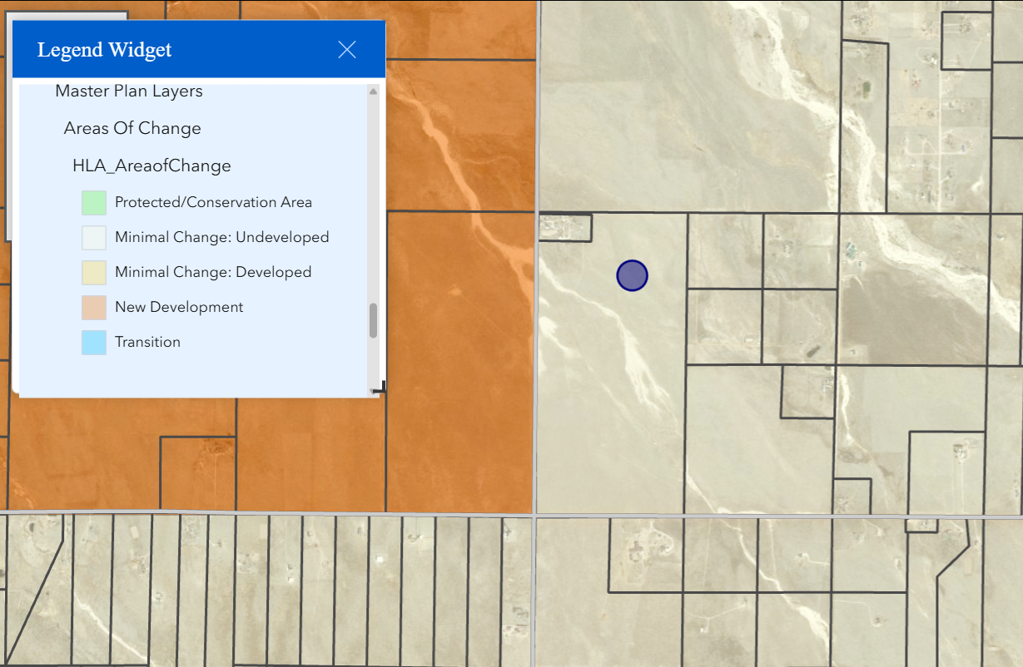

Goals, Objectives, Strategies:
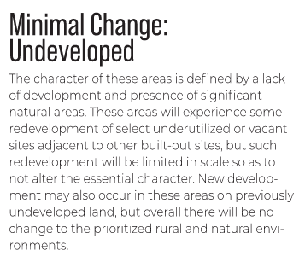

Key Area: None

Goals, Objectives, Strategies:

Water Master Plan Area:
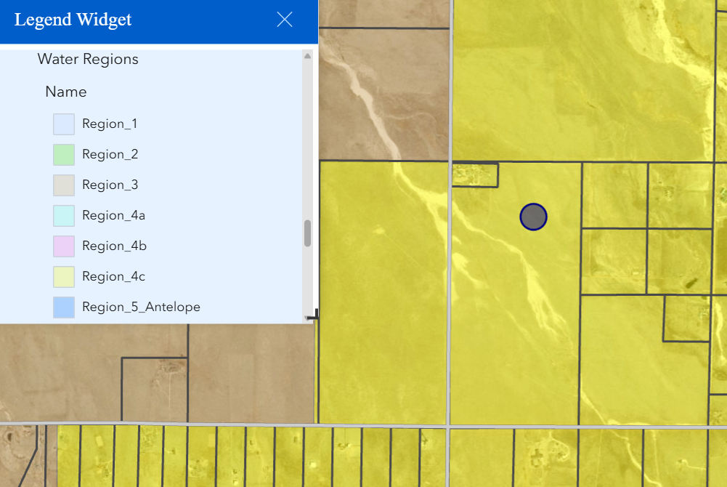

Recommendations:
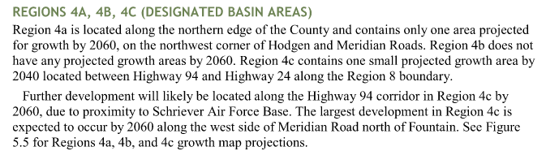

Wildlife impact
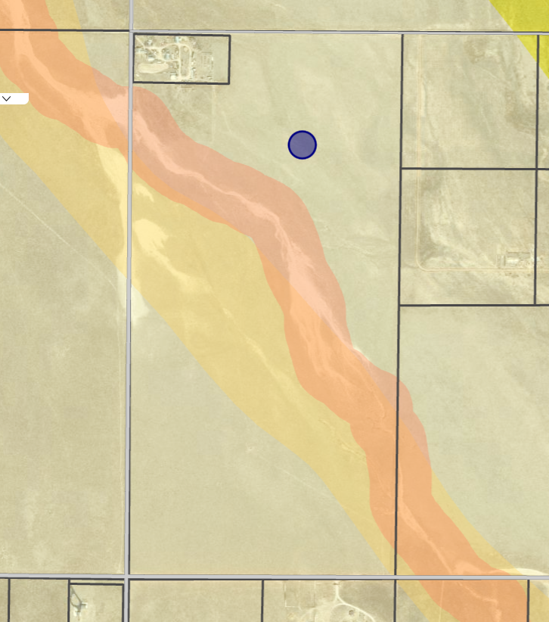
Low Wildlife Impact;
Prebble’s Jumping Mouse Habitat is possible next to creek, but no known in this area. Will send to USFWS for referral.

Parks Master Plan:
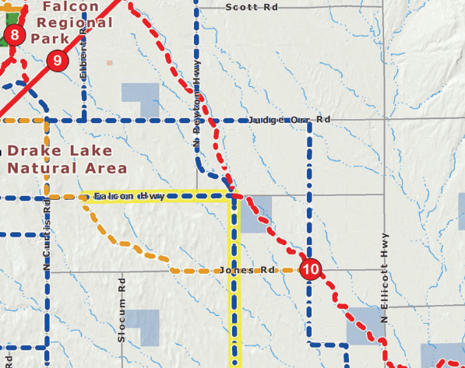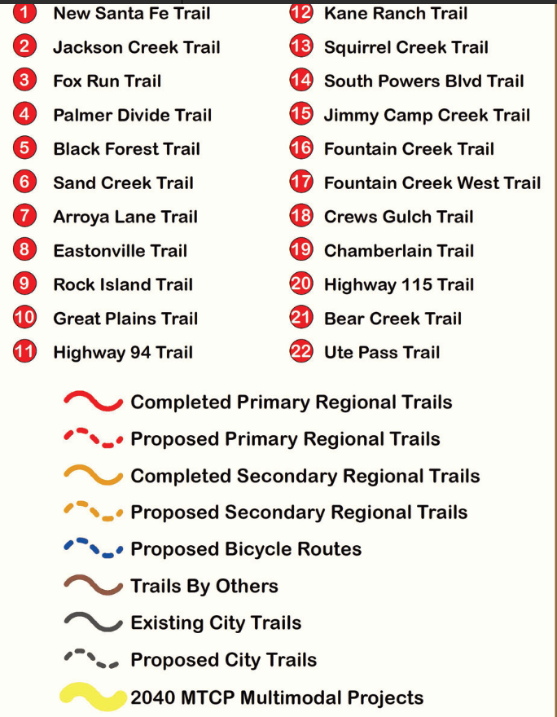

Helpful Links

Planning Website: https://planningdevelopment.elpasoco.com/

El Paso County Master Plan: https://planningdevelopment.elpasoco.com/#1510603950097-f5d985dc-35b2
Water Master Plan: https://planningdevelopment.elpasoco.com/#1515613078151-9a697e85-b1a7
Parks Master Plan: https://parks.elpasoco.com/parks-and-recreation/park-planning/
Mineral Extraction Master Plan: https://planningdevelopment.elpasoco.com/#1515613078151-9a697e85-b1a7

Forms and Templates: https://planningdevelopment.elpasoco.com/forms-and-affidavits/

Applications and Checklists: https://planningdevelopment.elpasoco.com/applications-and-checklists/

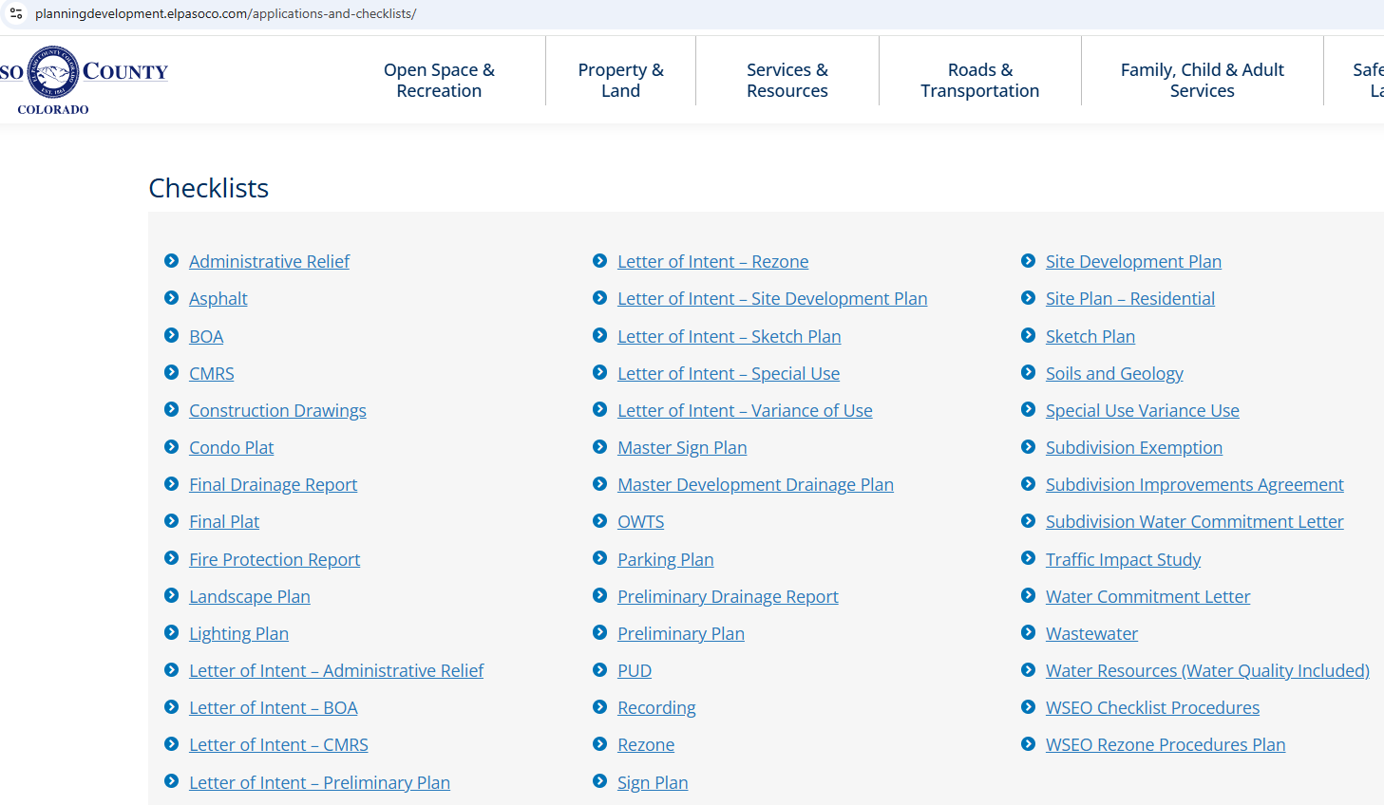

Land Development Code: https://library.municode.com/co/el_paso_county/codes/land_development_code

EDARP: https://epcdevplanreview.com/

Public GIS: https://experience.arcgis.com/experience/94cea8ccda3d4806a3fd500d2b5a4433?draft=true

Wrap Up
-If subdivision is proposed, recording fees, park and school fees and road impact fees may apply.

-Fees are subject to change. The fees at the time of application apply.

-Road Impact Fees
Please see the following website for information on the EPC Road Impact Fee Project. https://publicworks.elpasoco.com/road-impact-fees/ to include fee schedule.
As of December 15, 2016, per Resolution 16-454, on and after January 1, 2020, property in the unincorporated area of the county that receives a Land Use Approval either in a public hearing or administratively, is subject to the payment of Road Impact Fees. After December 31, 2024, in accordance with BoCC Resolution 24-377 the fee is paid for new residential and non-residential uses and structures and expansions of non-residential uses and structures. Road Impact fees are typically paid at time of building permit. If no building permit is being obtained for a particular Land Use application, then Road Impact Fees must be paid at the time of Site Development Plan or Special Use approval. If there are questions about EPC Road Impact program or fees, please contact DPW Development Review Services and the Engineer of the Day.

- Engineering Criteria Manual (ECM) Deviations.
The fee for any additional ECM deviation requests (more than two per land use application) - $1483.00 each per current Fee Schedule. Please note ECM deviation requests may result in additional processing and project review time. ECM Deviations should be submitted prior to the initial Site Development Plan or Final Plat submittal to preclude changes having to be made to engineering plans and documents if the deviation is not approved. Submission of an ECM deviation request does not imply or guarantee that the deviation will be approved. An ECM Deviation form must be submitted to include complete exhibits and justification excluding cost with supporting engineering criteria. If there are questions about ECM Deviation requests, please contact DPW Development Review Services and the Engineer of the Day.

-The fee for any additional waiver/deviation requests (more than two) - $550.00 each. Please note that requests for waivers and/or deviations may result in additional processing/review delay.

-All items requested must accompany the submittal for it to be complete, prior to payment request or the submittal will not be complete and ready for review agencies.

-A temporary use permit shall be applied for and approved for any staging area associated with development, such as a sales office, construction trailer, or contractor's equipment yard, prior to scheduling of the pre-construction meeting with El Paso County Planning and Community Development. If a Planned Unit Development is proposed, the temporary staging area should be shown on the development guideline and phasing plan.

-All prospective timelines for review are subject to departmental staffing and workload.

-Early Assistance is valid for 12 months from submittal of the EA application. If a project submittal is not received within 12 months, a new EA meeting may be required. An audio/video copy of the meeting is available in EDARP within the EA folder.

- Applications scheduled for public hearings may be heard as a regular item at the request of staff or a hearing body member.

- Any comments or commitments made by any member of the County Staff during this early assistance meeting are only preliminary in nature and should not be relied upon by the applicant. All prospective applicants should be informed that formal comments cannot be made by staff until after the application is submitted.

