February 24, 2026

Land Use Review
Planning & Community Development
30 South Nevada Avenue
Colorado Springs, CO 80903
RE: Briargate Pkwy and Voyager Pkwy Development | 1625 Springcrest Road, Colorado Springs, Colorado Project Statement for a Zoning Map Amendment

Project Description
Blackburn Communities, LLC (the “Developer”) wishes to develop a multifamily project on the existing parcel TSN 6232101002 located at the intersection of Briargate Parkway and Voyager Parkway and south of Springcrest Road. The site is currently vacant and undeveloped and is zoned as BP/CR HR (Business Park with a condition of record for a High-Rise overlay, restricting the height to 68-ft). The request for rezoning entails amending the current zoning of BP/CR HR to MX-M for multifamily residential use (See land use plan).
This site was zoned as BP/CR HR in 1999 and a development plan for a high-rise office building was approved in 1999 (CPC DP 99-125 and CPC P 99-120). The site has since remained vacant and undeveloped. The rezoning request is to rezone the parcel to MX-M which would be consistent with the surrounding zoning to the south and would allow for the development of multifamily residential on this parcel. The proposed MX-M zone will accommodate the proposed residential development and will reflect and support the adjacent MX-M commercial along Briargate. It is believed that with the proposed zoning request and conditions, the MX-M Residential use will reduce the overall impact on the current surrounding development by reducing the allowable building height and introduce a more neighborhood-like character with active open-space, a regional trail connection, and shared landscape features.

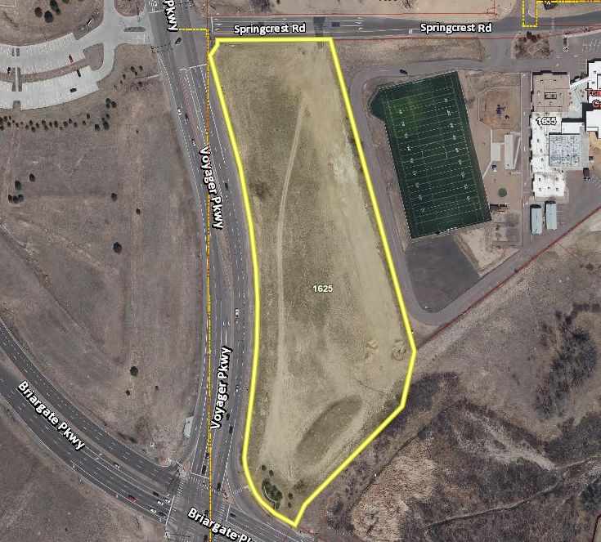
SITE
The Property to be rezoned is bounded as follows:
North: - Springcrest Road, Colorado Springs, CO 80920 (60-ft Public ROW); Residential
West: - Voyager Parkway, Colorado Springs, CO 80920; Principal Arterial
South: - Briargate Parkway, Colorado Springs, CO 80920; Principal Arterial
East: - The Classical Academy Central Campus
1655 Springcrest Rd, Colorado Springs, CO 80920
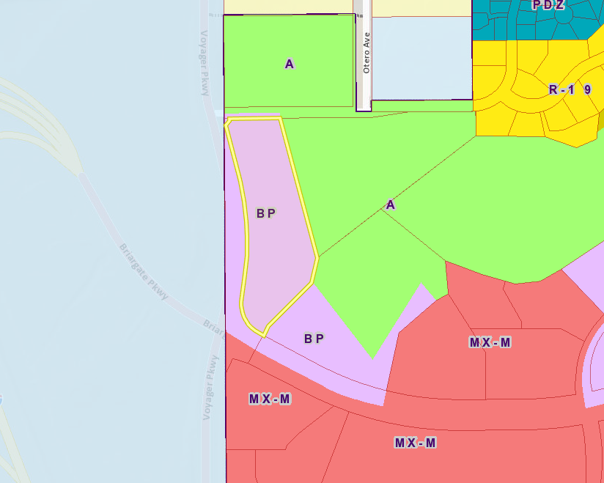
SITE

Zoning surrounding the site is Agriculture to the East and North. BP (Business Park) to the southeast and MX-M (Mixed Use Medium) to the South. The City of Colorado Springs boundary line lies west of the property with a small segment of land zoned BP between the County boundary line and the subject parcel.
The land uses around the site include the Briargate Assembly of God Church to the North, The Classical Academy Central Campus and Pine Creek Golf Course to the East, City of Colorado Springs land to the southeast, Briargate Business Campus to the South and the U.S. Air Force Academy to the west. The entire parcel is within the USAFA overlay. An avigation easement for the USAFA has been recorded on the plat.

Zone Map Amendment Criteria UDC 7.5.705.D

- The proposed rezoning is consistent with the goals and policies of the Colorado Springs Comprehensive Plan, with other plans and policies adopted by the City Council, and with the purpose statement of the proposed zoning district.
Response: The proposed rezoning to MX-M residential is consistent with the goals and policies of the Colorado Springs Comprehensive Plan, including the PlanCOS Vibrant Mixed Use Neighborhoods framework. The plan encourages diverse housing options and higher density residential developments in appropriate areas, which aligns with the vision to “build a great city that matches our scenery.”
The proposed rezoning is located within the Established Pine Creek Suburban Neighborhood. MX-M residential zoning will fulfil this typology’s goal to recognize, support, and enhance the existing character of these neighborhoods while supporting ongoing mixed-use investment and improved adaptation and sustainability.
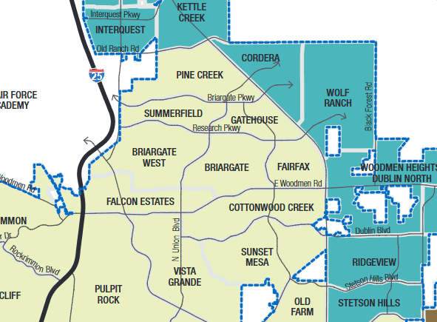
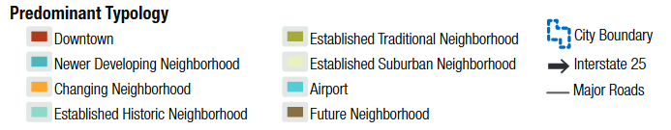
The zone change is consistent with the following PlanCOS Vibrant Neighborhoods: Goals and Policies:
Goal VN-2: Strive for a diversity of housing types, styles, and price points distributed throughout our city through a combination of supportive development standards, community partnerships, and appropriate zoning and density that is adaptable to market demands and housing needs.
- Policy VN-2.A: Promote neighborhoods that incorporate common desired neighborhood elements
  - Strategy VN-3.A-3: Support land use decisions and projects that provide a variety of housing types and sizes, serving a range of demographic sectors, and meeting the needs of residents and families through various life stages and income levels.
  - Strategy VN-2.A-5: Amend the City’s zoning code to allow attainable housing in multifamily and mixed commercial zoning districts in order to maximize the availability and distribution of this housing option in the city.
- Policy VN-3.A: Preserve and Enhance the physical elements that define a neighborhood’s character
  - Strategy VN-3.A-5: Update plans and City Code to encourage a blend of uses that positively affect neighborhood and neighborhood service.
  - Strategy VN-3.A-7: Encourage neighborhood plans and initiatives that reflect neighborhood identity and a built environment supporting residents of all age ranges and abilities.
- The rezoning will not be detrimental to the public interest, health, safety, convenience, or general welfare.
Response: MX-M residential zoning will allow for a multifamily apartment complex that will provide much-needed housing options, enhance the community services, and support local businesses by increasing the local resident population and providing and extending the Skyline Regional Trail. Multifamily residential developments are designed with predictable, low-impact traffic patterns and typically do not attract the high volume of transient visitors seen in commercial or business uses. This helps maintain a safer environment for surrounding areas.
- The location of the lands in the zoning map area being amended are appropriate for the purposes of the proposed zone district(s).
Response: MX-M Zoning and multifamily on this parcel will support the nearby MX-M commercial developments located southeast of the site. The proposed zone will provide a transition from the commercial uses south of the site to church, school and detached single family north and east of the site. MX-M residential for multifamily development will provide needed housing diversity on an infill lot. Multifamily housing in this location will provide housing choices, supported by the City Bus route along Voyager Parkway, Bike Route along Springcrest Road and Skyline Regional Trail located south of Briargate Parkway.

- If the application proposes to rezone a small area of land, the application demonstrates that: the size, scale, height density, and multimodal traffic impacts of development allowed upon approval will be compatible with surrounding development or can be made compatible through use restrictions approved through land use conditions.
Response: The size, scale, height, density, and multimodal traffic impacts of the proposed multifamily complex will be compatible with the surrounding development. The scale of the project will provide a suitable transition in building massing from MX-M uses to School, church and detached single family residential to the East and North. The project will provide buffers and incorporate green spaces throughout the development. The proposed rezoning will allow for a multifamily development that will support the adjacent and nearby commercial along Briargate Pkwy. It is believed that with the proposed zoning request and conditions, the MX-M Residential use will reduce the overall impact on the current surrounding development by reducing the allowable building height, reducing projected traffic and introducing a more neighborhood-like character with active open space landscape features.
Currently the parcel lays within the noted high-rise overlay zone, allowing up to 68 FT buildings. The proposed zoning will restrict the building height to 50 FT or the max allowable height within the MX-M zone.
Business Park zoning with a High-Rise Overlay was approved in 1999. The High-Rise overlay allowed for a 68 FT tall building(s). Since this time, market conditions and development potential of parcels have changed throughout the City. The pursued zone of MX-M will allow for market rate multifamily development on the irregularly shaped parcel. Multifamily uses on this parcel responds to current housing needs throughout the city and will support the nearby MX-M commercial. The proposed multifamily building will be restricted to 50 FT on this parcel which will transition the 6 lane Principal Arterial uses of Voyager Pkwy and Briargate Pkwy to the adjacent land uses of Church, School and Recreational Facilities north and east of the proposed development.
The existing bounds of Springcrest Road encroach into the subject parcel by approximately 13-ft. As part of this multifamily development, this area is planned to be dedicated as right-of-way to create a uniform 71-ft wide right-of-way street section with adequate pedestrian access to the extension of the Skyline Regional Trail along the western boundary of the site.
A traffic study completed by Kimley-Horn in April of 2025 and updated in February of 2026 found that the multifamily development can be successfully incorporated into the existing and future roadway network with improvements such as stop signs, a northbound right turn movement and timing splits. Data was collected during morning and afternoon peak hours (7:00–9:00AM and 4:00-6:00PM) and during school pick up and drop off times (8:15AM and 3:30PM) to assess the potential impact of the proposed development compared to the existing conditions.
Both school start time, 8:15 AM, and the school end time, 3:30 PM, are captured in the morning and midday analysis periods, respectively. While both these analysis periods show acceptable levels of service based on volumes and predicted queues, the Synchro model does not account for the gridlock independently caused by the school traffic backing up into public streets. The traffic volumes suggest the intersection should be operating acceptably but not if vehicles are being blocked along both Springcrest Road and Voyager Parkway preventing the ability to reach saturation flow rates along these roadways. This is trend in the traffic engineering industry with public charter and private schools in urban areas because these schools typically do not have bus operations or students walking to school and the majority of student pick-ups occurs from passenger vehicles.

It is recommended that Classical Academy elementary school and the City of Colorado Springs work together to create a solution to keep all potential drop-off/pick-up queues within the school’s property.

Regional access to the site will be provided by Interstate 25 (I-25) and Powers Boulevard (SH-21). Primary access will be provided by Voyager Parkway and Briargate Parkway. Direct access will be provided by right-in/right-out access along Voyager Parkway approximately 675 feet south of the Springcrest Road intersection and full movement access along Springcrest Road at the existing driveway cutout 300 ft east of the Voyager Parkway intersection. Multifamily housing primarily generates predictable, lower-volume traffic patterns concentrated around morning and evening commutes. This makes it a more manageable and less disruptive option for local infrastructure and neighborhood flow.
Landscape buffers will be provided with the Development plan. Buffers are proposed along the eastern boundary to mitigate potential impacts between the existing school and proposed multifamily use. The parcel is within the USAFA overlay and easement will be recorded with the replat. This parcel is also located outside of the 100-year floodplain.
- If an application proposes to rezone a relatively small area of land, it demonstrates that changes in zoning will not create significant obstacles for tenants or occupants of property in adjacent areas which may be adversely impacted by other public entities or property owners under Colorado Springs Comprehensive Plan goals that would be achieved by approval of this application.
Response: This property is within the USAFA overlay. A note to this effect has been recorded on the Final Plat and no impacts are anticipated with the use and the proposed zoning. MX-M zoning for multifamily development will support the adjacent MX-M zoning south along Briargate Pkwy and transition land uses from the principal arterial uses of Voyager Pkwy and Briargate Pkwy to Church, School and Recreational uses north and east of the intersection.
A traffic study completed by Kimley-Horn in April of 2025 and updated in February of 2026 found that the multifamily development can be successfully incorporated into the existing and future roadway network with the following conclusions and recommendations:
- Stop signs are installed on the approach exiting the development at the right-in/right-out access along Voyager Parkway and at the proposed full movement intersection along Springcrest Road.
- A northbound right turn movement should be provided within the existing acceleration/deceleration lane along Voyager Parkway at the right-in/right-out access.
- An eastbound right turn lane with 115 feet of length plus an approximate 50-foot taper should be implemented at the proposed access along Springcrest Road
- It is recommended that a striped chevron area be provided north of the existing southeast quadrant curb return of the Springcrest Road and Voyager Parkway
intersection to allow for a taper to be introduced prior to the new right turn lane. The introduced taper will prevent a vehicle weave that could be caused by a continuous right turn lane extending from the intersection.
- Timing splits for the eastbound and westbound approaches for the morning peak hour at the Briargate Parkway and Voyager Parkway
- If 2045 traffic volume projections are realized, dual southbound turn lanes may be needed at the Briargate Parkway and Voyager Parkway intersection to provide acceptable operations during the peak hours in 2045.
- It is recommended that Classical Academy elementary school and the City of Colorado Springs work together to create a solution to keep all potential drop-off/pick-up queues within he school’s property.
- If a Land Use Plan or amendment to a Land Use Plan accompanies this application, then Land Use Plan or amendment complies with criteria in Subsection 7.5.514C.3 (Land Use Plan Criteria).
Response: The rezoning application is accompanied by a Land Use Plan that complies with the criteria in Subsection 7.5.514.C3. The plan outlines the development's alignment with the city's long-term vision and goals for land use and community development. The Land Use Plan Criteria are addressed below.
- The application is consistent with any approved Concept Plans in this area for which the map is being amended or includes or is accompanied by a provision that approved Concept Plans that have been classified as implemented do not have to be amended to be considered consistent with an amended zoning map.
Response: The proposed MX-M zoning is compliant with the existing and built out Briargate Business Campus Master Plan and as a result not anticipated to require an amendment to the existing masterplan. Please refer to the “Briargate Business Campus Filing No. 20” for compliancy towards the master development plan.
- If an application is for the creation of an ADS-O district, then approval criteria applicable to creation of ADS-O districts in Section 7.2.607D.47.5.702 (Decision) shall also apply to consideration on zoning map amendments required to create or amend boundaries on ADS-O districts.
Response: This application is not requested to be within an ADS-O District.
- If rezoning to PDZ district; then proposed PDZ district is consistent with all applicable community amenities or other benefits as determined by Manager Planning Director; whether maintenance Colorado Springs Comprehensive Plan goals would not otherwise occur without such amenities/benefits provided either City Other governmental regulations.
Response: This application is not for rezoning to a PDZ district.
- Complies with the additional standards of the base zone district where the property is located (See Article 7.2 (Zone Districts)) or in an overlay district that applies to the property (See Part 7.2.6 Overlay Districts).
Response: Medium-to-high-density housing is permitted within the MX-M zoning. These uses are supportive of the MX-M zones with the intent to promote the adaptive reuse of vacant or underused sites. The proposed zone change and the requested building height adjustments will reduce the current allowable max building height from 68 FT to 57 FT.

Land Use Plan Criteria – UDC 7.5.514
- Consistency with the Colorado Springs Comprehensive Plan and other plans and policies adopted by City Council;
Response: Please see above. The proposed rezoning application is supportive of PlanCOS’s Vibrant Neighborhood’s typology and goals to provide a diverse and inviting community.
- Consistency with development standards the zone district in which the property is located, or would be located after a requested zone district change;
Response: The proposed use is consistent with the surrounding commercial, school and church/assembly uses. The proposed zone change and the requested building height adjustments will also be consistent with the current approved zone conditions. The conditions of the current allowed building heights under the high-rise overlay zone is 68 FT. Under the proposed new zone the building height is proposed to be 50’ maximum excluding minor mechanical and architectural parapet features. This will decrease the allowed building height by 18 FT, allowing for additional scenic viewing capacity. No high rise overlay is requested with this application.
- Compatibility with the land uses and development intensities surrounding the property;
Response: Within the mixed-use zoning and development environment, the proposed MX-M zone for residential will provide suitable transition from the major transportation corridors to the surrounding commercial, school and church/assembly uses. An extension of the Skyline Regional Trail will ensure access to existing development to the south and east of the parcel.
- Impacts of the permitted or requested uses, appropriate to the type of development, the neighborhood, and the community;
Response: The proposed MX-M residential zone will allow for high-density residential development, which will support the nearby commercial and transition land uses to the adjacent Church, School, City owned land and Pine Creek Golf Course. Multifamily in this location will support housing needs across the city, meet PlanCOS Vibrant Neighborhood goals and support nearby commercial developments.
Landscape buffers will be provided with the Development plan. Buffers are proposed along the eastern boundary to mitigate potential impacts between the existing school and proposed multifamily use. The parcel is within the USAFA overlay, an easement will be recorded with the replat. This parcel is located outside of the 100-year floodplain.
- Adequacy of proposed ingress/egress points and traffic circulation, both on and off the site;
Response: See above. The proposal provides adequate access. The ingress/egress point located along Voyager connects to an existing dedicated right turn lane to allow for smooth transitions. The ingress/egress point at Springcrest Rd. includes open landscaping for adequate sight distance standards for safe transitions. A traffic study completed by Kimley-Horn in April of 2025 and updated in February of 2026 found that the multifamily development additional trip generations can be successfully incorporated into the existing and future roadway network with improvements outlined in the study. The study included analysis of the adjacent school traffic and recommends that the school and City work together to create a solution that keeps all pick-up/drop-off lines within the school’s property.
- Capacity of existing streets, utilities, parks, schools, and other public facilities to serve proposed development;
Response: The site is served by Colorado Springs Utilities. Traffic impacts were analyzed within the traffic study. The study concluded that the development can be successfully incorporated into the existing and future roadway network with improvements. Park and School impacts will be addressed with fees in lieu. All Park and School fees will be paid at the time of Building Permit. Currently there have been comments concerning schools, park or infrastructure in the area. All proposed on site amenities will be maintained by on-site property management.
- Promotion of transitions in height, intensity, or character between proposed non-residential or mixed-use development and nearby low-density residential zone districts.
Response: It is believed that with the proposed zoning request and conditions, the MX-M Residential use will reduce the overall impacts on the current surrounding development by reducing the allowable building height, reducing projected traffic and introducing a more neighborhood-like character with active open space landscape feature. Regarding the proposed use, multifamily housing primarily generates predictable, lower-volume traffic patterns concentrated around morning and evening commutes. This makes it a more manageable and less disruptive option for local infrastructure and neighborhood flow.
_______________________________________________________________________________
Please contact Kimley-Horn and Associates if you have any questions or need additional information in regard to this application.

Sincerely,


KIMLEY-HORN AND ASSOCIATES, INC.

Joseph Menke, P.E.
Project Manager

