PRIVATE STORMWATER FACILITY AND WETLAND

MAINTENANCE AGREEMENT AND EASEMENT

This PRIVATE STORMWATER FACILITY MAINTENANCE AGREEMENT AND EASEMENT (Agreement) is made by and between El Paso County by and through THE BOARD OF COUNTY COMMISSIONERS OF EL PASO COUNTY, COLORADO (County), SR LAND, LLC and CLASSIC SRJ LAND, LLC (Owners), CLASSIC SRJ, LLC (Developer), and STERLING RANCH METROPOLITAN DISTRICT NO. 3 (District 3), a quasi-municipal corporation and political subdivision of the State of Colorado. The above may occasionally be referred to herein singularly as “Party” and collectively as “Parties.”

Recitals
- WHEREAS, District 3 provides various municipal services to certain real property in El Paso County, Colorado referred to as STERLING RANCH (the “Development”); and

- WHEREAS, District 3 and Owners are the owners of certain real estate (the “Stormwater Facilities Area”) in El Paso County, Colorado, which property is legally described in Exhibit A attached hereto and incorporated herein by this reference; and

- WHEREAS, Owners and Developer desire to plat and develop adjacent to the Stormwater Facilities Area and on property described in Exhibit B, attached hereto and incorporated herein by reference, a Subdivision to be known as Sterling Ranch East Filing No. 1; and

- WHEREAS, the development of Sterling Ranch, including this Subdivision, will materially increase the volume and decrease the quality of stormwater runoff from the Property; therefore, it is in the best interest of the public health, safety and welfare for the County to condition approval of the Subdivision on Developer’s promise to construct adequate stormwater control facilities including permanent stormwater quality structural Best Management Practices (“BMPs”) for the Development pursuant to the terms of the Development Agreement for Sterling Ranch recorded in the records of the El Paso County Clerk and Recorder at Reception No. 222098865 on July 22, 2022 (“Development Agreement”); and

- WHEREAS, the El Paso County Land Development Code, as periodically amended, requires the construction and maintenance of detention ponds and other drainage facilities adequate to maintain historic stormwater flow patterns, protect natural and man-made drainage conveyances, and prevent property damage in connection with land development and subdivisions, and further requires that developers enter into maintenance agreements and easements with the County for such drainage facilities; and

- WHEREAS, the El Paso County Drainage Criteria Manual, Volume 2, as amended by Appendix I of the El Paso County Engineering Criteria Manual (ECM), as each may be periodically amended, promulgated pursuant to the County’s Colorado Discharge Permit System General Permit (MS4 Permit), which MS4 Permit requires that the County take measures to protect the quality of stormwater from sediment and other contaminants, requires subdividers, developers, landowners, and owners of facilities located in the County’s rights-of-way or easements to provide adequate permanent stormwater quality facilities and BMPs with new development or significant redevelopment and to enter into maintenance agreements and easements with the County for such facilities and BMPs; and

- WHEREAS, Section 2.9 of the El Paso County Drainage Criteria Manual, Volume I provides for a developer’s promise to maintain a development’s drainage facilities in the event the County does not assume such responsibility; and

- WHEREAS, Owners, Developer, and District 3 desire to construct for the Development, including the Subdivision, drainage conveyance facilities, stormwater control measures, and permanent stormwater quality BMPs in the Sand Creek drainageway (collectively, “Stormwater Facilities”) in accordance with the Development Agreement as the means for providing adequate drainage and stormwater runoff control and to meet the requirements of the County’s MS4 Permit, and to operate, clean, maintain and repair such Stormwater Facilities; and

- WHEREAS, Developer desires to construct the Stormwater Facilities on the Stormwater Facilities Area as set forth on Exhibit A, attached hereto and incorporated herein by this reference; and

- WHEREAS, Developer, Owners, and District 3 shall be charged herein with the duties of providing the necessary easements and access to the Stormwater Facilities in the Stormwater Facilities Area; and

- WHEREAS, District 3 shall be charged herein with the duties of maintaining the Stormwater Facilities on property within the Stormwater Facilities Area that may be transferred to it; and

- WHEREAS, as required by the U.S. Army Corps of Engineers, Developer desires to construct and/or maintain wetlands on property as set forth on Exhibit E, attached hereto and incorporated herein by this reference (the Wetlands Maintenance Area), in conjunction with the Development, and on property within the Stormwater Facilities Area as set forth in the U.S. Army Corps of Engineers Permit (SPA-2015-00428), attached hereto as Exhibit G and incorporated herein by this reference in conjunction with the Subdivision; and

- WHEREAS, Developer shall be charged with the duty of constructing the Stormwater Facilities and wetlands and District 3 shall be charged with the duties of operating, maintaining and repairing the Stormwater Facilities and any appurtenant improvements on the property described in Exhibit A and the wetlands on the property described in Exhibit E; and

- WHEREAS, the County, in order to protect the public health, safety and welfare, desires the means to access, construct, maintain, and repair the Stormwater Facilities, and to recover its costs incurred in connection therewith, in the event the Developer or District fails to meet their obligations to do the same; and

- WHEREAS, the County conditions approval of this Subdivision on the Developer’s promise to construct the Stormwater Facilities, and further conditions approval on District 3’s promise to clean, maintain and repair the Stormwater Facilities, and on District 3’s promise to reimburse the County in the event the burden falls upon the County to construct, clean, maintain or repair the Stormwater Facilities serving this Development; and

- WHEREAS, the County, in order to secure performance of the promises contained herein, conditions approval of this Subdivision upon District’s and Owners’ grant herein of a perpetual Easement over their respective portions of the Stormwater Facilities Area as described in Exhibit A for the purpose of allowing District 3 access to construct, upgrade, clean, maintain and/or repair the Stormwater Facilities, and allowing the County to periodically access and inspect the Stormwater Facilities and, when necessary, to construct, clean, maintain or repair the Stormwater Facilities; and

- WHEREAS, the County, in order to secure performance of the promises contained herein, conditions approval of this Subdivision upon Developer’s grant herein of a perpetual Easement over the Wetlands Maintenance Area described in Exhibit E for the purposes of allowing District 3 access to maintain the wetlands existing and constructed thereon and allowing the County to periodically access and inspect the Wetlands Maintenance Area and, when necessary, to clean, maintain or repair the wetlands; and

- WHEREAS, pursuant to Colorado Constitution, Article XIV, Section 18(2) and Section 29-1-203, Colorado Revised Statutes, governmental entities may cooperate and contract with each other to provide any function, services, or facilities lawfully authorized to each.

Agreement

NOW, THEREFORE, in consideration of the mutual Promises contained herein, the sufficiency of which are hereby acknowledged, the Parties agree as follows:

- Incorporation of Recitals: The Parties incorporate the Recitals above into this Agreement.

- Covenants Running with the Land: Developer agrees that this entire Agreement and the performance thereof shall become a covenant running with the land, which land is legally described in Exhibit B attached hereto, and that this entire Agreement and the performance thereof shall be binding upon itself and its successors and assigns.

The Owners agree that this entire Agreement and Owners’ performance of their obligations hereunder shall become a covenant running with their land legally described in Exhibit A attached hereto, and that this entire Agreement and Owner’s performance of their obligations hereunder shall be binding upon itself and its successors and assigns.

- Construction: Developer shall construct the following Stormwater Facilities on the Stormwater Facilities Area described in Exhibit A:

Sand Creek channel improvements in accordance with the Sand Creek Restoration Construction Plans (most recent draft dated November 11, 2023) and antipating County approval with pending updated submittal by Developer.

Developer shall not commence construction of the Stormwater Facilities until El Paso County has approved in writing the plans and specifications for the Stormwater Facilities and this Agreement has been signed by all Parties and returned to the County. Developer shall complete construction of the Stormwater Facilities in substantial compliance with the Development Agreement and the County-approved plans and specifications for the Stormwater Facilities and shall provide certification from a Colorado registered Professional Engineer that the Stormwater Facilities were constructed in compliance with and provide the volume and capacity required by such plans and specifications in accordance with ECM requirements. Developer shall maintain the Stormwater Facilities until acceptance by District 3 for its respective maintenance obligations as set forth herein, and Final Acceptance of the County-Maintained Stormwater Facilities by El Paso County for its ownership and respective maintenance obligations as set forth herein. Failure to meet these requirements shall be a material breach of this Agreement and shall entitle the County to pursue any remedies available to it at law or in equity to enforce the same, subject to Section 1(b)(i) of the Development Agreement. Construction of the Stormwater Facilities shall be substantially completed within the timeframe set forth in the Development Agreement.

In the event construction of the Stormwater Facilities is not substantially completed within the timeframe set forth in the Development Agreement, or if the Subdivision is in violation of its ESQCP terms and conditions and Developer and District 3 have not made an effort to remedy the violation in a reasonable amount of time as determined by the County, then the County may exercise its discretion to complete the Stormwater Facilities and shall have the right to seek reimbursement from the Developer, District 3, and their respective successors and assigns for its actual costs and expenses incurred in the process of completing construction.

If Developer is required by the U.S. Army Corps of Engineers or other agency to construct and/or mitigate wetlands on the Wetlands Maintenance Area described in Exhibit E in conjunction with the Development, the wetlands mitigation plan shall be provided to the County after completion of construction, representing the as-built conditions.

Notwithstanding anything to the contrary contained herein, the parties hereto expressly agree and acknowledge that pursuant to the Development Agreement, Classic SRJ, LLC has agreed to construct and install the Sand Creek Channel Improvements (as defined in the Development Agreement) adjacent to this subdivision, including wetlands mitigation, for which collateral will be posted in connection with said Development Agreement and not with this Subdivision. To secure and guarantee performance of its obligations as set forth therein, Classic SRJ, LLC agrees to provide collateral to remain in effect at all times until the improvements are completed and accepted in accordance with Chapter 5 of the ECM. Therefore, if any terms, provisions, conditions, and/or obligations contained herein conflict with the Development Agreement, the provisions of the Development Agreement shall control and supersede any conflicting terms contained herein.

- Maintenance of Stormwater Facilities and Wetlands: District 3 agrees for itself and its successors and assigns that it will regularly and routinely inspect, clean and maintain all of the Stormwater Facilities in compliance with the County-reviewed Operation and Maintenance Manual, attached hereto and incorporated herein by this reference as Exhibit F, and otherwise keep the same in good repair, all at its own cost and expense. District 3’s obligation to maintain the County-Maintained Stormwater Facilities specifically identified in Exhibit C, attached hereto and incorporated herein by reference, in the Stormwater Facilities Area described in Exhibit A shall terminate upon County acceptance of the County-Maintained Stormwater Facilities. No trees or shrubs that will impair the structural integrity of the Stormwater Facilities shall be planted or allowed to grow within or adjacent to the Stormwater Facilities. Exhibit D, attached hereto, provides a non-exclusive list, for ease of reference, of District Stormwater Facilities which will remain District 3’s responsibility to maintain.

District 3 agrees for itself and its successors and assigns, that it will maintain and properly manage the grasses, wetlands and other vegetation in the Stormwater Facilities Area in compliance with the USACE conditions, the “Routine Maintenance Activities” specified in Exhibit F and other requirements or conditions of approval. Such obligation with respect to the Stormwater Facilities Area shall continue even after closure of the USACE permit as structural stability of the channel is dependent on proper maintenance of all vegetated areas.

If the County maintains or repairs any wetlands or non-structural vegetated areas in the course of properly maintaining the structural Stormwater Facilities or to protect the structural facilities from erosion or other hazards, the provisions described in Section 6 of this Agreement may apply.

- Creation of Easements: Developer hereby grants the County and District 3 a non-exclusive perpetual easement upon and across the Developer’s property described in Exhibit B. The purpose of the easement is to allow the County and District 3 to access, inspect, clean, repair and maintain the Stormwater Facilities and wetlands; however, the creation of the easement does not expressly or implicitly impose on the County a duty to so inspect, clean, repair or maintain the Stormwater Facilities or any appurtenant improvements until the time of County acceptance of the County-Maintained Stormwater Facilities.

Owners hereby grant the County and District 3 non-exclusive perpetual easements upon and across the Owner’s Property described in Exhibit A for the purposes of access to the Stormwater Facilities Area and Wetlands Maintenance Area, and inspection, construction, cleaning, maintenance and repair of the Stormwater Facilities and any appurtenant improvements and wetlands. The creation of the County’s easement does not expressly or implicitly impose on the County a duty to so inspect, construct, clean, repair or maintain the Stormwater Facilities, the Wetlands Maintenance Area or any appurtenant improvements until, with respect to the County-Maintained Stormwater Facilities only, the time of County acceptance of the County-Maintained Stormwater Facilities.

Neither Developer nor District 3 shall suffer any mechanics’ or materialmen’s liens to be enforced against the Owner’s property within the Stormwater Facilities Area or other property of Owner for work done or materials furnished in connection with Developer’s and District 3’s obligations under this Agreement. Owner shall have no obligations with respect to the Stormwater Facilities other than to provide the property and access thereto, without obstruction, pursuant to the easement described herein.

- County’s Rights and Obligations: Any time the County reasonably determines, in the sole exercise of its discretion, that the Stormwater Facilities have not been properly cleaned, maintained, or otherwise kept in good repair, the County shall give reasonable notice of such to the responsible Party and its successors and assigns. The notice shall provide a reasonable time to correct the problems. Should the responsible Parties fail to correct the specified problems, the County may enter upon the properties described in Exhibit A to perform the needed work and shall have the right to seek reimbursement from the responsible Parties for its actual costs and expenses in performing the work. Notice shall be effective to the above by the County’s deposit of the same into the regular United States mail, postage pre-paid. Notwithstanding the foregoing, this Agreement does not expressly or implicitly impose on the County a duty to inspect, construct, clean, repair or maintain the Stormwater Facilities prior to its acceptance of the County-Maintained Stormwater Facilities.

- Actual Costs and Expenses: The Developer and District 3 agree and covenant, for themselves and their successors and assigns, that they will reimburse the County for its actual costs and expenses incurred in the process of completing construction of, cleaning, maintaining, or repairing the Stormwater Facilities, wetlands, or non-structural vegetated areas pursuant to the provisions of this Agreement.

The term “actual costs and expenses” as used in this Agreement shall be liberally construed in favor of the County, and shall include, but shall not be limited to, labor costs, tools and equipment costs, supply costs, engineering and design costs, and costs to contract with specialized professionals or consultants, including but not limited to wetlands scientists, regardless of whether the County uses its own personnel, tools, equipment and supplies, etc. to perform the work. In the event the County initiates any litigation or engages the services of legal counsel in order to enforce the provisions arising herein, the County shall be entitled to its damages and costs, including reasonable attorney’s fees, regardless of whether the County contracts with outside legal counsel or utilizes in-house legal counsel for the same.

- Contingencies of Land Use/Land Disturbance Approval: Developer’s and District 3’s execution of this Agreement is a condition of subdivision, land use, or land disturbance approval. Additional conditions of this Agreement include, but are not limited to, the following:

- Conveyance of Developer’s property described in Exhibit B from Developer to District 3 and recording of the Deed for the same upon District and County acceptance of the required improvements; and

The County shall have the right, in the sole exercise of its discretion, to approve or disapprove any documentation submitted to it under the conditions of this Paragraph, including but not limited to, any separate agreement or amendment, if applicable, identifying any specific maintenance responsibilities not addressed herein. The County’s rejection of any documentation submitted hereunder shall mean that the appropriate condition of this Agreement has not been fulfilled.

- Agreement Monitored by El Paso County Planning and Community Development Department and/or El Paso County Department of Public Works: Any and all actions and decisions to be made hereunder by the County shall be made by the Executive Director of the El Paso County Planning and Community Development Department and/or the Executive Director of the El Paso County Department of Public Works. Accordingly, any and all documents, submissions, plan approvals, inspections, etc. shall be submitted to and shall be made by the Executive Director of the Planning and Community Development Department and/or the Executive Director of the El Paso County Department of Public Works.

- Indemnification and Hold Harmless: Developer and District 3 agree, for themselves, their successors and assigns, that they will indemnify, defend, and hold the County harmless from any and all loss, costs, damage, injury, liability, claim, lien, demand, action and causes of action whatsoever, whether at law or in equity, arising from or related to their intentional or negligent acts, errors or omissions or that of their agents, officers, servants, employees, invitees and licensees in the construction, operation, inspection, cleaning (including analyzing and disposing of any solid or hazardous wastes as defined by State and/or Federal environmental laws and regulations), maintenance, and repair of the Stormwater Facilities or wetlands, and such obligation arising under this Paragraph shall be joint and several. Nothing in this Paragraph shall be deemed to waive or otherwise limit the defense available to the County or District 3 pursuant to the Colorado Governmental Immunity Act, Sections 24-10-101, et seq. C.R.S., or as otherwise provided by law.

Developer and District 3 shall indemnify, defend and hold Owners harmless from and against any and all obligations, liabilities, claims, liens, demands, loss, damage, injury, suit, causes of action, costs and expenses (including, without limitation, attorneys’ fees) whatsoever in any way relating to or arising out of either (i) any stormwater runoff or drainage from the Subject Property and Stormwater Facilities Area shown in Exhibit A that enters or crosses the Owners’ property or other properties, or (ii) the activities or obligations of Developer, District 3, or their respective agents or representatives under this Agreement. At all times during any construction or maintenance activities within the Stormwater Facilities Area shown in Exhibit A Developer and District 3 shall maintain, or cause to be maintained, in full force and effect, a policy of comprehensive general liability insurance issued on a form and with an insurance company reasonably acceptable to Owner, and with such commercially reasonable coverage limits as Owners may from time to time require. Prior to any construction or maintenance activities, Developer and District 3 shall provide Owners with a certificate of insurance evidencing that Owners have been named as additional insureds under such policy. Such certificate shall provide that such policy shall not be cancelled or amended without thirty (30) days’ prior written notice to Owners.

- Severability: In the event any Court of competent jurisdiction declares any part of this Agreement to be unenforceable, such declaration shall not affect the enforceability of the remaining parts of this Agreement.

- Third Parties: This Agreement does not and shall not be deemed to confer upon or grant to any third party any right to claim damages or to bring any lawsuit, action or other proceeding against the County, the Developer, District 3, or their respective successors and assigns, because of any breach hereof or because of any terms, covenants, agreements or conditions contained herein.

- Solid Waste or Hazardous Materials: Should any refuse from the Stormwater Facilities be suspected or identified as solid waste or petroleum products, hazardous substances or hazardous materials (collectively referred to herein as “hazardous materials”), the Developer and District 3 shall take all necessary and proper steps to characterize the solid waste or hazardous materials and properly dispose of it in accordance with applicable State and/or Federal environmental laws and regulations, including, but not limited to, the following: Solid Wastes Disposal Sites and Facilities Acts, §§ 30-20-100.5 – 30-20-119, C.R.S., Colorado Regulations Pertaining to Solid Waste Disposal Sites and Facilities, 6 C.C.R. 1007-2, et seq., Solid Waste Disposal Act, 42 U.S.C. §§ 6901-6992k, and Federal Solid Waste Regulations 40 CFR Ch. I. The County shall not be responsible or liable for identifying, characterizing, cleaning up, or disposing of such solid waste or hazardous materials. Notwithstanding the previous sentence, should any refuse cleaned up and disposed of by the County be determined to be solid waste or hazardous materials, the Developer and District 3, but not the County, shall be responsible and liable as the owner, generator, and/or transporter of said solid waste or hazardous materials.

- Applicable Law and Venue: The laws, rules, and regulations of the State of Colorado and El Paso County shall be applicable in the enforcement, interpretation, and execution of this Agreement, except that Federal law may be applicable regarding solid waste or hazardous materials. Venue shall be in the El Paso County District Court.

- Limitation on Developer’s Obligation and Liability: The obligation and liability of the Developer hereunder shall only continue until such time as the Final Plat as described in the fourth paragraph (Paragraph D) of the Recitals set forth above is recorded and the Developer completes the construction of the Stormwater Facilities and wetlands in accordance with the Development Agreement referenced above and transfers all applicable maintenance and operation responsibilities to District 3. By execution of this agreement, District 3 agrees to accept all responsibilities and to perform all duties assigned to it, including those of the Developer, as specified herein.

- Agreements superseded: HSN1 223041857, SRF3 222103273

[Remainder of page intentionally left blank]

OWNER:
Executed this _________ day of ______________, 20___, by:
CLASSIC SRJ LAND, LLC

By: __________________________________________
Douglas Stimple, CEO of Manager

The foregoing instrument was acknowledged before me this _______ day of __________, 20___, by Douglas Stimple, CEO of Manager OF CLASSIC SRJ LAND, LLC.

Witness my hand and official seal.
My commission expires: _________________
__________________________________________
Notary Public
DISTRICT 3
Executed this _________ day of _________________, 20___, by:

STERLING RANCH METROPOLITAN DISTRICT #3

By: __________________________________________
DOUGLAS STIMPLE, PRESIDENT
Attest:
By: __________________________________________
LOREN F. MORELAND, SECRETARY

The foregoing instrument was acknowledged before me this _______ day of ___________, 20___, by DOUGLAS STIMPLE, PRESIDENT, and LOREN F. MORELAND, SECRETARY, STERLING RANCH METROPOLITAN DISTRICT NO.3

Witness my hand and official seal.
My commission expires: _____________________________________

_____________________________________________
Notary Public
DEVELOPER

Executed this ________ day of _______________________, 20___, by:

CLASSIC SRJ, LLC

By: __________________________________________
Douglas Stimple, CEO of Manager

The foregoing instrument was acknowledged before me this _____day of ______________, 20___, by Douglas Stimple, as CEO of Manager of Classic SRJ, LLC.

Witness my hand and official seal.
My commission expires: _________________

__________________________________________
Notary Public

Executed this _______ day of _____________________, 20___, by:

BOARD OF COUNTY COMMISSIONERS
OF EL PASO COUNTY, COLORADO
By: _________________________________
Meggan Herington, Executive Director
Planning and Community Development Department
Authorized Signatory pursuant to LDC

The foregoing instrument was acknowledged before me this _______ day of ______________, 20___, by Meggan Herington, Executive Director, Planning and Community Development Department.

Witness my hand and official seal.
My commission expires: ________________

________________________________
Notary Public

Approved as to Content and Form:

_____________________________
Assistant County Attorney

EXHIBIT B
Subject Sterling Ranch East Filing No. 1

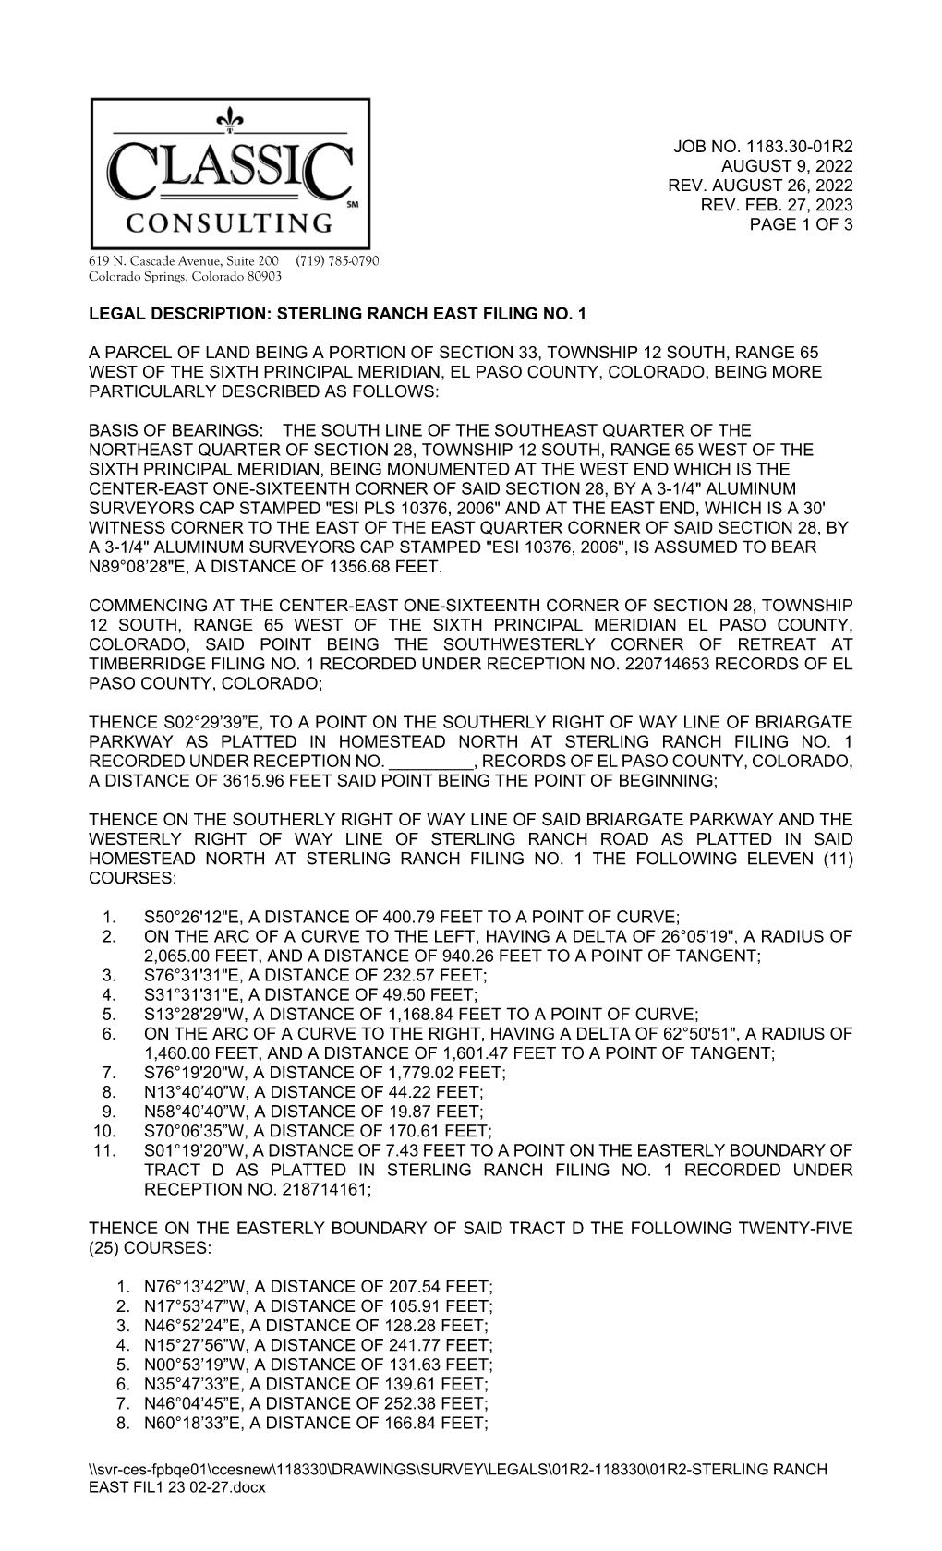

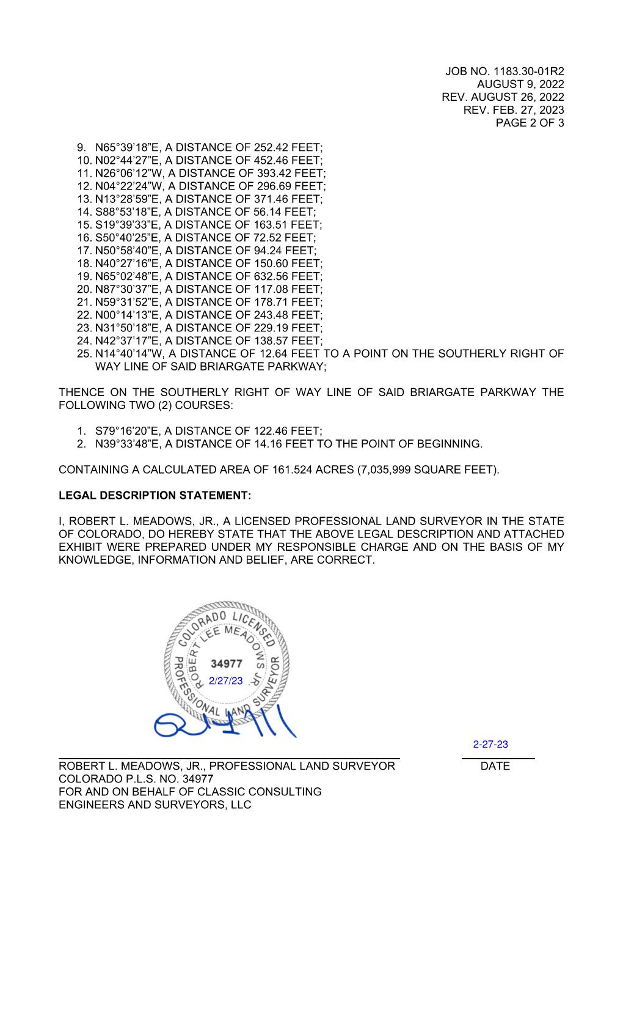
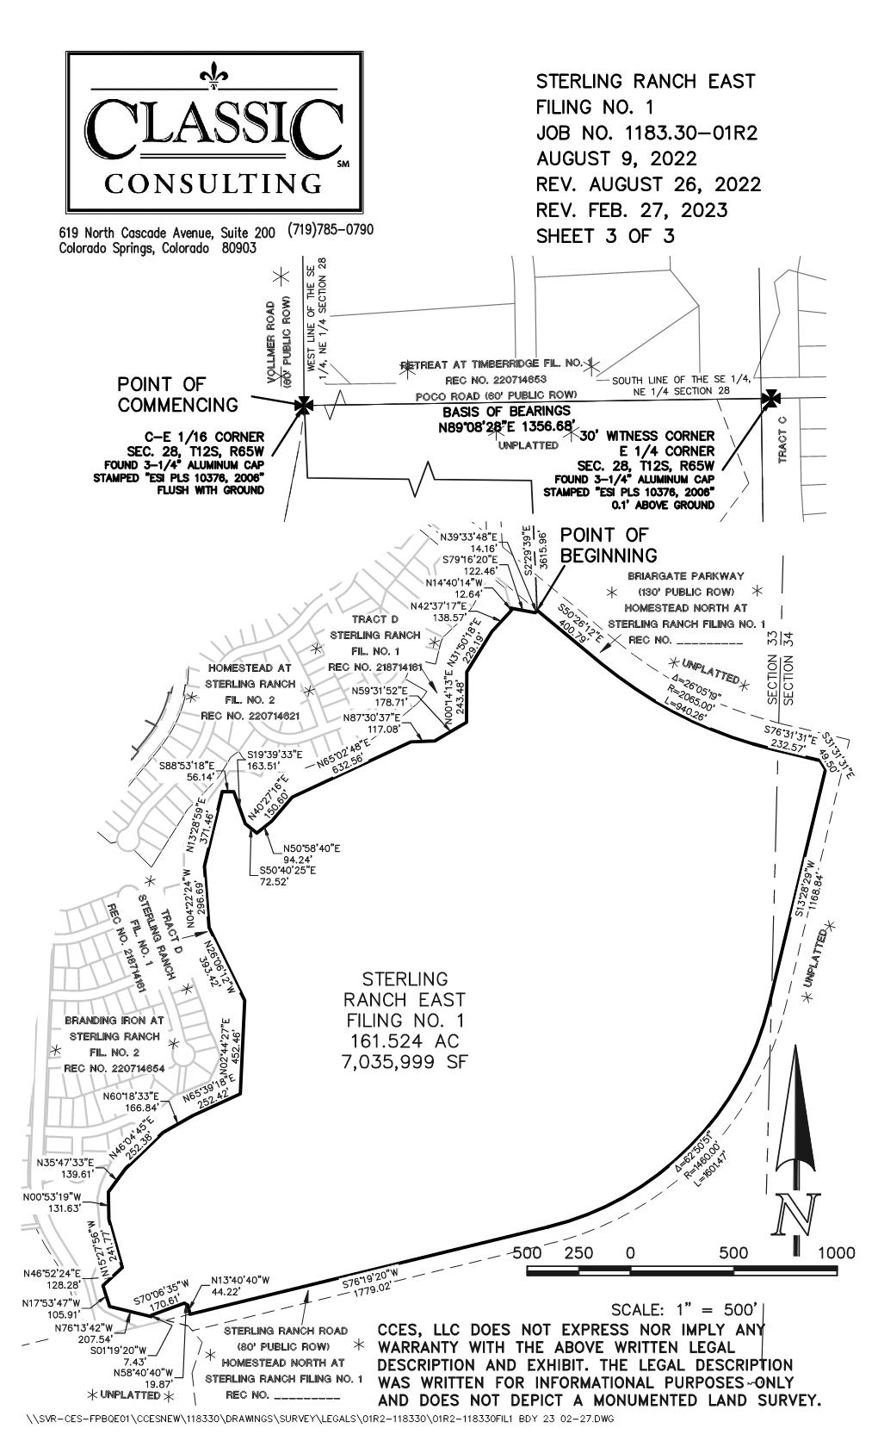
EXHIBIT A
Stormwater Facilities Area
(Both Owner and Developer properties)
Tract B, Sterling Ranch Filing No. 3
Tract D, Sterling Ranch Filing No. 1

Tract C, Homestead North at Sterling Ranch Filing No. 3

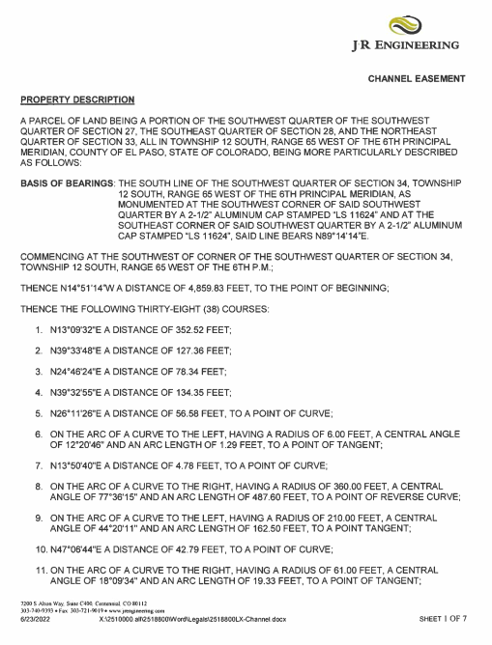

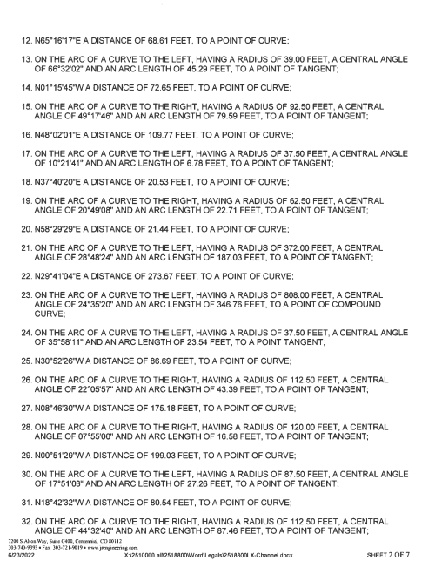

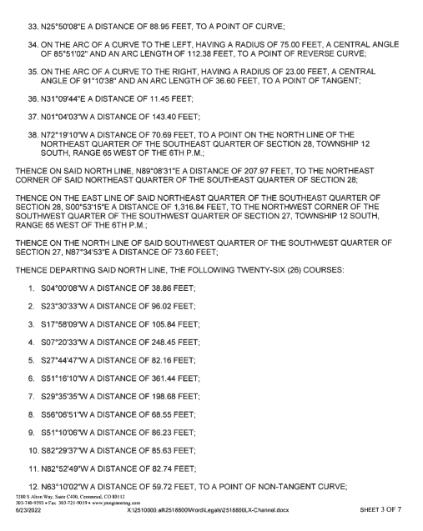

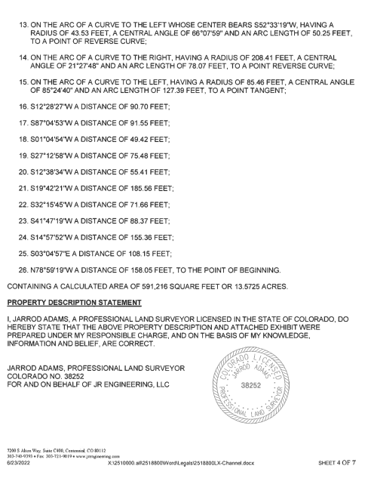

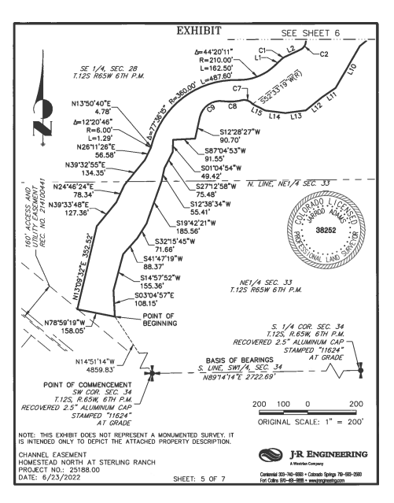

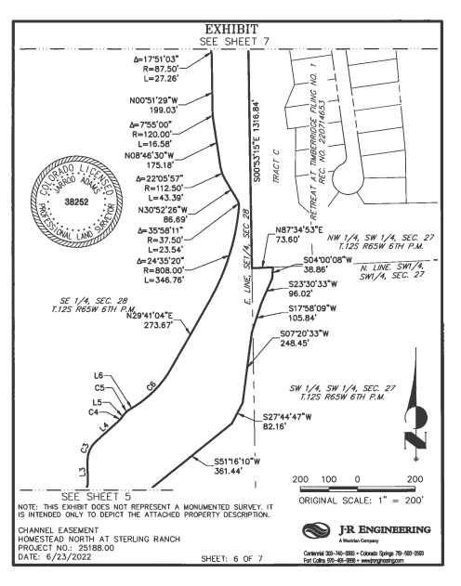

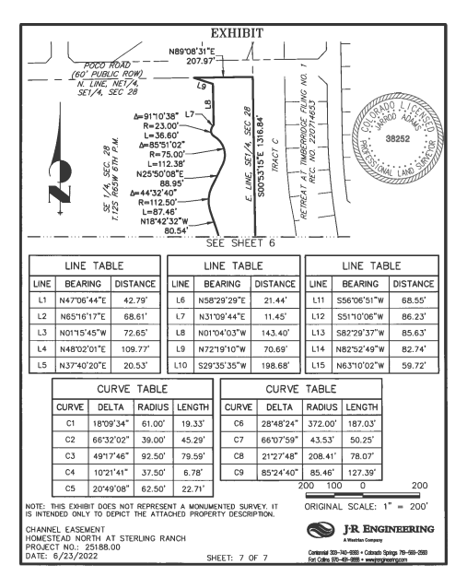

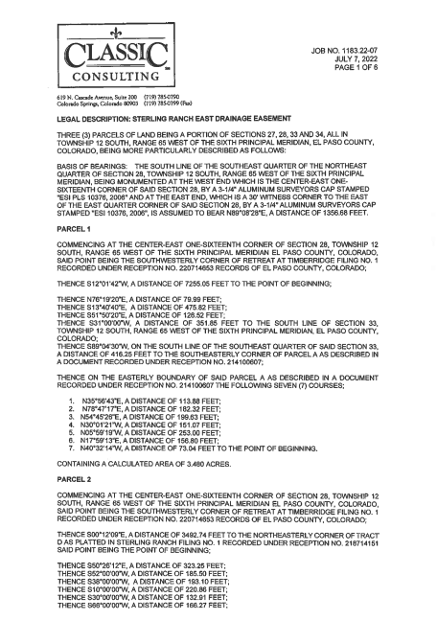

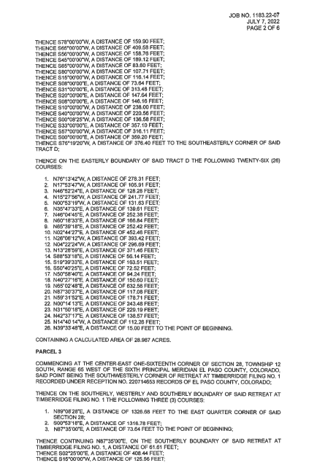

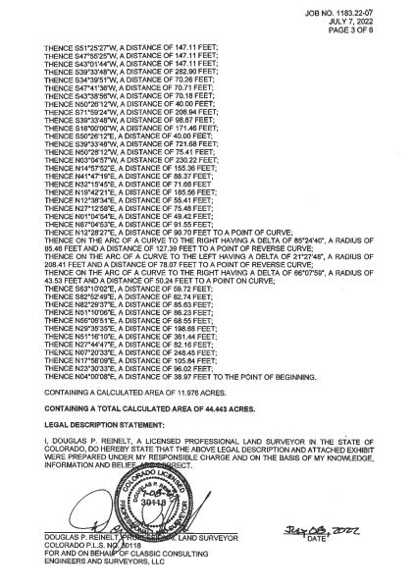

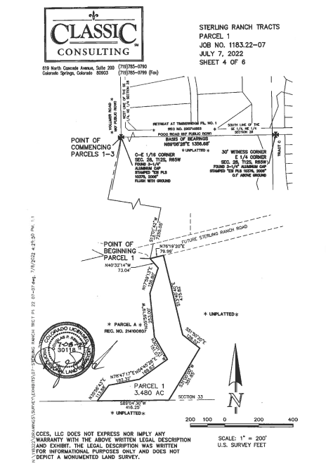
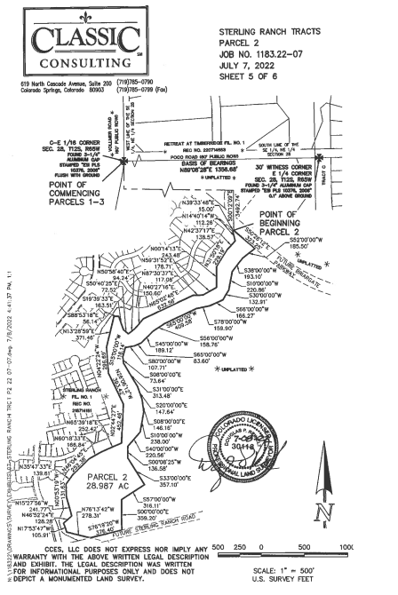

EXHIBIT C

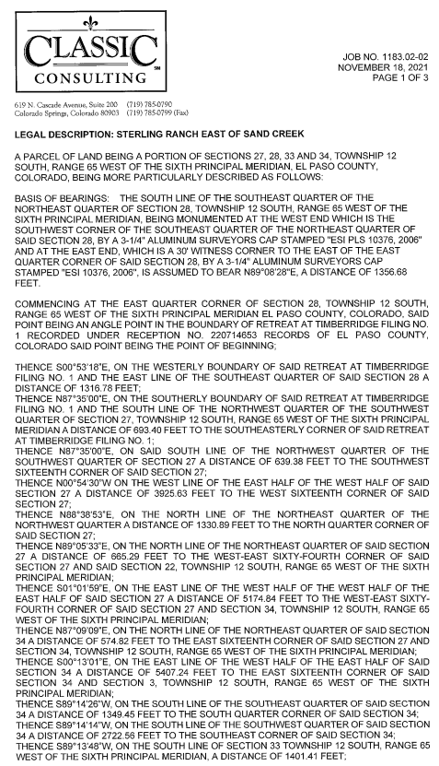
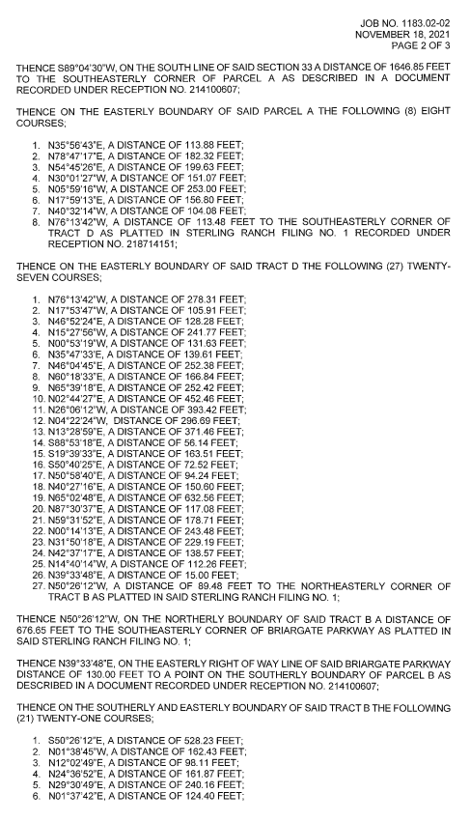
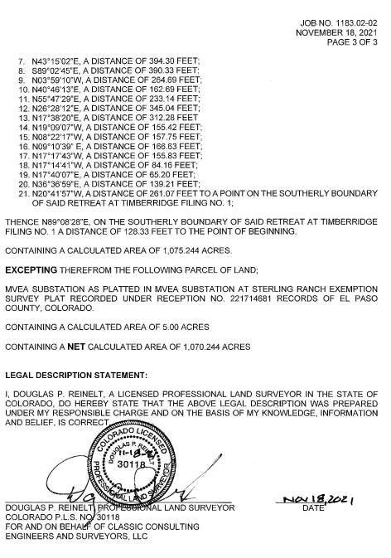

EXHIBIT D
County-Maintained Stormwater Facilities

Item Description Comment ___
Sloping Boulder Drop Structures:
South Reach 1: Two; GSB #1 at Plan station 3+86 and GSB #2 at Plan station 8+35
Middle Reach 2: Three; GSB #3 at Plan station 41+61, GSB #4 at Plan station 50+22 and GSB #5 at Plan station 53+76
North Reach 3: Four; Briargate Bridge GSB B* at Plan station 60+75, Briargate Bridge GSB A* at Plan station 61+70, GSB #7 at Plan station 75+34 and GSB #8 at Plan station 78+42
North Reach 4: None
* - in accordance with details in the Briargate Bridge Construction Plans dated July 14, 2022 and approved August 9, 2022.

Check Structures (Sheet Piles separate from GSBs):
South Reach 1: Two; SPC#1 at Plan station -2+91 and SPC#2 at Plan station -2+38
Middle Reach 2: Five; SPC #3 at Plan station 25+01, SPC #4 at Plan station 32+98, SPC #5 at Plan station 38+47, SPC #6 at Plan station 48+55, and Briargate Bridge* at Plan station 57+16
North Reach 3: Two; Briargate Bridge* at Plan station 62+10 and SPC #7 at Plan station 82+21
North Reach 4: None (County maintains two existing check structures constructed by Retreat at TimberRidge.)

Bank Stabilization Areas:
South Reach 1: None
Middle Reach 2:
North Reach 3:
North Reach 4: XXXX (County also maintains existing bank stabilization constructed by Retreat at TimberRidge.)

Bridges: at Sterling Ranch Road and Briargate Parkway

Channel Linings/Riprap:
South Reach 1: None
Middle Reach 2:
North Reach 3:
North Reach 4:
Maintenance Access / Trails: Aesthetic/debris by District. Trail/maintenance access section by EPC.
South Reach 1:
Middle Reach 2:
North Reach 3: Add east access at Timber Ridge/SRE.
North Reach 4:

EXHIBIT E
District Stormwater Facilities
(All items not listed as “County-Maintained Stormwater Facilities,” including but not limited to the following, for clarification purposes only)

Item Description Comment ___
Sloping Boulder Drop Structures Only GSB #6, as shown on the Sand Creek Restoration Construction Plans
Existing Ponds All
Trash/Debris Clean-up All areas, including areas of EPC ownership
Wetlands All, in perpetuity, including any in EPC ownership
Weed Management Mowing All areas, including any in EPC ownership
Trickle Channels All, including all riffle drops
Check Structures (Sheet Piles) None
Structures All related to water rights ponds
Channel Linings/Lifts All, as depicted on the Sand Creek Restoration Construction Plans
Maintenance Access / Trails Aesthetic/debris by District. Trail/maintenance access section by EPC. See Conc. Section. See District Sections (non-EPC access). Add east access at Timber Ridge/SRE.
Southerly Off-site Damage District maintenance if erosion/failure
Fencing All
Retaining Walls All

+Wetlands – Developer/District required through USACOE monitoring multi-year period. Channel Design/Variance dependent upon wetlands in perpetuity.
+Discuss Platting option (now versus later)
+Access EPC access easement to south boundary Timber Ridge #1.

EXHIBIT F
Wetlands Maintenance Area

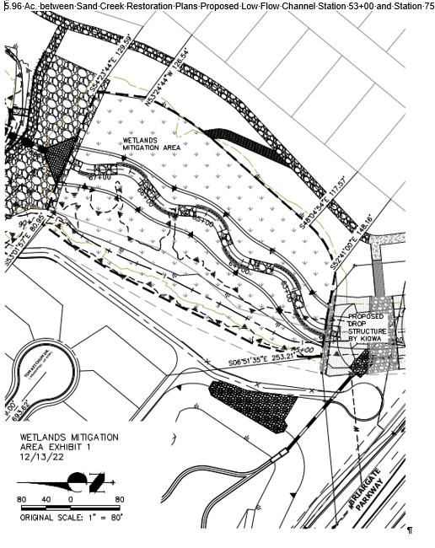

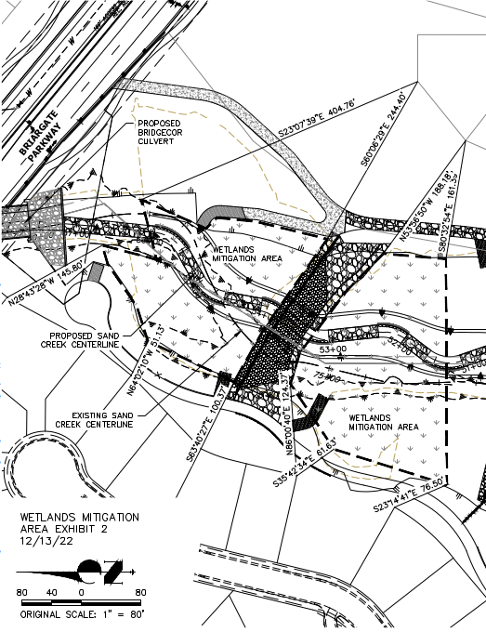

Need more exhibits?

EXHIBIT G
Open Drainage Channel Inspections, Operations and Maintenance (O&M)

Routine maintenance of the open drainage channel system consists of litter and debris pickup, vegetation management, erosion control, and sediment removal when necessary. Removal of excessive shrubs and trees is required to ensure that the channel will flow in conformance with the original design. Mowing and vegetation management shall be performed with care to ensure that soils remain stable and not to cause erosion. Noxious weed management shall be performed as necessary and as required under project approval conditions. All dead trees and trees growing in the flowline of a structure such as a bridge or culvert shall be removed.

Removal of sediment shall be performed with the use of equipment such as a skid steer, backhoe, and front-end loader. The removed materials shall be hauled to an acceptable landfill site unless otherwise legally permitted to be utilized elsewhere. Materials are not to be stored onsite. Equipment shall utilize the designated access roads and shall not be used in a manner to cause damage to adjacent vegetated and stable areas to the extent possible. If drainage channels contain wetlands many activities, including maintenance, may be subject to regulation and permitting.

Erosion control and restoration work such as side slope reconstruction, revegetation, riprap installation, and other stabilization methods will require the use of heavy equipment.

Maintaining altered watercourses is a minimum requirement of the National Flood Insurance Program (NFIP). In fact, failure to maintain such watercourses may result in a revision to the community’s Flood Insurance Rate Map (FIRM). If a stream is altered after the community’s FIRM is published, the NFIP requires the community to ensure that the channel’s carrying capacity is not adversely altered. This is required in 44 CFR 60.3(b)(7) of the Federal Emergency Management Agency’s (FEMA’s) NFIP regulations.

Table 1 – General Channel Maintenance Guidelines
Activity | Maintenance Action | Frequency of Action
Mowing, vegetation management, and lawn care | Occasional mowing to limit unwanted vegetation. Maintain irrigated turf grass as 2 to 4 inches tall and non-irrigated native grasses at 4 to 6 inches tall, except in wetland areas. | Routine – depending on aesthetic requirements.
Debris and litter removal | Remove debris and litter from the entire channel to improve flow characteristics and aesthetics. Dispose of as appropriate. | Routine – including annual, pre-storm season (April and May) and following significant rainfall events.
Erosion and sediment control | Repair and revegetate eroded areas in the channel. | Non-routine –as necessary based on inspection.
Structural | Repair inflow structures, low flow channel linings, and energy dissipation structures as needed. | Non-routine – repair as needed based on regular inspections.
Inspections | Inspect channel to ensure continued function as initially intended. Check for erosion, slumping, excessive sedimentation, overgrowth, embankment and inflow integrity, and damage to any structural elements. Report any illicit discharge immediately. | Routine – annual inspection of hydraulic and structural facilities. Also check for obvious problems during routine maintenance visits.
Nuisance control | Address odor, insects, and other issues associated with stagnant or standing water. | Non-routine –as necessary per inspection or complaint.
Sediment removal | Remove accumulated sediment from the channel bottom. | Non-routine –as necessary per inspection.

Routine Maintenance Activities
The majority of this work consists of scheduled mowing, litter and debris pickups for the drainage channel during the growing season. It also includes activities such as weed control. These activities normally will be performed numerous times during the year. These items typically do not require any prior correspondence with EPC, however, completed inspection and maintenance forms shall be retained and submitted to EPC for each inspection and maintenance upon request. The Routine Maintenance Activities are summarized below, and further described in the following sections.

Table 2 – Summary of Routine Maintenance Activities
Activity | Maintenance Action | Look for: | Minimum Frequency
Mowing | 2”-4” irrigated grass height; 4-6” natural grass height | Excessive grass height/aesthetics | Routine – twice annually
Litter / Debris Removal | Remove and dispose of litter and debris | Litter / debris in drainage channel | Routine – twice annually
Woody growth control / weed removal | Treat w/herbicide or hand pull | Noxious weeds, undesirable vegetation | Routine – minimum twice annually

Properly dispose of litter and debris materials at an approved landfill or recycling facility. It should be noted that major debris removal may require other regulatory permits prior to completing the work.

Noxious weeds and other unwanted vegetation must be treated as needed throughout the drainage channel. This activity can be performed either through mechanical means (mowing/pulling) or with herbicide. Consultation with the County Environmental Division is recommended prior to the use of herbicide. Herbicides should be utilized sparingly and as a last resort. All herbicide applications should be in accordance with the manufacturer’s recommendations.

Minor Maintenance Activities
This work consists of a variety of isolated or small-scale maintenance/operational problems. Most of this work can be completed by a small crew, hand tools, and small equipment. These items may require prior approval from EPC depending on the scope of work. Completed inspection and maintenance forms shall be retained for each inspection and maintenance period. In the event that the drainage channel needs to be dewatered, care should be given to ensure sediment, filter material and other pollutants are not discharged. The appropriate permits shall be obtained prior to any dewatering activity.

Table 3 – Summary of Minor Maintenance Activities
Activity | Maintenance Action | Look for: | Minimum Frequency
Sediment/Pollutant Removal | Remove and dispose of accumulated sediment from the channel bottom. | Minor sediment and pollution build-up in channel bottom; potential decrease in channel flow rate | Non-routine – as needed based on inspection.
Erosion Repair | Repair eroded areas and revegetate; address cause. | Rills/gullies on sides of channel | Non-routine – as needed, based on inspection.

Major Maintenance Activities
This work consists of larger maintenance/operational problems and failures within the stormwater drainage facilities. This work will likely require approval from EPC Engineering to ensure the proper maintenance is performed. This work requires that Engineering Staff review the original design and construction drawings to assess the situation and necessary maintenance activities. This work may also require more specialized maintenance equipment, design plans/details, surveying, and assistance through private contractors and consultants. In the event that the drainage channel needs to be dewatered, care should be given to ensure sediment, filter material and other pollutants are not discharged. The appropriate permits shall be obtained prior to any dewatering activity.

Table 4 – Summary of Major Maintenance Activities
Activity | Maintenance Action | Look for: | Minimum Frequency
Major Sediment / Pollutant Removal | Remove and dispose of sediment. Repair vegetation as necessary | Large quantities of sediment in the channel and reduced conveyance rate/capacity | Non-routine –as necessary based on inspection.
Major Erosion Repair | Repair erosion – find cause of problem and address to avoid future erosion | Severe erosion including gullies, excessive soil displacement, unusual areas of settlement, holes | Non-routine –as necessary based on inspection.
Structural Repair | Structural repair to restore portions of the channel to its original design | Deterioration and/or damage to structural components – broken concrete, damaged pipe, drop/check structures or dissipators | Non-routine –as necessary based on inspection.
Drainage Channel Rebuild | Contact EPC Engineering | Overall channel failure | Non-routine –as needed due to complete failure of drainage channel

Inspection Procedures
Periodic inspections of drainage channels and associated stormwater control measures in developed areas are needed in every community to prevent the accumulation of debris deposited by storms, dumping, or natural processes. Inspections must be conducted at least once each year and after each storm that could adversely impact the drainage system. Inspections are also needed in response to citizen complaints.

Conduct annual visual inspections during the dry season to determine if there are problem inlets where sediment/trash or other pollutants accumulate. Inspection and maintenance records should be used to determine problem areas that may need to be checked more often. Appropriate action must be taken after an inspection identifies the need for maintenance or cleaning.

The attached form includes the typical information necessary for and during an inspection. Similar forms or electronic record keeping may be utilized if all relevant information is recorded. The entity responsible for channel maintenance is required to submit the periodic inspection reports upon request by County Staff. Inspections involving decisions about structural issues shall be signed by a licensed professional engineer.

Inspections of inflow structures including detention spillways and water quality outlet pipes discharging to the channel shall be coordinated with channel inspections.

Illicit discharges such as dumping of home goods or garbage, appliances, yard wastes, paint spills, abandoned oil containers and other pollutants shall be immediately reported to EPC Staff and other agencies as appropriate. Reference El Paso County Ordinance No. 07-01, as amended. EPC recommends that the responsible entity encourage public reporting of improper waste disposal by posting “No Dumping” signs, neighborhood notices, and/or social media when available, with contact information to report violations.

Wetlands
If drainage channels contain wetlands many activities, including maintenance, may be subject to regulation and permitting. The responsible maintenance entity shall maintain wetlands vegetation as appropriate and in consultation with the proper authorities including the U.S. Army Corps of Engineers when applicable. The responsible maintenance entity shall ensure proper training / licensing of contractors and staff to minimize the potential for damages to the wetlands.

All applicable safety and environmental considerations with regards to the application of any pesticides or herbicides shall be verified. It is also strongly encouraged that the responsible entity employ or consult a wetlands specialist or certified arborist with the ability to identify invasive/exotic species. Due to the sensitive nature of using chemicals near water bodies, a written Quality Assurance/Quality Control (QA/QC) plan shall be implemented.

Employees shall be trained in accordance with any local, state, and federal regulations and laws prior to any application of chemicals. A copy of the QA/QC plan must be submitted to the County Environmental Division prior to any chemical applications. In addition to the QA/QC plan, copies of the Safety Data Sheets (SDS) for all the chemicals being used shall be provided upon request.

The Clean Water Act (CWA) establishes the basic structure for regulating discharges of pollutants into the waters of the United States and regulating quality standards for surface waters. The basis of the CWA was enacted in 1948 and was called the Federal Water Pollution Control Act, but the Act was significantly reorganized and expanded in 1972. "Clean Water Act" became the Act's common name with amendments in 1972.

Section 404 - establishes a program to regulate the discharge of dredged and fill material into waters of the United States, including wetlands. CWA Section 404(b)(1) Guidelines – U.S. Environmental Protection Agency (EPA) (Although they are called “guidelines,” these criteria are established in regulations (40 CFR Part 230) and are legally binding.)
https://www.epa.gov/cwa-404/clean-water-laws-regulations-and-executive-orders-related-section-404

Open Drainage Channel Inspection Report Form

Date: __________________________ Inspector: _________________________________

Type of inspection: Post-Storm ______ Complaint ______ Routine ______

Location: (Identify stream or basin name, downstream and upstream streets or reference points, and location of problem. Provide sketch as needed.)

__________________________________________________________________________

__________________________________________________________________________

__________________________________________________________________________

Type of problem: Litter ___ Minor ___ Obstruction ___ Structural ___ Illicit Discharge** ___

Recommended maintenance: _________________________________________________

__________________________________________________________________________

__________________________________________________________________________

Is equipment needed? ______ If so, list equipment needed: __________________________

__________________________________________________________________________

Date: __________________________ Offsite Right of entry needed? __________________

Work order description: _______________________________________________________

__________________________________________________________________________

__________________________________________________________________________

__________________________________________________________________________

__________________________________________________________________________

State permit(s) needed? _____ Work order number: __________________________

Date: Crew chief: ____________________________

Maintenance performed: ______________________________________________________

__________________________________________________________________________

__________________________________________________________________________

__________________________________________________________________________

Inspected by: _______________________________________________________________

Use other side for additional recommendations for this site.
**Report illicit discharges to the County and appropriate agencies.
EXHIBIT H
U.S. Army Corps of Engineers Permit
(XX pages)

