Preliminary Acceptance Punch List
Sterling Ranch Filing No. 2 (Phase 1), SF2015
Date: 10/23/2025
Dear Chaz,
This notice is to remind you that the Preliminary Acceptance Punchlist generated by El Paso County Department of Public Works Development Services for the project referenced above has yet to be addressed. This Punchlist was generated based on observations during the Preliminary Acceptance Walk conducted on 10/22/2025.

Please be advised that El Paso County is currently holding Construction Surety for this project in the amount of $3,114,250.21. Construction Surety will not be released until all items documented on the Punchlist have been addressed and all other requirements for Preliminary Acceptance have been met. Please refer to the Punchlist for identification of the specific items needing to be addressed for Preliminary Acceptance.
Please note that pursuant to Engineering Criteria Manual Section5.3.15.C, the County may draw on Construction Surety to perform the necessary repairs or corrections identified in the Punchlist if not addressed by 04/22/2026. Once you believe all Punchlist items have been addressed, please contact Edward Skelton to schedule a follow-up Preliminary Acceptance Walk. Inspector can be reached at 719-439-3958 / edwardskelton@elpasoco.com.

Punch List Items

Bynum Dr
- 8627 Bynum Dr. remove and replace ped ramp landing
- 8770 Bynum Dr. Inlet lid is out of tolerance. Over 2% slope. Remove and replace
- Stop sign at Bynum Dr. and Cordgrass Dr. is to short per the MUTCD spec
- Bynum Dr. and Sterling Ranch Rd. patch cross pan
- Remove and replace ADA landing across from the mailboxes
- Remove and replace 3 sections of the cross pan at Blue Feather Loop and Bynum Dr.
- Inlet lid is out of tolerance
- Crack seal asphalt patch at Bynum Dr. and Blue Feather Loop
- Bottom of stop sign should be 7’ minimum Bynum Dr. and Alzada Dr.
- 8766 ADA ramp is out of tolerance

Alzada Dr.
- 7758 Alzada Dr. patch stone
- 7748 Alzada Dr. patch curb and sidewalk
- Alzada Dr. and Beaverhead Cir. Stop sign is too short per the MUTCD spec

Beaverhead Cir.
- 8718 Beaverhead Cir. patch curb
- Beaverhead Cir. and Cordgrass Dr. Yellow “No Outlet” sign is overhanging the sidewalk. Out of spec per the MUTCD
- 8766 Beaverhead Cir. patch curb
- 8762 Beaverhead Cir. ped ramp slope is out of tolerance. Remove and replace
- 8830 Beaverhead Cir. patch gutter
- 8846 Beaverhead Cir patch sidewalk
- 8878 Beaverhead Cir. asphalt patch
- Grind and patch curb in tract area between 8878 and 8845 Beaverhead Cir.
- 8845 Beaverhead Cir. remove and replace curb and gutter
- 8813 Beaverhead Cir. patch or remove and replace stone (remove spray paint x if patch)
- Beaverhead Cir. and Cordgrass Dr. stop sign is too short per the MUTCD spec

Cordgrass Dr.
- 7711 Cordgrass Dr. bottom section of ADA ramp needs to be removed and replaced.
- Tract sidewalk between 7726 and 7758 Cordgrass Dr. remove and replace curb and gutter.
- Tract sidewalk between 7726 and 7758 Cordgrass Dr patch stone or remove and replace (remove spray paint x if patch)
- 7790 Cordgrass Dr. ped ramp landing is out of tolerance. Remove and replace

Sterling Ranch Rd.
- Remove and replace cracked curb and gutter (Item 23)
- Remove and replace cracked curb and gutter (Item 24)
- Remove and replace cracked curb and gutter (Item 25)
- Remove and replace cracked curb and gutter (Item 26)
- Install missing median sign (Item 27)
- Complete landscaping (as needed in all bare spots throughout the filing (Item 28)
- Ped ramp slope is out of tolerance. Remove and replace (Item 29)
- Remove and replace the cross pan at Hazlett Dr. and Sterling Ranch Rd (Item 30)
- Remove and replace curb and gutter (Item 31)
- Replace sign (7’ minimum to bottom of sign per MUTCD) (Item 32)
- Remove and replace curb and gutter (Item 33)
- Remove and replace ADA bottom section (Item 34)
- Remove and replace square return section at ADA ramp
- Remove and replace square return section at ADA ramp
- Replace truncated domes to be within 6-8” of flowline
- Remove and replace bottom section of ped ramp (Item 38)
- Remove and replace ped ramp (item 39)
- Remove and replace 3 cracked sections of the cross pan and 1 cracked section of the cross pan
- Remove and replace curb at ADA ramp (Item 41)
- Truncated domes must be between 6”-8” from corner to edge of outside flowline
- Fix trip hazard, grind or replace stone/s
- Patch stone (Item 43)
- Remove and replace ADA landing (Item 44)
- Patch curb (Item 45)
- Remove and replace curb and gutter (Item 46)
- Remove and replace cross pan (Item 47)
- Remove and replace curb and gutter (Item 48)
- Remove and replace ADA ramp (Item 49)
- Remove and replace 3 sections of cross pan (Item 50)
- Remove and replace 2 curb and gutter sections (Item 51)
- Remove and replace 3 curb and gutter sections at the inlet (Item 52)
- Remove and replace ADA ramp and ensure truncated domes are 6-8” within front of flowline (Item 53)
- Patch gutter (Item 54)
- T crossing sign is too low. Bottom of the sign should be 7’ (Item 55)
- Patch curb (Item 56)
- Patch 5 sections of curb and gutter (Item 57)
- Remove and replace 1 section of curb and gutter (Item 58)
- Remove ADA ramp and landing. Out of tolerance
- Remove and replace ADA bottom section (Item 59)
- Install Median sign (Item 60)
- Remove and replace 2 ADA ramps and patch ADA landing (Item 61)
- Correct striping to match plans on the west bound Sterling Ranch and Markeffel Rd(Item 62)
- Remove and replace curb/ bull nose on median (Item 63)
- Replace missing curb (Item 64)
- Remove and replace ADA landing (Item 65)
- Inlet lid out of 2% tolerance. Remove and replace sidewalk behind inlet. (Item 66)
- Remove and replace ADA landing (Item 67)

Thank You
 | Edward Skelton  Inspector 1  Department of Public Works  719-439-3958  Edwardskelton@elpasoco.com  https://publicworks.elpasoco.com/

Punch List Items

Remove and replace Patch Signs

Bynum Dr
- 8627 Bynum Dr. remove and replace ped ramp landing
- 8770 Bynum Dr. Inlet lid is out of tolerance. Over 2% slope. Remove and replace
- Stop sign at Bynum Dr. and Cordgrass Dr. is to short per the MUTCD spec
- Bynum Dr. and Sterling Ranch Rd. patch cross pan
- Remove and replace ADA landing across from the mailboxes
- Remove and replace 3 sections of the cross pan at Blue Feather Loop and Bynum Dr.
- Inlet lid is out of tolerance
- Crack seal asphalt patch at Bynum Dr. and Blue Feather Loop
- Bottom of stop sign should be 7’ minimum Bynum Dr. and Alzada Dr.
- 8766 ADA ramp is out of tolerance

Alzada Dr.
- 7758 Alzada Dr. patch stone
- 7748 Alzada Dr. patch curb and sidewalk
- Alzada Dr. and Beaverhead Cir. Stop sign is too short per the MUTCD spec

Beaverhead Cir.
- 8718 Beaverhead Cir. patch curb
- Beaverhead Cir. and Cordgrass Dr. Yellow “No Outlet” sign is overhanging the sidewalk. Out of spec per the MUTCD
- 8766 Beaverhead Cir. patch curb
- 8762 Beaverhead Cir. ped ramp slope is out of tolerance. Remove and replace
- 8830 Beaverhead Cir. patch gutter
- 8846 Beaverhead Cir patch sidewalk
- 8878 Beaverhead Cir. asphalt patch
- Grind and patch curb in tract area between 8878 and 8845 Beaverhead Cir.
- 8845 Beaverhead Cir. remove and replace curb and gutter
- 8813 Beaverhead Cir. patch or remove and replace stone (remove spray paint x if patch)
- Beaverhead Cir. and Cordgrass Dr. stop sign is too short per the MUTCD spec

Cordgrass Dr.
- 7711 Cordgrass Dr. bottom section of ADA ramp needs to be removed and replaced.
- Tract sidewalk between 7726 and 7758 Cordgrass Dr. remove and replace curb and gutter.
- Tract sidewalk between 7726 and 7758 Cordgrass Dr patch stone or remove and replace (remove spray paint x if patch)
- 7790 Cordgrass Dr. ped ramp landing is out of tolerance. Remove and replace

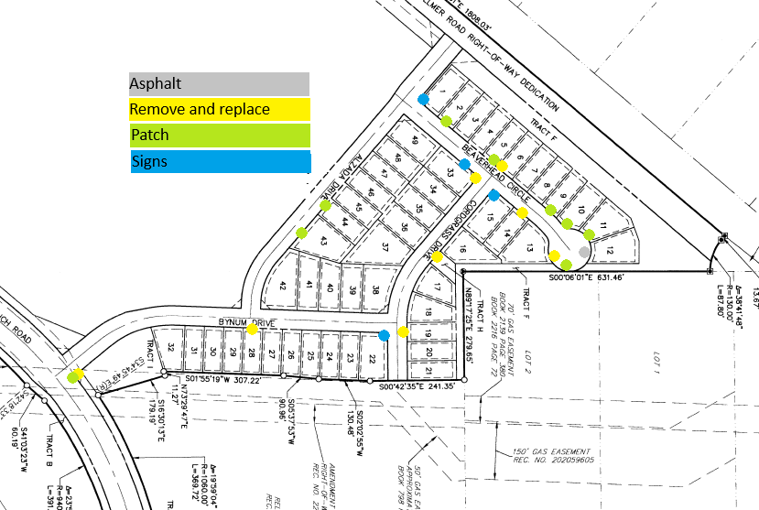

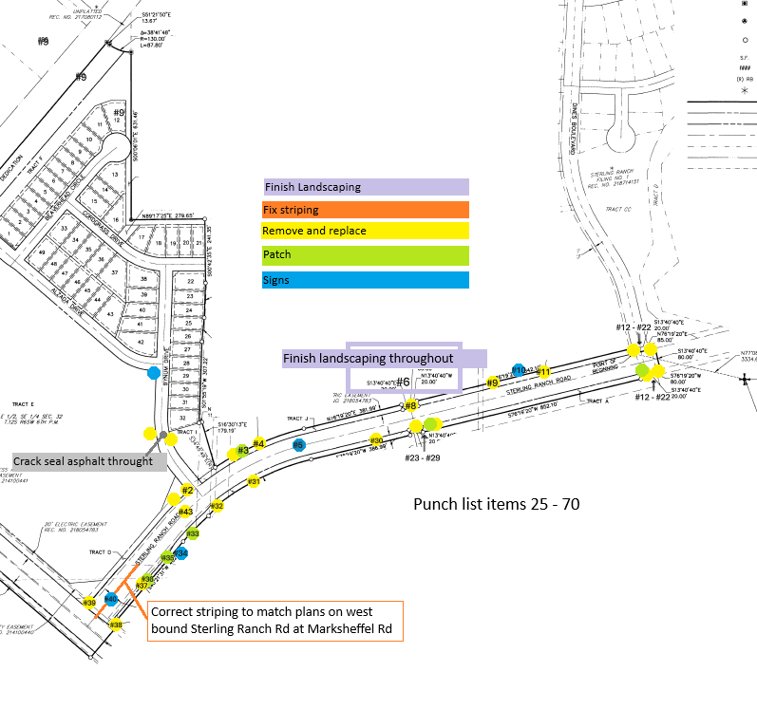
jjjjjj

