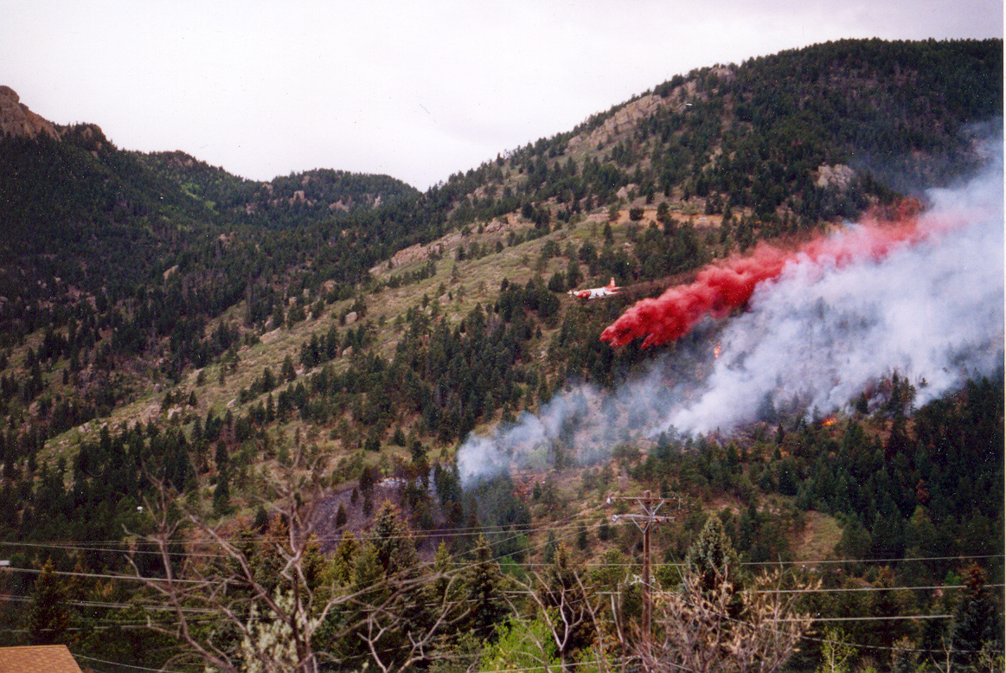
Wildfire Hazard & Mitigation Report
Old Stage Trust aka Yakalo Ranch

El Paso County, CO
Wildfire Hazard Evaluation Report

For the

Old Stage Trust Development

El Paso County, CO

Prepared for: Angela Gregg
Old Stage Trust
5415 Old Stage Road
Colorado Springs, CO 80906-5710
(808) 445-6671

Prepared by: Stephen J. Spaulding
Consulting Forester
423 Crystola Canyon Road
Woodland Park, CO 80863-9130
(719) 641-0769

Warning and Disclaimer: The degree of protection from wildfire hazards intended to be
provided by this plan is considered reasonable for planning purposes. It is based on accepted
forestry and fire science methodology. This plan is intended to aid the Old Stage Trust in minimizing the dangers and impacts from wildfire hazards. Fire is a natural force and a historical part of the ponderosa pine and native grassland ecosystems. Therefore, unforeseen or unknown wildfire conditions, natural or man-made changes in conditions such as climate, vegetation, fire breaks, fuel materials, fire suppression or protection devices, and ignition sources may contribute to future damages to structures and land uses even though properly permitted within designated wildfire hazard areas.

March 2026

General Description

The Old Stage Trust development proposes recreational use of the property with undeveloped camp sites. The property is located along the east and west sides of Old Stage Road within El Paso County, locally identified as 5415 Old Stage Road. The property is the last privately owned parcel before crossing onto the Pike National Forest. The parcel listed under this report is identified with the El Paso County Assessor's Schedule Number 7500000275.

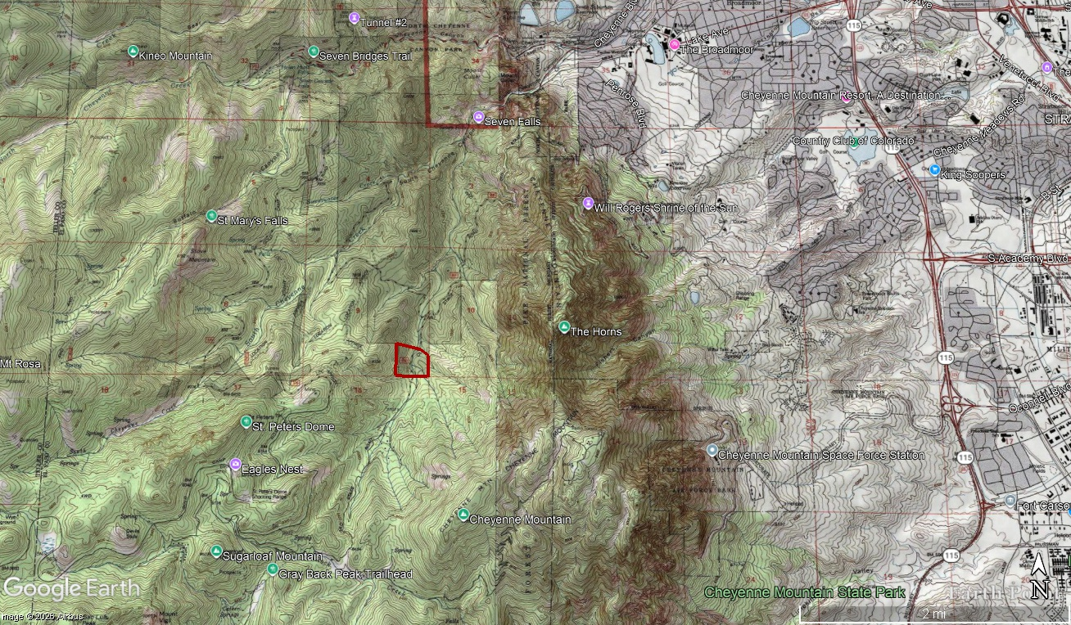
Map 1 – General Vicinity
The subject property is bordered on the east, south and west sides by the USDA – Forest Service, Pikes Peak Ranger District. The north border is bounded by two private properties.

The area does have a wildfire history. Most notably, the Stable Fire burned in January of 1950. It was the most destructive wildfire at that time with 9 fatalities and reaching over 28,000 acres in size.

Wildfire Hazard

The Colorado State Forest Service developed a wildfire risk assessment tool in 2012 referred to as the Colorado Wildfire Risk Assessment Web Portal (CO-WRAP). This assessment was recently updated to include wildfire events and acres mitigated up to 2017. A copy is attached to this report.

Within the assessment report, the Wildfire Risk to Assets within the property is considered the Highest (see Map 3). Wildfire risk is a composite rating which identifies the probability of loss or harm from a wildfire. Risk identifies the greatest impacts from a wildfire to a range of assets, such as the level of Wildland Urban Interface. Wildfire Risk is determined uniformly across the entire state.

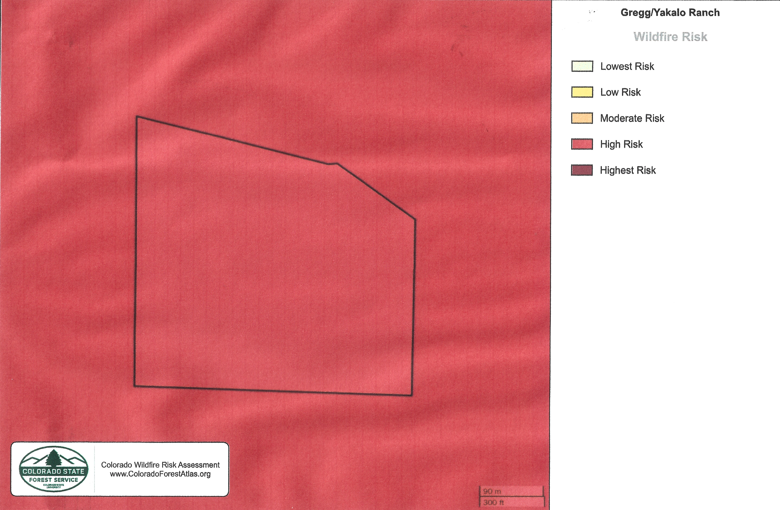
Map 3 – Wildfire Risk

The High-Risk Rating may be a result of Old Stage Road bisecting the property. This road is heavily utilized for passive recreation and access to the Pike National Forest. This would reflect a high potential for fire ignitions. In addition, there is also a high fuel load of conifers and steep slope on the western half of the property.

The Burn Probability is the annual probability of any location becoming subjected to a wildfire event. The assessment assigns a rating of high (see Appendix C, pg. 26).

The CO-WRAP assessment uses a detailed and distinct series of fuel models. This is a more dynamic approach as it does not delineate between smaller fuel beds but considers them uniform across large areas. So even though there may be clusters of shrubs or grasses present, a refined timber fuel model might be described incorporating these variations.

A field inspection was performed on March 24, 2026, and again on April 1st, 2026, to determine if any change should be made to the CO-WRAP assessment. This included a forest inventory to help determine any future silviculture activity.

The topography of the area influences the high risk to the assets rating dramatically. The flame length of any fire burning within the property may range from eight (8) feet upwards to beyond twelve (12) feet. This condition is directly related to steep slopes found, particularly in the western half of the site.

Any fire originating on the lower portion of a slope could burn rapidly uphill. The high traffic volume along Old Stage Road provides a predictable source of fire ignitions. As an example, the 24 Fire which broke out on Wednesday, March 18th of 2026 was determined to have been started by a vehicle malfunction.

The Wildland Urban Interface Risk is very low and did not garner a rating in the assessment. This area has very little residential development so wildfire would not threaten many homes or pose a risk to lives.

The assets most at risk are the forest cover itself; the watershed benefits that the forest provides and the riparian corridor that drains into South Cheyenne Creek. The Waldo Canyon Fire provided an example of the impacts from the loss of forest cover as it relates to watershed and stream protection, with many instances of flash flooding post fire. Risk reduction and mitigation about the forest cover can be found in the section covering forest management.

The Burn Probability rating of high appears somewhat misleading. The assessment provides a listing of actual ignitions by year. Focusing in and around the site, there are very few reported ignitions that have occurred (see Map 4). This low number of ignitions could be attributed to a lack of reporting or a public response to wildfire awareness.
The Heat Map (see Map 5) or fire ignitions in and around the property reflect the highest rating. Fire Ignitions is an ignition density that reflects historical ignition patterns. Occurrence is derived by modeling historic wildfire ignition locations to create an ignition density map. Historic fire report data were used to create ignition points for all Colorado fires. This included both federal and non-federal fire ignition locations.

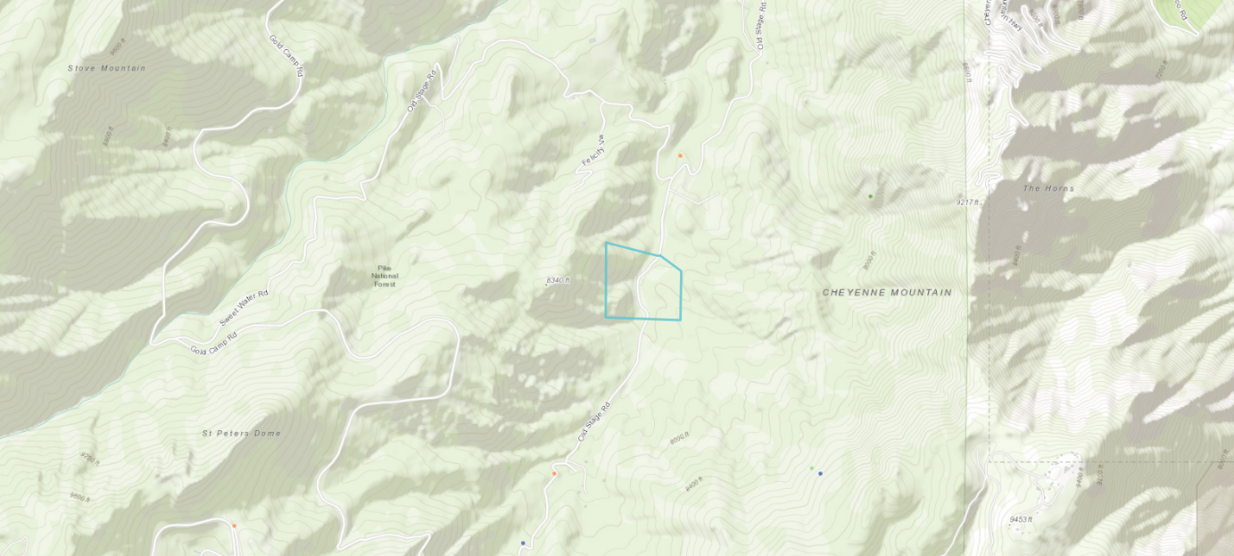
Map 4 – Location of Reported Ignitions

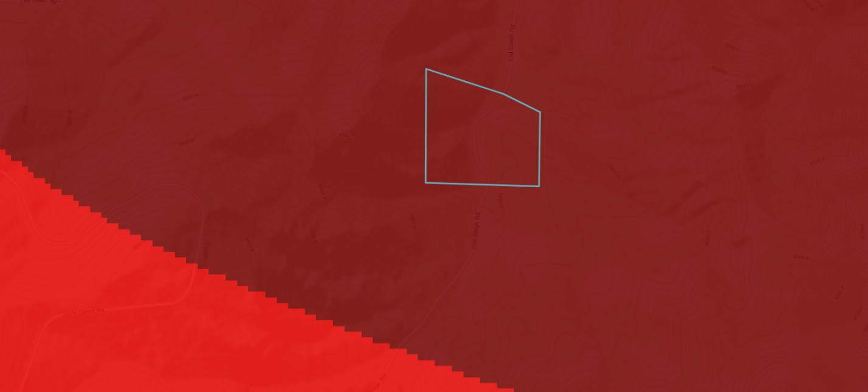
Map 5 - Heat Map

Despite the low actual number of known ignitions, the high recreational use and thunderstorm activity, there remains a high probability of a fire ignition somewhere in the area.

Based upon the field inspection, the wildfire risk was confirmed as high. If fuel mitigation is successfully completed along Old Stage Road, the risk could be lowered in select locations to moderate.

Wildfire Behavior

This rating considers the role of the three major components that affect wildfire behavior: fuels, topography and weather. These three components will be examined in relation to the Lost Valley Ranch improvements.

Fuels

The area was field checked, and the results of the COWRAP Assessment were adjusted. based upon the observed fuel models on the property. The USDA – Forest Service Intermountain Forest and Range Experiment Station in Ogden, Utah, developed these fuel model descriptions. They are used as aids in estimating fire behavior (see Appendix A).

The criteria for choosing a fuel model reflects that wildfire will burn in that fuel type which best supports that fire to spread. There may be more than one fuel model represented on any given area of land. In addition, current and expected weather conditions will influence the condition of these fuels.

From the COWRAP assessment most of the property is considered as Timber Understory Dynamic ML (TUML1). This fuel model is comprised of approximately 30 acres. This fuel model is like the TU5 model, which is Very High Load, Dry Climate Timber-Shrub. This model describes ground fuels that are composed of heavy forest conifer litter with a shrub or small tree understory (see Photo 1).

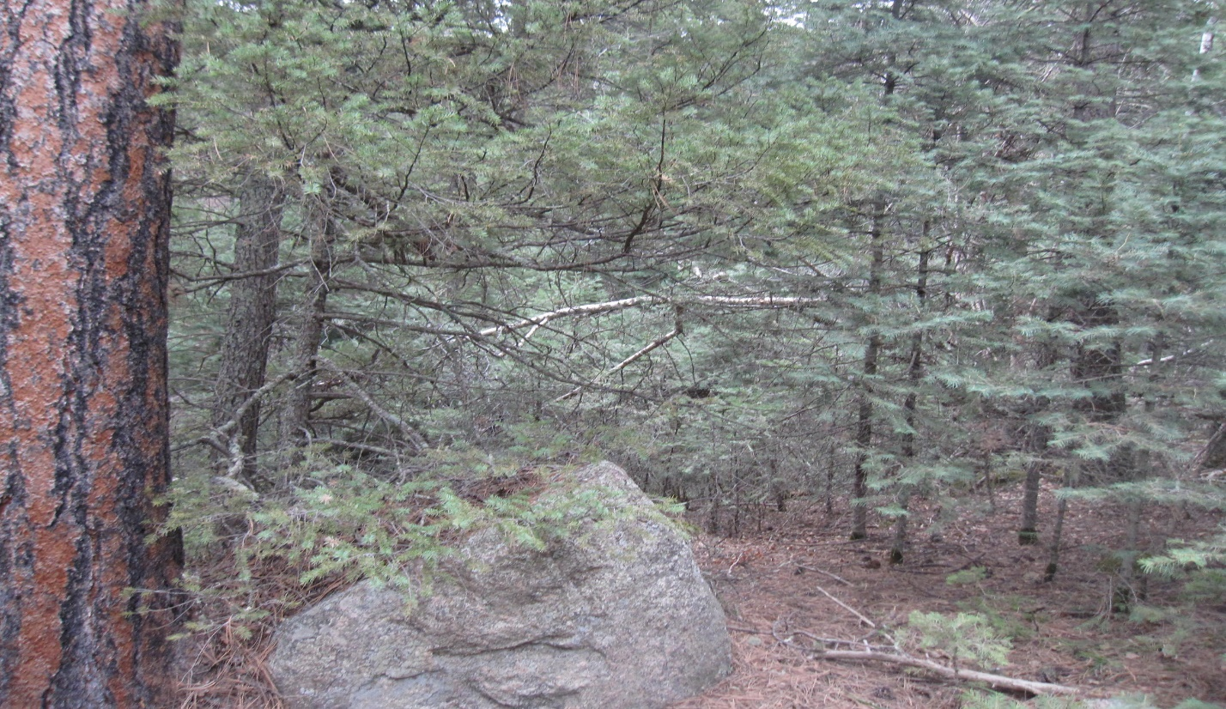
Photo 1. Typical view within the mixed conifer forest. The white fir and Douglas-fir trees are serving as the shrub component of this fuel model.
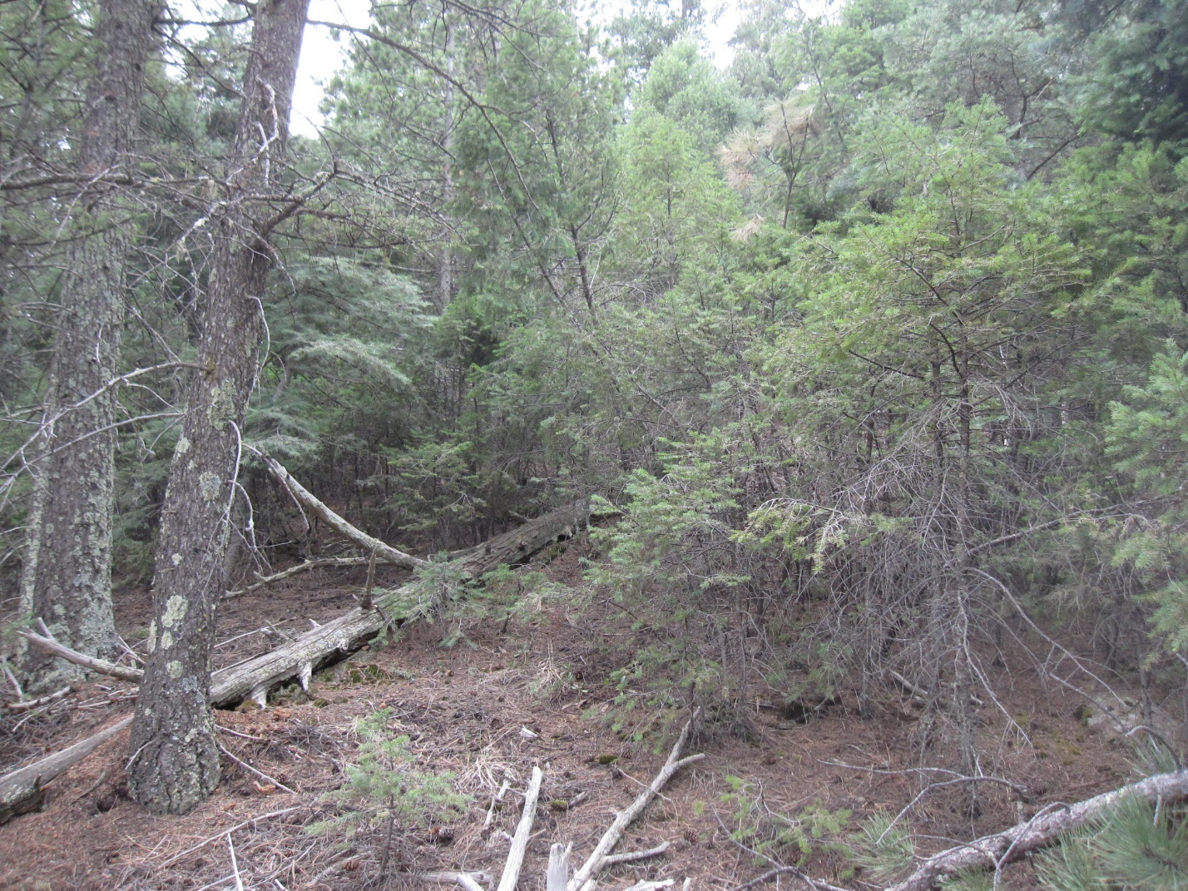
Photo 2. A view of the mixed conifer forest on the west side of Old Stage Road.

Photo 2 shows a location with a higher load of heavy fuel, dead material that is three (3) inches in diameter or larger. This material may not be entirely consumed by a fire as it appears to have been in contact with the soil surface for an extended period.

For the most part, the conifer needles and other litter appear to be compressed on the forest floor. While the litter layer will still burn, flame lengths will be low, and a fire may just smolder through the needle layer. This does not mean that enough heat could be generated to ignite some clumps of small trees, particularly white fir. This may even generate enough heat to ignite some of the larger overstory, commonly referred to as ‘torching’.

This condition is reflected in the assessment. The type of wildfire predicted is a passive canopy fire. This is a crown fire where the crowns of individual trees or small groups of trees burn, but solid flaming in the canopy cannot be maintained except for short periods.

The assessment may be incorrect in calculating the acreage of this fuel model. Photo 3 shows a distinct break from a high load TU5 fuel model to a low load model (TU1). This fuel is found on the upper reaches of a slope, particularly to the west along the property boundary. Approximately, four (4) acres contribute to this fuel model.

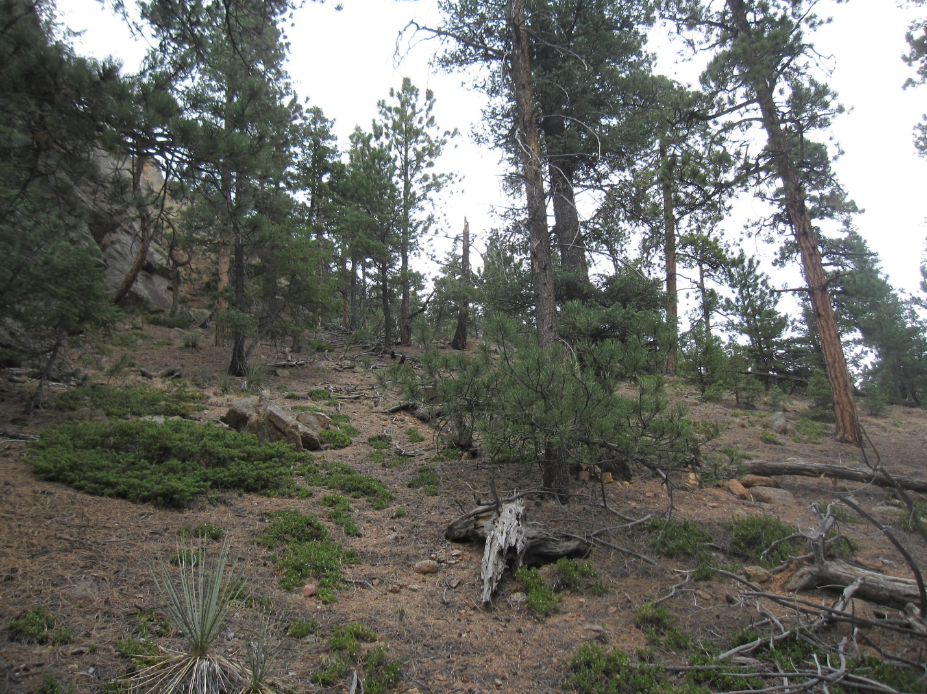
Photo 3. Note the relative absence of a conifer understory and litter covering the soil surface.

This condition can be attributed to a greater exposure to the sun, creating a drier growing condition more suited to ponderosa pine than the firs. The slope steepness allows dead conifer litter to move downhill during precipitation events.

Topography

The topography of the site is one of the main factors that will influence the spread of fire. The aspect or compass direction that any slope faces influence the fuel type that exists and the amount of preheating these fuels receive by the sun. Aspect can also influence the effects of diurnal winds, as they move upslope during the daylight hours and down slope during the evening and early morning hours.

As the percentage of slope increases, the rate of fire spread by convection increases. In other words, wildfire burns faster moving uphill (see Figure 1).

Figure 1. Slope Affects Fire Spread

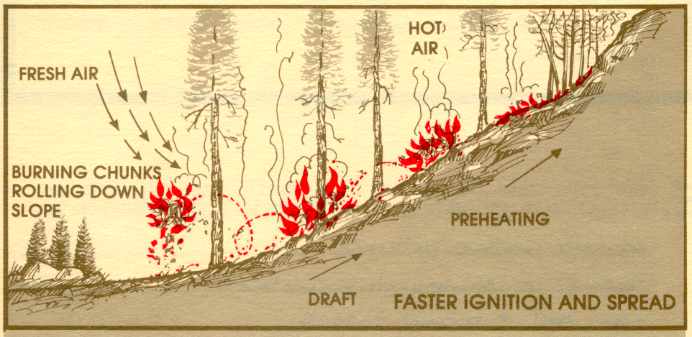

The slopes on the property range from 13% up to 30%. Slopes greater than 25% are considered extreme slopes in their effect on wildfire behavior (see Photo 4).

However, slope can have the opposite effect when burning downhill. This was observed during the Waldo Canyon fire in this area. The fire crept downhill relatively slowly from the Rampart Range and there were many instances of fire spread being halted by narrow social and game trails.

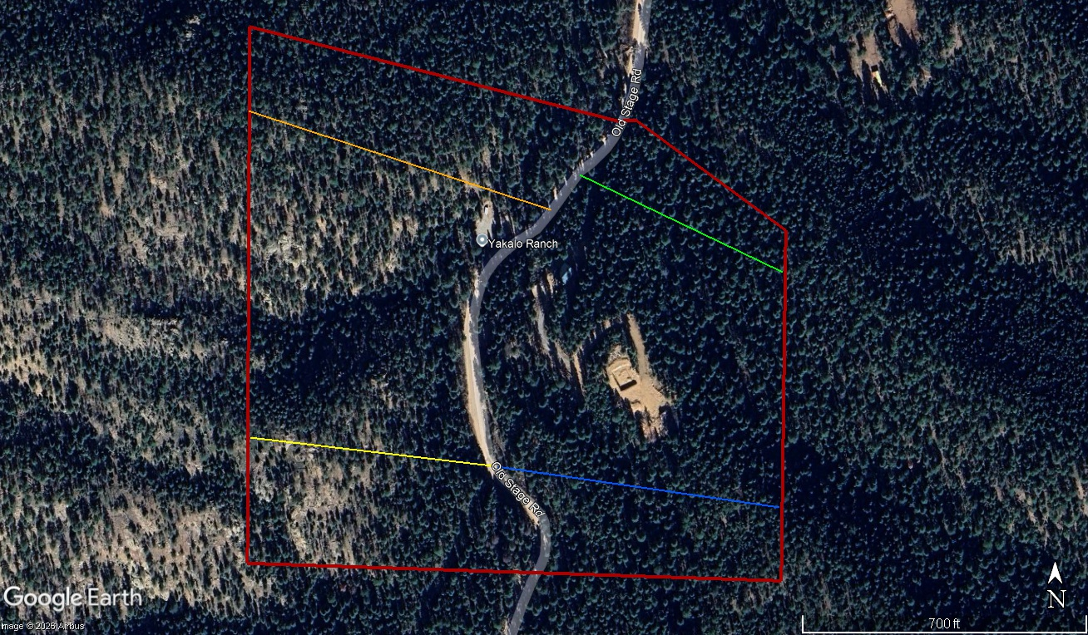
Photo 4. The colored lines express the slope percentage across the property. The orange line is 51%, the yellow line is 40%, the green is 15% and the blue line is 20%.

Figure 2 depicts the effect the drainages or box canyons have on a fire. These topography features tend to funnel a wildfire uphill within a narrow profile and the preheating effect tends to ignite the side slopes of the drainage (see Photo 5). Structures placed at the mouth of the drainage are most at risk from wildfire. Placing residential structures at the top of the slopes on the ridgeline should be avoided, if possible.

Figure 2. Drainages Tend to Draw in Fire
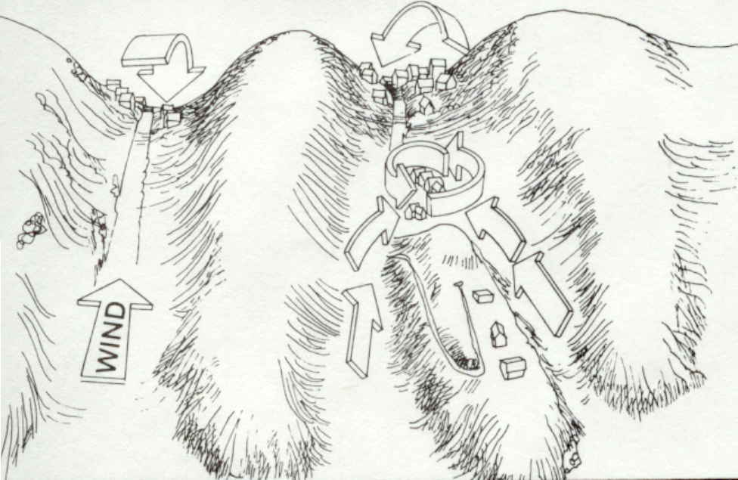
Graphic Courtesy of Colorado Springs Fire Department

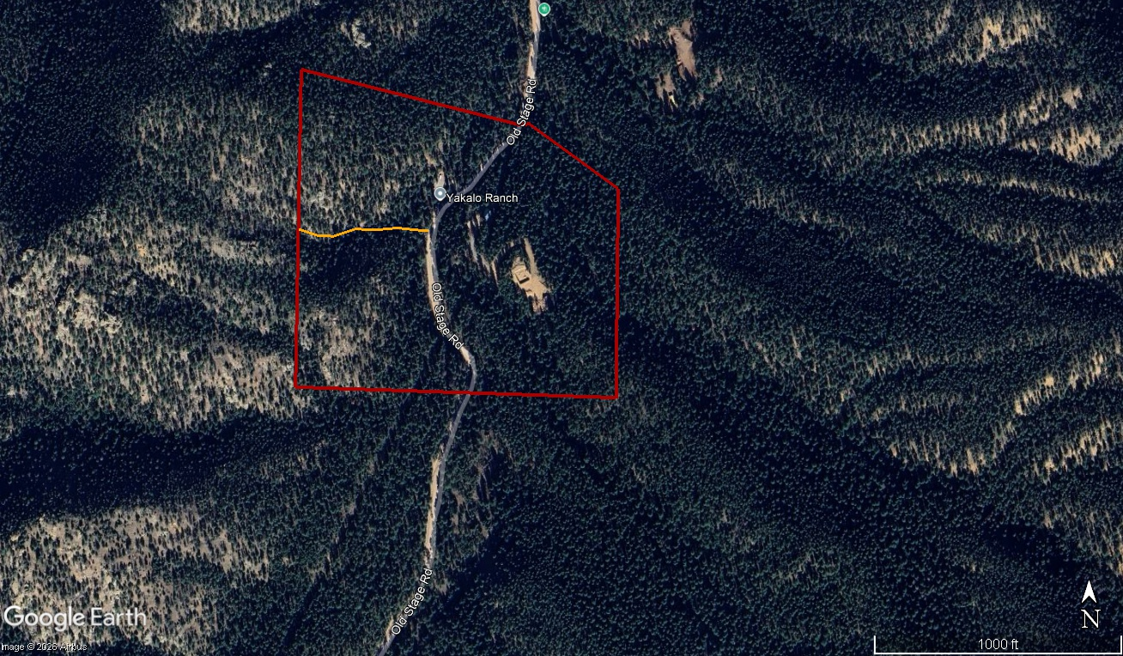
Photo 5. The orange line depicts a drainage that could draw fire uphill. The conifer stand on the south edge would be susceptible to ignition.

Weather

Weather is the most variable of all the factors. The accumulative effects of weather over time can influence vegetation curing and fuel moisture content.

Grass, for example, are described as being one-hour time lag fuels. Time lag is a measure of the rate at which a given dead fuel gains or loses moisture. Hence grasses tend to be influenced by the weather conditions on an hourly basis. Wood fuels that are three inches in diameter or larger are considered 1,000-hour time lag fuels. This type of fuel requires a long period of dry or wet weather to affect its combustibility.

Winds can influence the direction and rate of spread of wildfire. Of greater concern is the short spotting of the fire by embers transported by winds ahead of the main fire.

The effect of wind on a fire was on display most dramatically during the Marshall Fire in Boulder County (December - 2021) . This fire grew to over 6,200 acres and destroyed 1,084 homes. The wind gusts of up to 115 miles per hour where reported. The wildfire reached the town of Superior, three miles away, in just one hour.

It should be noted that this level of high wind activity is not uncommon along the foothills. Finally, it should not be assumed that the main periods of fire danger would be in the summer months. As history has shown, out of season fire events are much more common than might be expected by the public.

Current climate conditions are mimicking historical wildfire from 1950. The Stable Fire burned up Cheyenne Mountain and may have burned on the subject property. This observation was made from charred material found on the surface of the forest. It is not unreasonable to assume that embers were lifted over the summit of Cheyenne Mountain. These embers could have ignited spot fires or the fire burned slowly downhill.

The Stable Fire occurred during a period of warm spring like weather and an absence of snow fall over that winter. This is like the climate conditions that exist at present.

While the weather may contribute greatly to a wildfire event, it is immune to outside influences.

Predicted Fire Behavior

Using the USDA – Forest Service BehavePlus fuel modeling system 5.05, the following predictions can be made based upon an assumed 80-degree temperature day with a relative humidity of 18% with little cloud cover at 1:00 p.m. in the month of July.

Using the inputs of the 1-hour dead moisture being 7%, the 10-hour and 100-hour dead fuels are both set at 10%; live herbaceous (grasses) and live woody stems are set at 200%. This would be an expectation of mid-summer growth. It could be a windy day, or the site is experiencing strong downdrafts from thunderstorms, so the windspeed is set at 20 mph. Slopes steepness is set at 40%.

Based on these inputs, wildfire would spread at a rate of 1,683 feet per hour (28 ft./min.) with a flame length of approximately eleven (11) feet.

If the inputs are changes to reflect a growing season plagued by long term drought, the outcome is decidedly different. The 1-hour dead fuel moisture is lowered to 3%. The 10-hour and 100-hour dead fuels have dried to 5%. The live fuel moisture is 50%, reflecting with early dry growing season conditions. The live woody fuel moisture is composed of leaves and fine stems that have matured and are set at 100%, which would normally be a late growing season condition.

The wind speed of 20 mph and a slope of 40%, remain the same as in the previous example. With the drier conditions, flame lengths could reach 14.4 feet. The rate of spread accelerates up to 4,765 feet per hour or 79 feet per minute.

The calculations above are based on a fire igniting on the west side of Old Stage Road. If the scenarios are repeated for the east side of the road, the same inputs are used except for the slope per cent which is reduced to 17% as an average.

When compared to the first scenario above, the rate of spread remains comparable at 1,617 feet per hour (27 ft./min.). The flame length is only slightly lower at 10.8 feet. The factor that mostly influences the calculations is windspeed when combined with the steep slopes. Reducing the wind speed to 10 m.p.h. results in a flame length of 7.6 feet and a spread rate of 746 feet per hour (12.4 ft./min.). This would remain a difficult fire to suppress.

The probability of fuels igniting in advance of the fire front is 47%. In the time that it may take for the fire to be noticed, reported to the fire department’s dispatch office and for the arrival of the initial attack force, the fire could have traveled over 400 feet. Spotting fires from torching trees may carry 0.7 miles.

It is predicted that local suppression forces will not be able to contain the initial fire outbreak with mobile engines and hand constructed control lines.

It should be noted that these predictions are based upon normal weather conditions prevailing over the course of a year. Weather conditions that were exhibited from the winter of 2022 through the present date have been outside of normal conditions resulting in the catastrophic losses experienced throughout the western United States this past fire season. Again, the Marshall Fire and the recent 24 Fire provide an insight into what fire behavior might occur even in the winter season.

If such conditions are present on or in the vicinity of the proposed development site, any wildfire event can be predicted to be more severe and resistant to initial control efforts.

Wildfire Mitigation

It should be noted here that the occurrence of a wildland fire on this property and any subsequent spread of a wildfire to adjacent land could never be eliminated. In the Spaatz Fire, near Monument, suppression forces were able to arrive on scene in approximately four minutes after the fire was reported. Even with this rapid response, the wildfire reached a size of 67 acres before it was controlled.

The potential for loss can be reduced, and the odds can be improved that initial response forces can be successful in keeping a wildfire to the smallest size possible and structure loss to a minimum. But even with the best efforts of suppression forces, there will always exist a level of risk of loss to wildfire.

The only way to reduce the risk of loss from wildfire is to modify the factors that influence fire behavior. Of the three factors discussed previously, the only factor that could be modified prior to a wildland fire is the fuels. The efforts in modifying fuels can be targeted to their arrangement, continuity and availability.

• Arrangement

The arrangement of fuel considers the size, shape and compactness of the fuel itself. Smaller fuel sizes have greater surface area exposure for preheating. If these smaller sized fuels are only lightly compacted in spacing this results in easier ignition and increased combustion.

Fuels that are tightly compacted and larger in size have lower surface areas. This reduces ignition and combustion.

One technique in reducing the readily ignitable fuel level would be to remove fuels, such as dead leaves, fallen limbs and other small organic debris, from any recreational camp site. However, it is not practical to remove these types of fuels from the entire site.

The most likely source of ignition will come from visitors and their activities. These sources of ignition may come from portable camp stoves, gas lanterns and campfires.

It is suggested here that the reduction of the most ignitable fuel be carried out within ten (10) feet of any constructed camp site. This will reduce the amount of readily ignitable fuel in proximity to the site and campfire ring. It should also retard the spread of a fire and provide suppression forces additional time to contain a fire quickly.

Once a camping site is constructed, the Home Ignition Zone should be followed. Home Ignition zones coupled with Defensible Space are intended to slow a fire down so that it may be controlled and extinguished. There are three zones that comprise a Home Ignition Zone. Detailed information these concepts can be found on the Colorado State Forest Service website at the following link: Protect Your Home & Property from Wildfire | Colorado State Forest Service | Colorado State University

The first zone is the one that contains the most opportunity for modification. This zone is designed to prevent fames from coming in direct contact with the structure and extends out for a minimum of five feet from any structure. A brief synopsis of the steps that can reduce the risk of ignition at a camp site from fire is found below.

Use non-flammable, hard surface materials in this zone, such as rock, gravel, sand, cement, bare earth or stone/concrete pavers would normally be utilized. In this instance, exposing bare mineral soil in a radius of five (5) feet around the campfire ring should serve that purpose. Remove all flammable vegetation, including shrubs, slash, mulch and other woody debris. Do not store firewood for campfire us inside this zone.

Prune tree branches hanging over the camp site to eight feet. This will reduce the risk of flames from a campfire reaching and potentially igniting the forest canopy. Remove all dead fuel within 10 feet of the camp site, this includes larger downed trees. Regularly rake all conifer needles, branches and twigs and other debris from within the ten (10) foot zone. This should be performed after high wind events and fall needle drop,

The second zone extends up to 10 feet from any structure. To retard the spread of fire in Zone 2 may include all or some of the following steps described below.

Mowing any grass to 4 inches tall or less where practical. Avoid large accumulations of surface fuels such as logs, branches, slash and mulch. Remove enough trees to create at least 10 feet of space between crowns. Measure from the outermost branch of one tree to the nearest branch on the next tree. Small groups of two or three trees may be left in some areas of Zone 2. Spacing of 30 feet should be maintained between remaining tree groups to ensure a fire does not jump from one group to another. Remove ladder fuels under remaining trees. Prune tree branches to a height of 6-10 feet from the ground or a third of the total height of the tree, whichever is less. Remove stressed, diseased, dead or dying trees and shrubs.

Zone 3 is mostly concerned with improving forest health. Any locations within this zone with excessive fuel load should receive treatments as described in Zone 2.

Additional information on the development of wildfire safety zones is available through the Colorado State Forest Service at the following link: 2021_CSFS_HIZGuide_Web.pdf
Besides incorporating the mitigation steps described above, treat slash from any thinning activity by either removal from the site, chipping in place or lop and scattering any limbs.

• Continuity

The second factor affecting fuels that can be modified is their continuity. Is the fuel continuous or patchy in nature? Is the fuel layered in such a manner that it can leave the ground and spread into a vegetative canopy?

In this instance, the Timber Understory fuel model is continuous. It extends west to east and up and down the slopes.

The fuel is layered in the understory with younger trees ranging in height up to fifteen feet. A fire burning on the ground could climb into the understory canopy layer. The height of overstory trees can reach upwards of forty feet or higher. This should reduce the risk of a fire in the understory directly igniting the main canopy.

• Availability

The final consideration is the availability of the fuel to be physically burned. This factor is influenced by the weather on a daily or yearly basis and cannot be readily influenced.

The canyons in the Cheyenne Mountain area can experience cooler and wetter conditions than would be experienced on south or west facing exposures. The valley would be slower to warm in the summer months, and any precipitation would tend to linger through the morning hours. There are several springs and intermittent creeks which should increase humidity levels which should influence the availability of one (1) hour time lag fuels.

The current weather patterns have contributed to a long-term drought situation that has influenced the overall availability of the fuels to burn. The trend of above average daytime temperatures and below normal precipitation levels have allowed fuels to reach a higher state of availability than might normally be the case, particularly during winter months. This may result in wildfire acting in a manner that might be more characteristic of mid-to-late summer burning conditions.

Other Considerations

Campfires

As an added precaution, fire extinguishers should be provided for users at each campsite that is not vacant. It would be unreasonable to keep one constantly at a site that is not being actively used. The proximity of campsites to Old State Road could lead to theft and loss. It is suggested here that fire extinguishers be provided during the user’s check-in (see Photo 6).

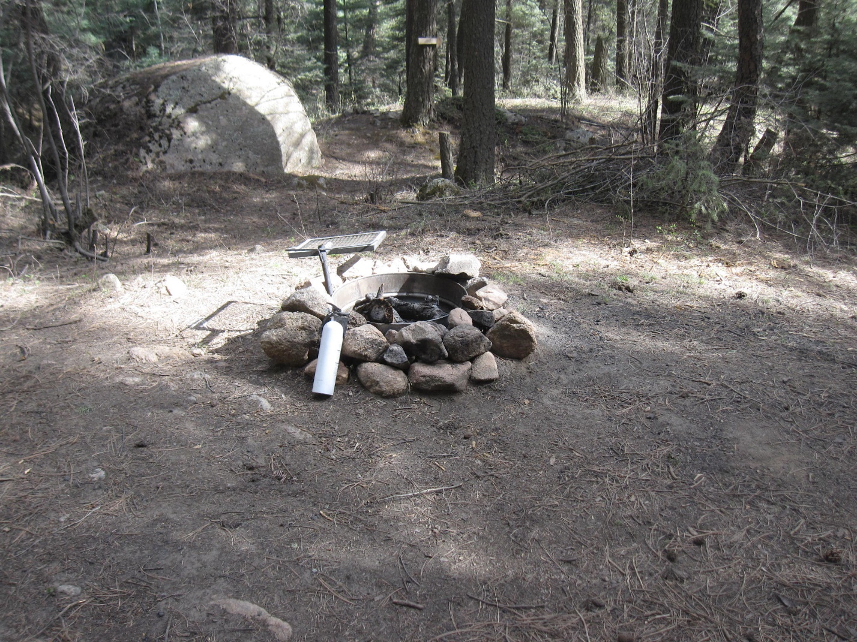
Photo 6. Fire extinguisher is located at Blueberry Camp.

The first defense against a campfire escaping a fire ring are the users of the campsite themselves. A pointed shovel should be provided at each campsite. As most campsites are situated near a water source, a bucket should be provided as well. This would allow users to completely extinguish any campfire and provide for a means to suppress any embers that may spark out of the fire ring.

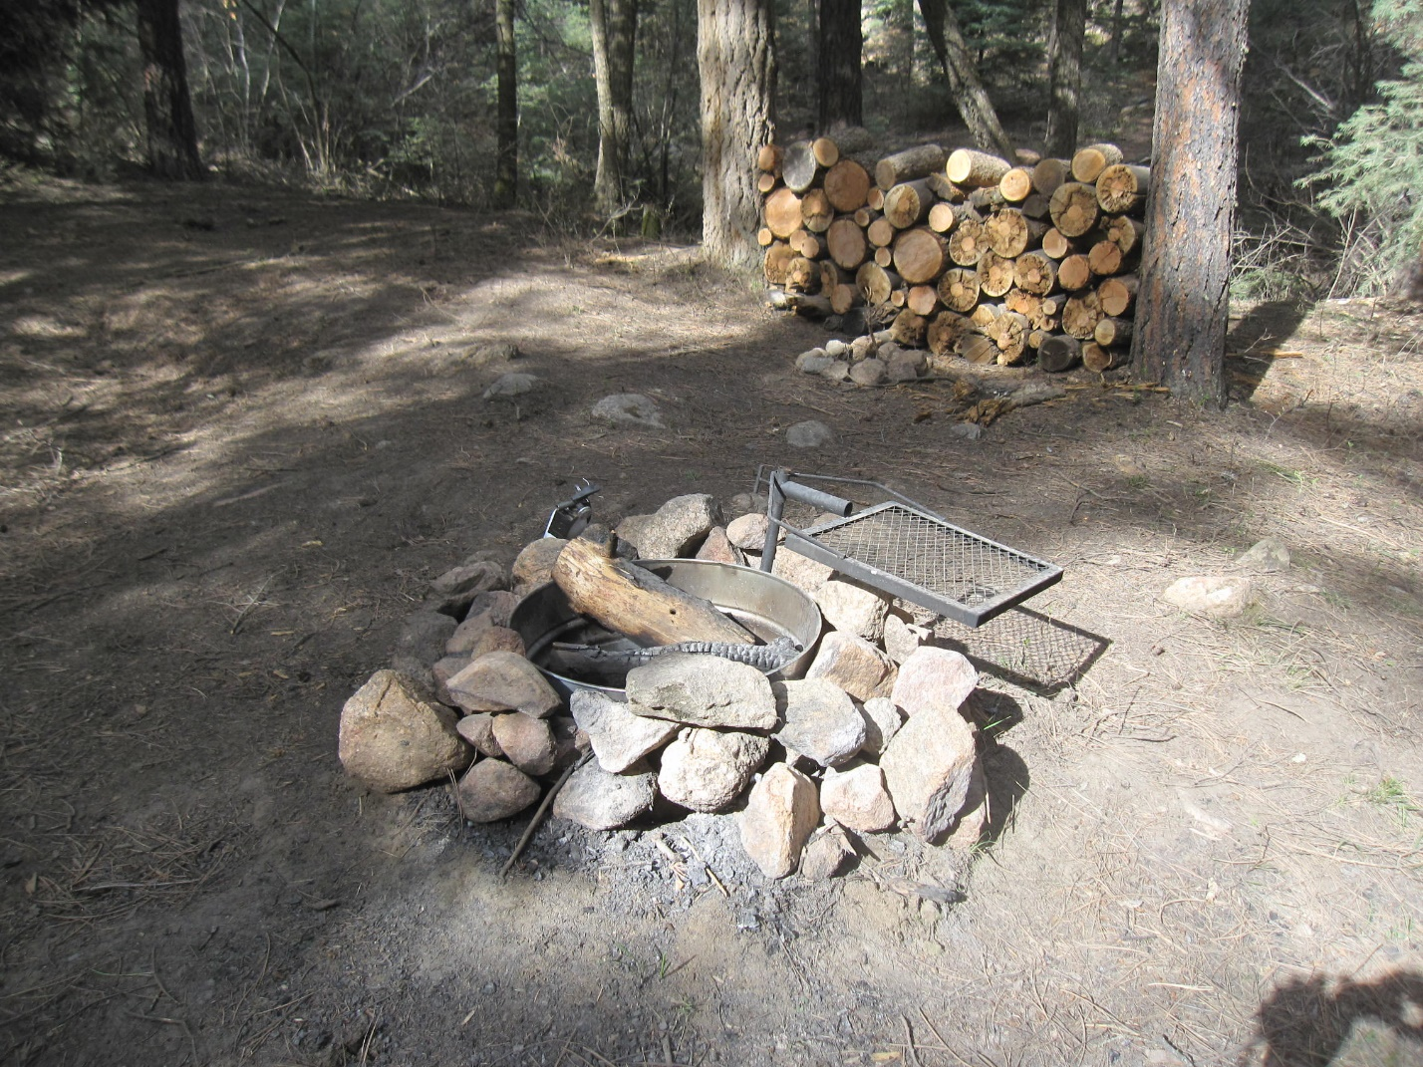
Photo 7. An example of a campfire pit with steel ring perimeter. Firewood stack is situated eleven feet away from the pit.

As a rule, firewood stacks should be located at least ten (10) feet away from all campfire pits. The area around the campfire pit should be raked on a regular basis to remove any fine fuels such leaves, needles and small twigs. As the camp sites receive use, it would be reasonable to expect that the fire pit would be bordered by bare mineral soil. Removing the flammable litter would reduce the risk of an ember igniting a fire outside of the campfire pit.

The area around camp sites should be thinned and the debris disposed of prior to use. Any tree removal must consider that some level of screening should be provided either between campsites or from traffic on Old Stage Road.

Any branches that hang over the fire pit within ten (10) feet or less should be removed. This should prevent accidental ignition of a fire in a tree canopy due to heat and flame lengths from a campfire.

Roads and Driveways

Roads and driveways should be constructed in accordance with NFPA 1141, Fire Protection for Planned Building Groups, if planned. Specifically, road widths should not be less than twenty-four feet to allow for simultaneous access of emergency equipment and evacuation of visitors.

Driveways should provide a minimum width of twelve feet and a minimum vertical clearance of fifteen feet. The grade of any driveway should not exceed 12%. The entrance to any driveway from public roads should not exceed a ninety-degree angle. A turnaround should be provided at all structure sites on driveways over three hundred feet in length. These turnarounds should be within fifty feet of any structure.

Water Supply

The property lies within the unincorporated land of El Paso County, and the county is the authority having jurisdiction for providing fire protection. At present, there is no readily available water supply for extended fire suppression.

The initial response to a wildfire event would be from the Broadmoor Fire Department under a mutual aid agreement with the county. The station is located at 750 El Powar Road. and is approximately five (5) miles away from the property. It may take upwards of 25 minutes to reach the property as the route is mostly on a winding dirt road.

Fire apparatus available at the Broadmoor Fire Department consists of 1 – Type 2 Engines containing a total water capacity of 305 gallons. There is also 1 – Type 6 Brush Trucks with a slide-in pump with a capacity of 75 gallons and a crew vehicle (Type 7) with a slide -in pump with a 10-gallon capacity.

The station is manned by five (5) full-time and eleven (11) part-time individuals. Response time to a wildfire incident may vary depending on other department responses to requests for assistance.

Under mutual aid agreements, the City of Colorado Springs Fire Department has two stations that could provide suppression support under initial attack. The first could be Station 13 located at 1475 Cresta Road. The next could be Station 4 at Southgate and Lake Drive.

As the property is bordered on three sides by land managed by the USDA-Forest Service, the Pikes Peak Ranger District would respond to any wildfire incident.

Forest Management

An inventory of the forest was conducted in conjunction with the wildfire hazard review. A series of random plots were visited, and trees were measured for diameter, height and condition (see Appendix B).

Based upon the inventory results, the average diameter is 11.64 inches with 319 trees per acre on average. And of those trees, 211 trees (66%) lie in the 2-4-inch diameter classes (see Chart 1). The composition of the forest stand is classified as mixed conifer.

The high number of trees in 2-4-inch diameter classes could be attributed to the Douglas-fir and subsequently, white fir, experiencing a heavy cone crop. White fir can produce a heavy cone crop every 3-9 years. Douglas-fir may experience a heavy cone crop every 7 years. As white fir is going to be more prolific, any soil disturbance may increase its presence in the forest stand overall.

The forest can be described as a two-story stand. There is a dominant overstory component, with all species having a pronounced presence. Within the 14 -inch to 22-inch diameter classes, ponderosa pine comprises 9 stems per acre with the fir providing an additional 6.

There is a definitive understory stand composed of mostly Douglas-fir and white fir. In the 2-inch diameter class, they account for over 50% of the stems. In the 4-inch class, they account for 39% of the stems which are entirely Douglas-fir.

The tally of one 2-inch or 4-inch diameter tree can skew the inventory result. For example, ponderosa pine had only 2 stems tallied but it resulted in a projection of an average of 115 stems per acre. Visual observation of the forest would refute that conclusion.

From a forest health standpoint, the forest does need management at present. The dog-hair thickets should be thinned. No more than 50% of the stems in each thicket should be removed on the initial treatment. Stems with a larger or thicker caliper should not be removed as they will be less susceptible to being bent over by heavy snowfall. Caliper is the diameter of the stem at ground level.

A second thinning treatment will be necessary within 5-10 years as the smaller stems mature. Again, it may require upwards of 50% of the remaining stems to be removed. This should result in the final number of stems per acre.

Mountain pine beetle activity is present but is limited to random individual tree infestation. The Blueberry Camp has two pine trees infested with this insect. It is the two trees where the firewood is stacked between. This appears to be a coincidence and there is a low risk to an extensive outbreak of this insect.
There were no dwarf mistletoe infections found during the inventory. Dwarf mistletoe is a parasitic plant that locally infects ponderosa pine and Douglas-fir

Chart 1. Comparison of Conifers by Diameter Classes

Finally, any trees that have fallen and are dead should be removed where practical. These dead trees provide heavy fuel to burn if wildfire were to occur. When feasible, these trees could be placed perpendicular to the slope in drainages to act as water bars. The threat of erosion off the property is high due to the decomposed granite composition of the soil. As forest cover is removed on steep slopes this may help retard water erosion in the event of heavy precipitation events.

Appendix A

Fuel Model Descriptions

Fuel Model 10 Summary Page

Source: Anderson, Hal E. Aids to Determining Fuel Models for Estimating Fire Behavior, National Wildfire Coordinating Group, General Technical Report INT-122, April 1982.

“This report presents photographic examples, tabulations, and a similarity chart to assist fire behavior officers, fuel management specialists, and other field personnel in selecting a fuel model appropriate for a specific field situation. Proper selection of a fuel model is a critical step in mathematical modeling of fire behavior and fire danger rating.

Moderate Load, Humid Climate Grass-Shrub (GS3) Summary Page
Low Load Dry Climate Timber-Grass-Shrub (TU1) Summary Page

Source: Scott, Joe H. & Burgan, Robert E. 2005. Standard fire behavior fuel models: a comprehensive set for use with Rothermel’s (1972) surface fire spread model. Gen. Tech. Rep. RMRS-GTR-153, Fort Collins, CO: U.S. Department of Agriculture, Forest Service, Rocky Mountain Research Station. 72 p.

“This report describes a new set of standard fire behavior fuel models for use with Rothermel’s surface fire spread model and the relationship of the new set to the original 13 fire behavior fuel models.”

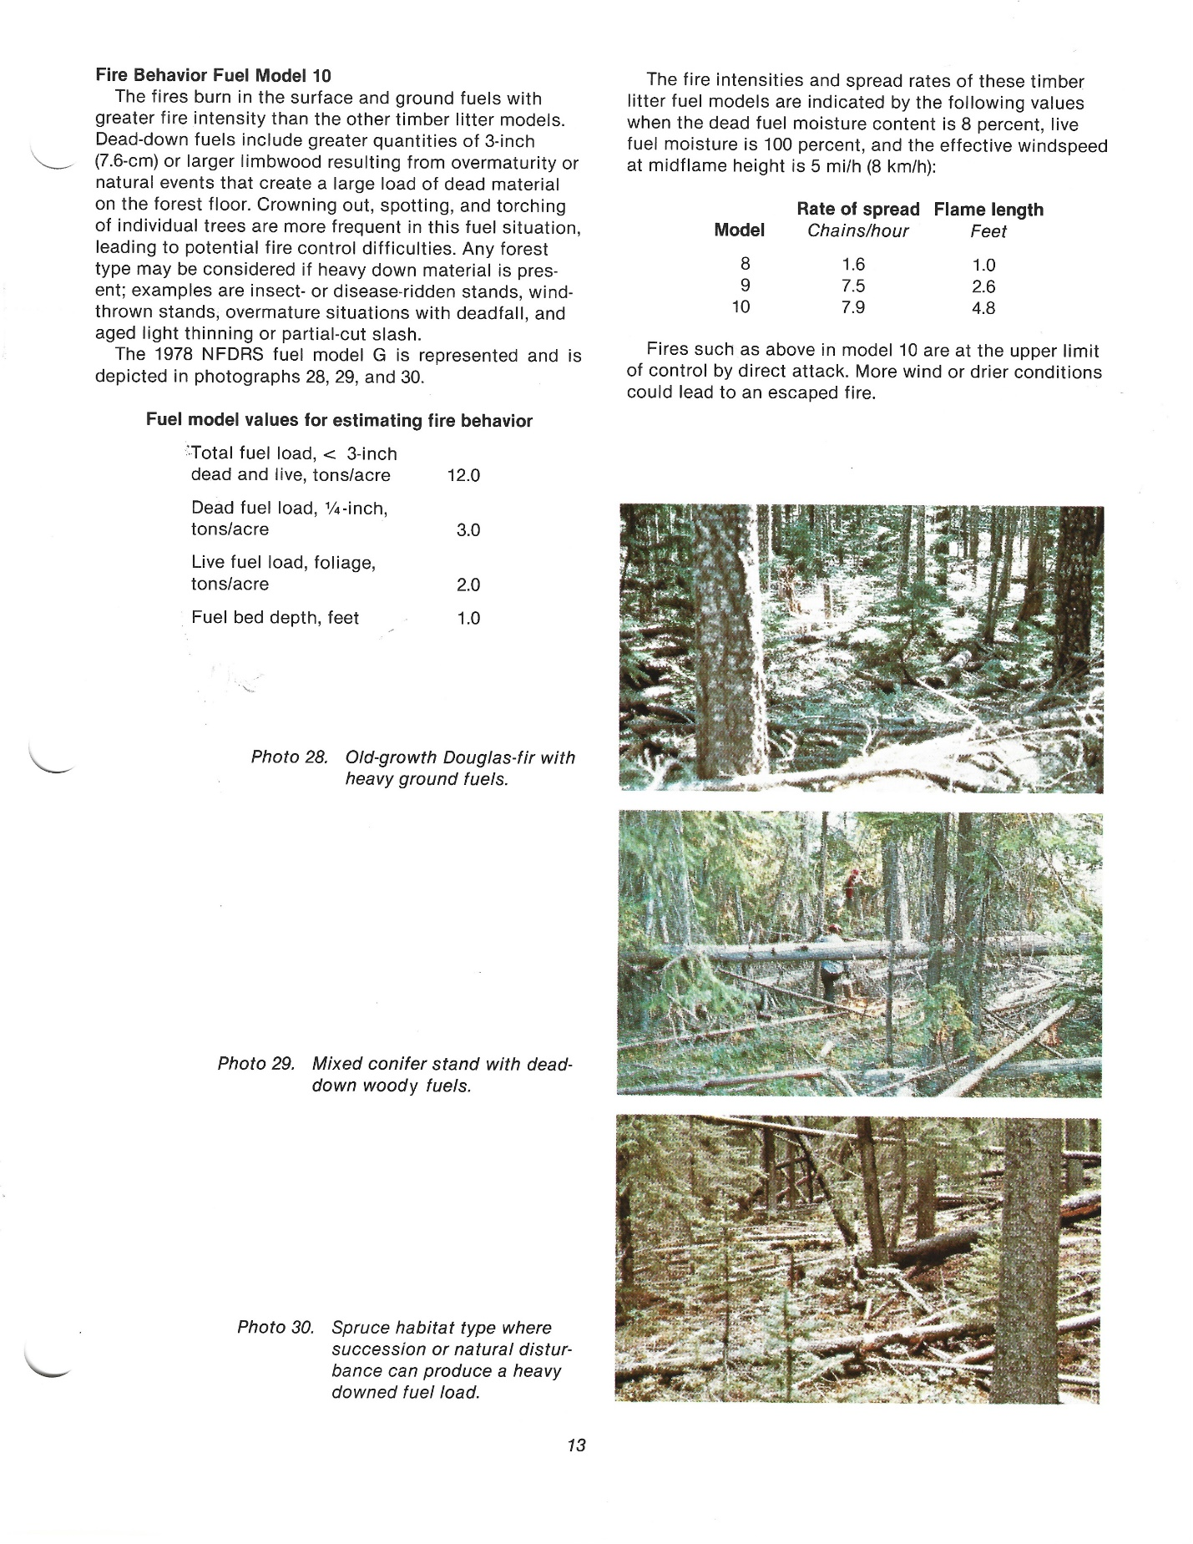

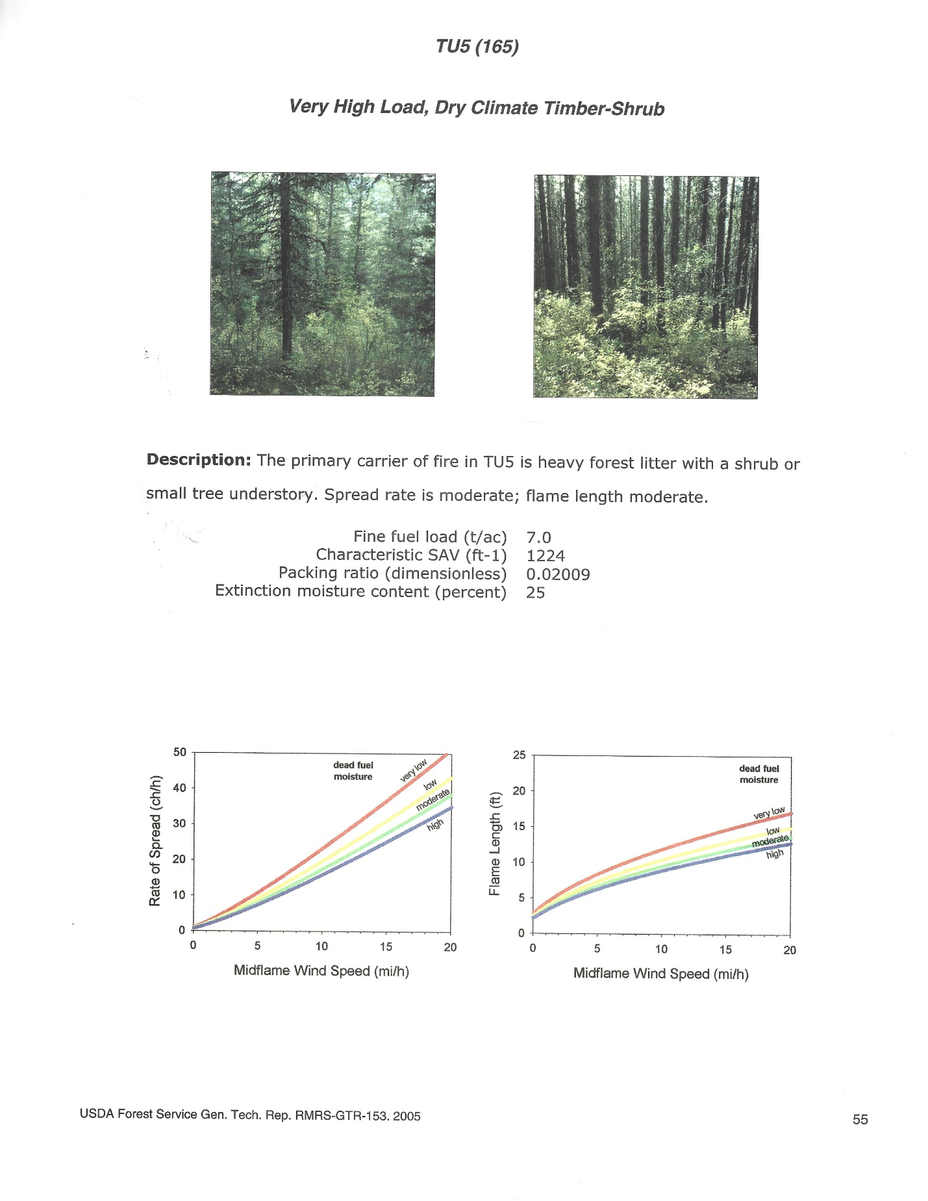
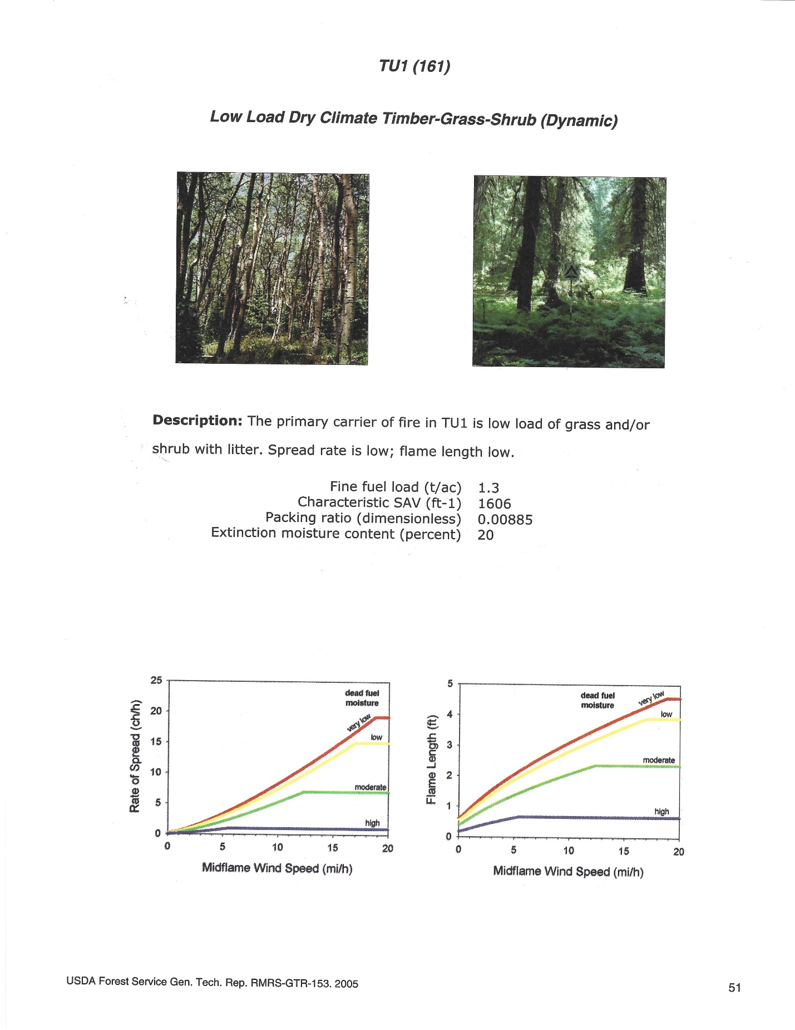

Appendix B

Inventory Summary Sheet

NOTE: Volume data for the Lost Valley Ranch Inventory was obtained by performing a variable plot cruise. Detailed data was collected at each plot. Errors are inherent in any sampling process where only a portion of the population is measured. The minimum accuracy requirement for this inventory is at least +/- 20 percent standard error at one standard deviation.

Height measurements were obtained, when possible, using a Nikon Forestry Pro Laser Rangefinder/Hypsometer.
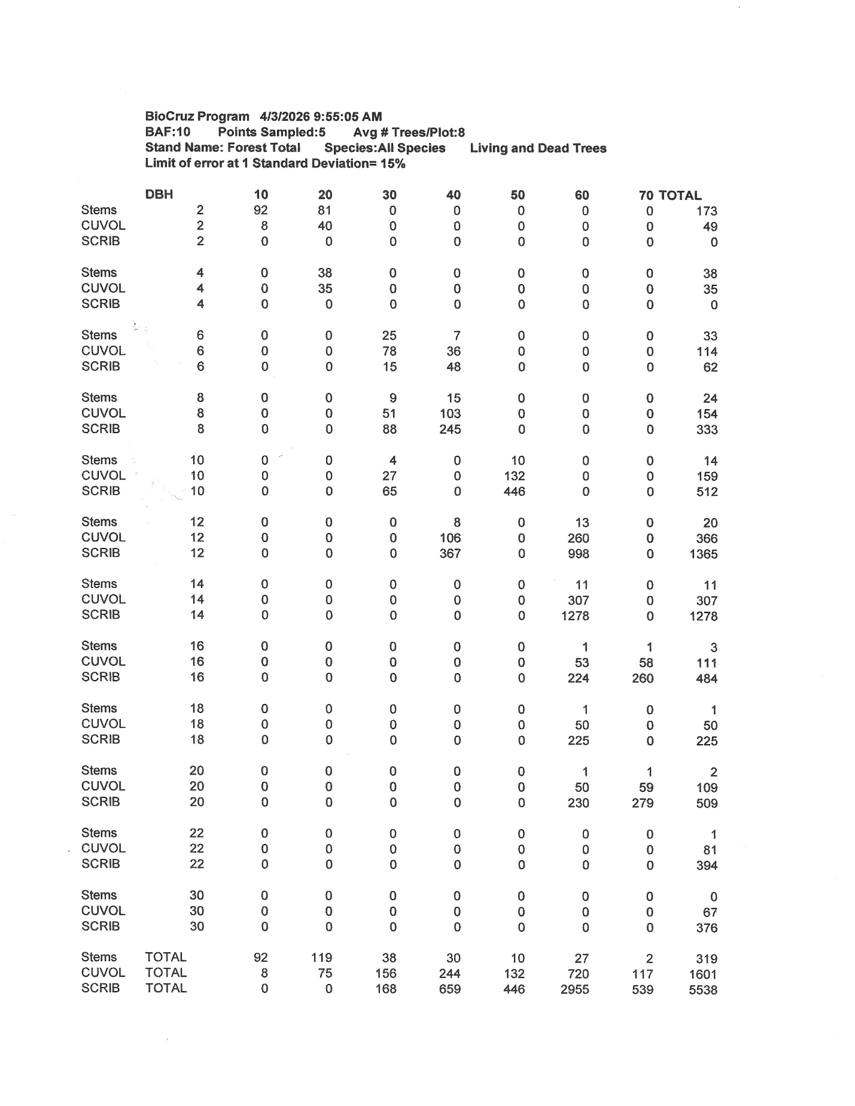

Appendix C

COWRAP Assessment

(Provided under Separate Cover)

