Early Assistance Meeting Number: EA2695
Project Name: TMS Construction Garage Condos
Project Location: 18950 Base Camp Rd
Project Parcel Nos. 7111303004
Project Description: Development of a garage condo building adjacent to the existing TMS Construction headquarters by the owners of TMS. Schematic site plan and building elevations will be provided for more information.
Meeting Date: Wednesday, August 26, 2026 @ 11 am

El Paso County Planning & Community Development Planning Checklist

Request – Map Provided by Applicant
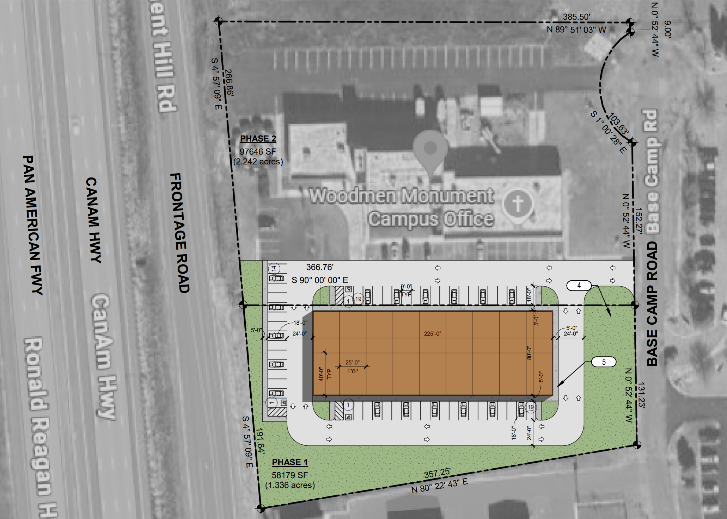

Zoning (check conditions of approval)
Existing Zone(s)
Zone |  | Name
CS |  | Commercial Service

Zone Map
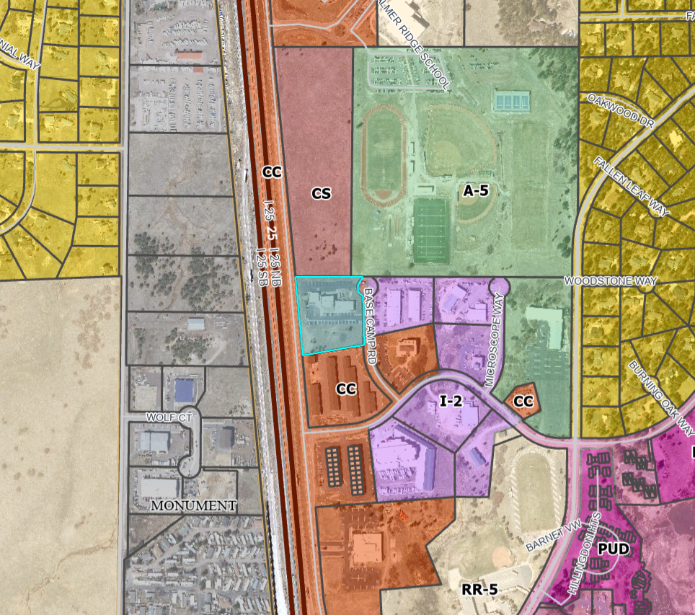

Zoning Analysis
- CS, Commercial Services District. The CS zoning district is intended to accommodate retail, wholesale or service commercial uses that serve the general public.
- The garage condos are intended for future ownership by nearby businesses
- The principal uses of “Mini-Warehouse” or “Recreational Vehicle and Boat Storage” are both allowed in the CS zone with submittal and approval of a Site Development Plan

Zoning District Requirements (density, lot size, lot design standards, building setbacks)
Minimum Zone District Area: 2 acres (11)
Minimum Lot Size: none
Minimum Front setback: 25 ft (1,3,11)
Minimum Rear setaback: 25 ft (1,2,3,11)
Minimum Side setback: 25 ft (1,2,3,11)
Minimum Lot Coverage: None
Maximum Height: 45 ft
¹ Gasoline pumps and canopies shall be at least 15 feet from the front property line or public right-of-way, except where the landscaping regulations require a greater setback.
² The minimum setback is 25 feet from the perimeter boundary of the district, but no minimum setback is required from any internal side or rear lot line within the same district. ***Northern boundary line would not need to adhere to setbacks***
³ Temporary uses shall be setback at least 25 feet from all property lines and 100 feet from Residential zoning districts.
¹¹ If the building is established as or converted to condominium units in accordance with Chapter 7 of this Code, the building and lot shall meet the minimum lot area and setbacks, but the individual units are not required to meet the minimum lot area, maximum lot coverage, or setback requirements.

Map of Platted Lot/ Tract (check plat notes & conditions of approval):
Plat 10535 - Greater Europe Mission Sub Fil No 1 (2000)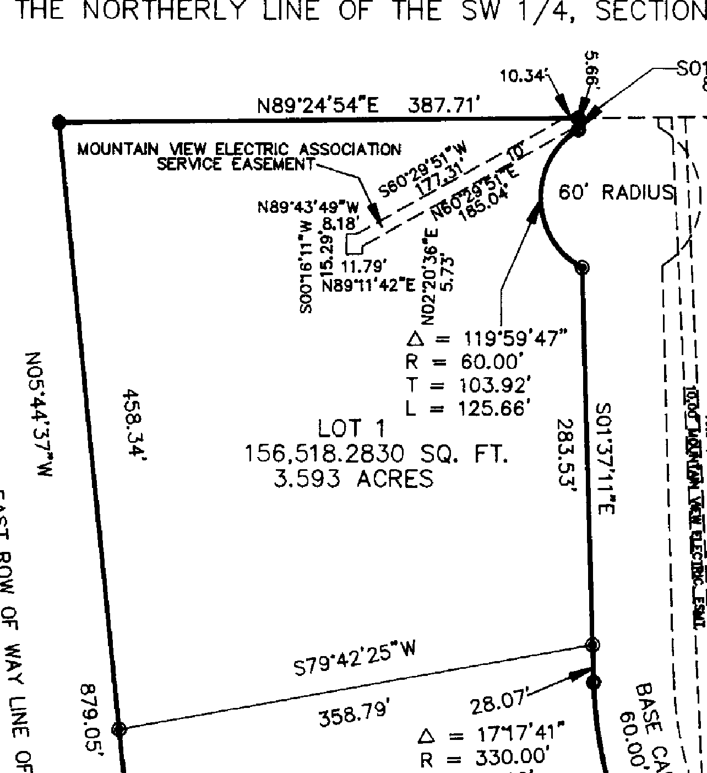
Plat notes from Plat 10535 (2000)
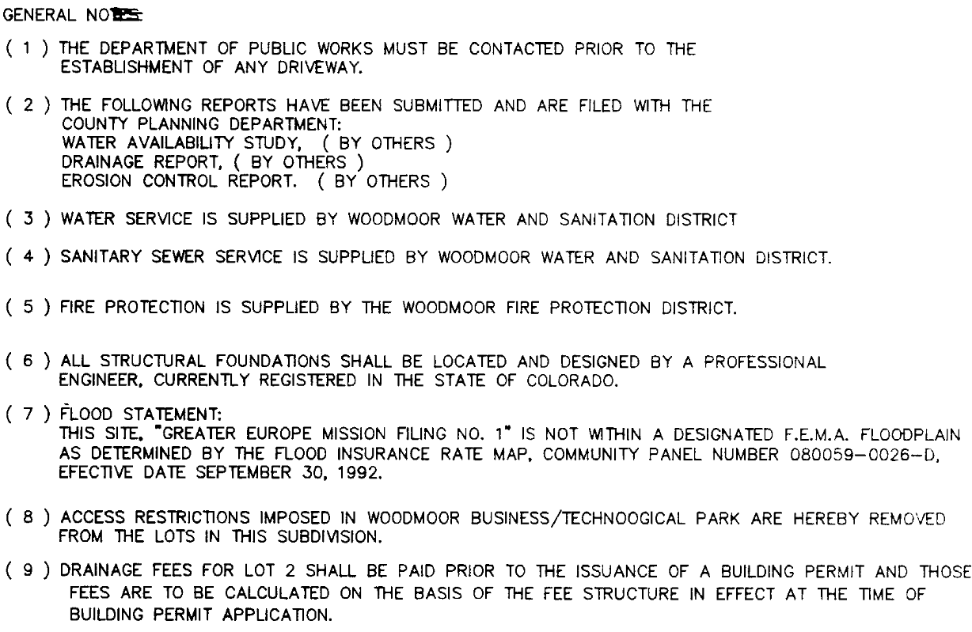
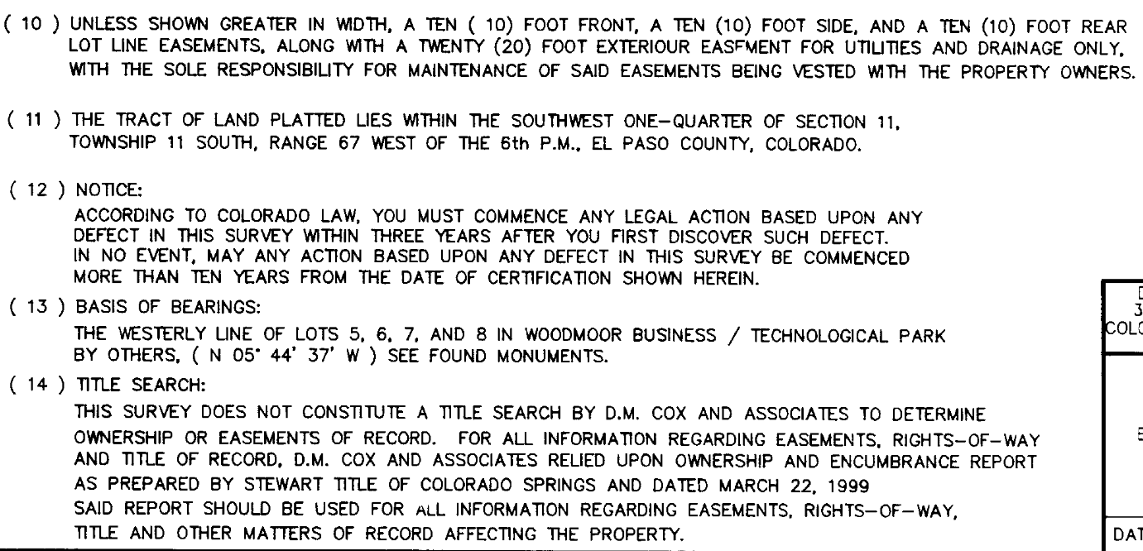

Application Type(s) Hearing: Required/ Optional/ No
Site Development Plan | No
Condo Plat – Subdivision Exemption | No

Processing Issues and Options
(5) Condominiums and Townhome Exemptions. A conversion of existing multiple units to condominium or townhome units as defined by C.R.S. § 38-33-103, as amended, where there is no increase in density from what was originally approved, shall be exempt from the definition of the term "subdivision".

(1) Condominium and Townhome Plats.
(a) Purpose. The purpose of this Section is to provide standards and criteria for approving an exemption plat for the creation of condominium units in existing buildings, townhomes on owned lots, and for new construction where the intent to create condominium units or townhome units was established with the approval of the final plat.
(b) Applicability. A condominium map or townhome plat may be approved where a condominium or townhome is proposed to be established on land that was platted in a manner intended for condominium or townhome uses at the density proposed, where the proposal involves:
• The conversion of an existing building to condominium units;
• The construction of a building in order to establish condominium; or
• The establishment of townhome units, where land ownership is conveyed to the homeowner.
(c) Approval Criteria. The PCD Director, in approving a condominium map or townhome plat, shall find:
• The proposed uses in the condominium units or townhome units are consistent with existing zoning of the site;
• The site complies with the approved Site Development Plan, where applicable;
• The condominium map or townhome plat is consistent with the intent of the original subdivision of the property and does not result in an increase in density;
• The condominium map or townhome plat complies with the monumentation and plat preparation standards required by State Statute;
• Access and utility connections as appropriate are provided for any subsequent phases of the project;
• Homeowners' association documents or their equivalent address the unit owners' rights and responsibilities with respect to parking, loading and access facilities, landscaping, utilities and any other common areas and facilities on the site; and
• Perpetual maintenance of common facilities by property owners is provided for by the homeowners' association documents and allow for the option of County to take over maintenance and charge the cost to the property owners until property owners demonstrate they can adequately maintain the property if the property owners fail to adequately maintain the common facilities.
(d) Completed Action. An action establishing a condominium or townhome shall be considered completed and in effect when an approved condominium map or townhome plat is filed for recording with the Clerk and Recorder.

Relevant Past History:
- 1971: Property was originally platted as Lots 7 and 8 in the Woodmoor Business/Technological Park subdivision (Plat #3689)
- 2000: Property was re-platted as Lot 1 in the Greater Europe Mission Sub Fil No 1 (Plat #10535, PCD Fil No VR00001)
- 2023: Site Development Plan approved (PCD Fil No PPR2329) on the parcel to the north

Design and Landscaping

Site Design/Layout (Lot pattern, circulation/road design, open space, preservation of natural features, compatibility internally and with adjacent land uses)
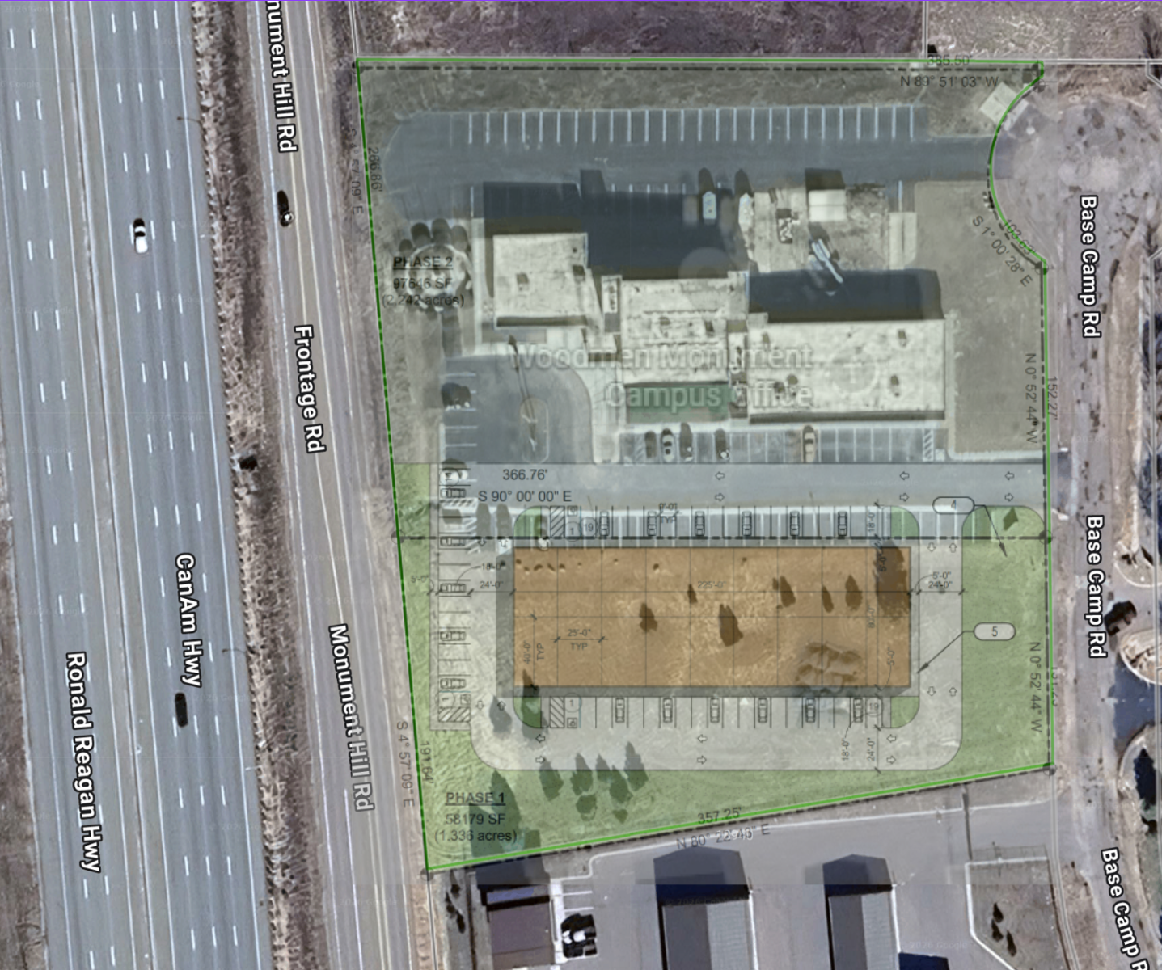

Landscaping
☐ | Expressway, Principal arterial area depth – 25’-Trees required 1 per 20’
☐ | Urban interchange/Intersection area depth – 25’- N/A
☐ | Minor arterial area depth 20’ – Trees required 1 per 25’
☒ | Non-arterial area depth 10’ – Trees required 1 per 30’
☒ | Parking lot landscaping required
☐ | Buffer between non-residential and residential districts separated by a non-arterial road or public alley  Zone Boundary Buffer

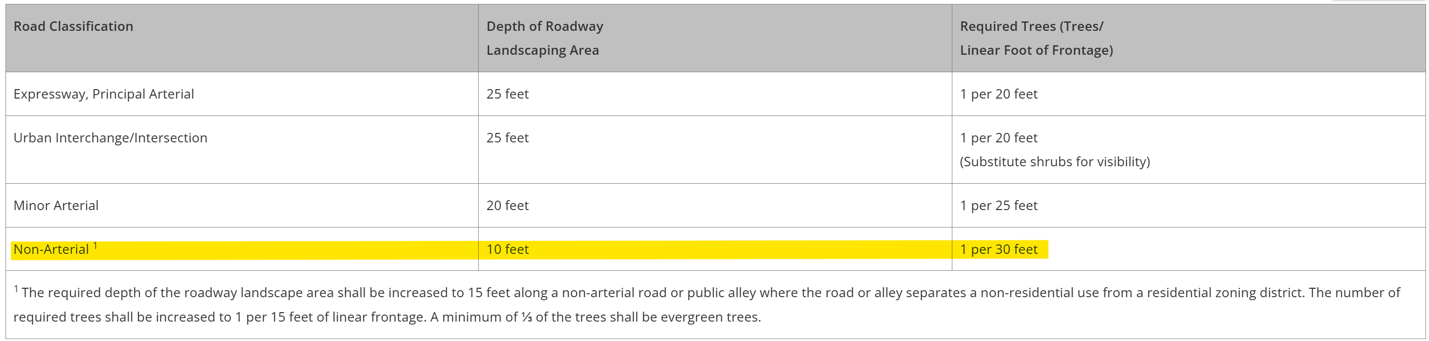

6.2.2. Landscape Requirements
(B) Roadway Landscaping Requirements
(C) Parking Lot Landscape Requirements
(2) Parking Lot Islands.
1 island shall be provided for every 15 spaces. An island, finger or corner must be a minimum of two parking spaces in size (18' x 18' or 9' x 36' in order to qualify as a required island, finger, or corner. Parking lots containing fewer than 15 spaces shall not be required to provide islands but must include some other form such as a finger or corner plantings to satisfy the requirement.

Signage:
If you would like to submit a plan for signage with this submittal, we can give the plans a cursory review, however, the signage would need to be submitted via a separate sign plan in EDARP for official approval.

6.2.10. Signs, On-Premise
(D) Regulations by Zoning District.
(2) Commercial and Industrial Zoning Districts.

Parking Requirements:
6.2.5. Parking, Loading and Maneuvering Standards
(D) Parking Space Requirements.
Table 6-2. Minimum Parking Requirements by Use
(ii) Parking for Uses Not Listed. The required parking spaces for a use which is not specifically listed in Table 6-2 shall be determined by the PCD Director based on the requirements of other similar uses.
(iv) Parking Required to Accommodate All Uses on Lot. Where a lot or parcel has more than 1 use, or a primary use with accessory use, the total number of parking spaces required shall be the sum of the requirements for the various uses.

Table 6-3. Disabled Parking Space Requirements
Once you determine how many spaces you will need, use this table to determine the required number of ADA spaces
Possible Use Type:
Warehouse — A building or portion thereof used by the occupant for the inside storage, safekeeping, distribution or selling at wholesale of goods and materials in the regular course of commercial dealing and trade.
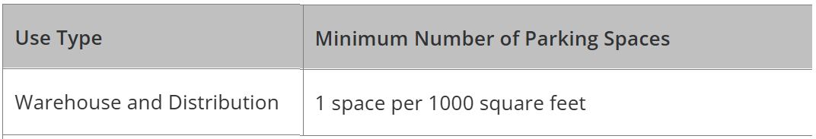

Lighting:
6.2.3. Lighting

d) Maximum Levels. Maximum on-site lighting levels shall not exceed 10 foot candles, except for loading and unloading platforms where the maximum lighting level shall be 20 foot candles.
(e) Measurement at Property Boundaries. Light levels measured at the property line of the development site adjacent to residential property or public right of way shall not exceed 0.1 foot candles as a direct result of the on-site lighting.

Photometric Plan Required | ☒

Site Characteristics\ Constraints\ Environmental Standards:

☐ |  | 30% or greater slope | Topography: | N/A
☐ |  | CGS review previous concerns discussed | Soils/geology: |  | Tomah-Crowfoot Complex
☐ |  | Floodplain | Floodplain comment: |  |  | Not in Floodplain
☐ |  | Noise mitigation required | Noise comment: |  |  |  | N/A
☐ |  | Preble’s mouse | N/A
Minimal Slope – orange areas
Wildlife Impact Level 1 – Low
Wildland Urban Interface – Moderate Intensity

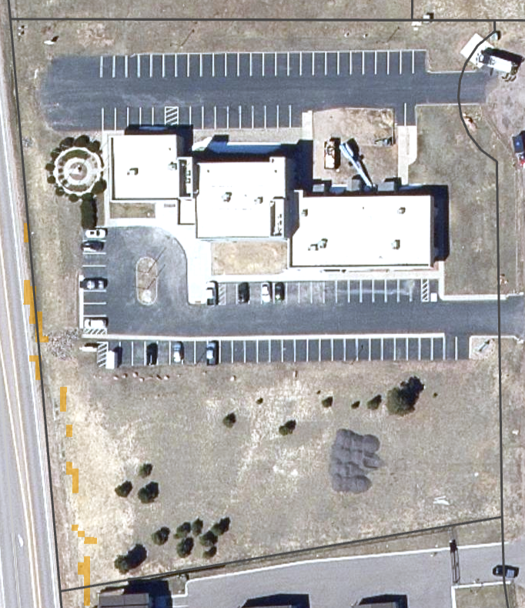

Districts

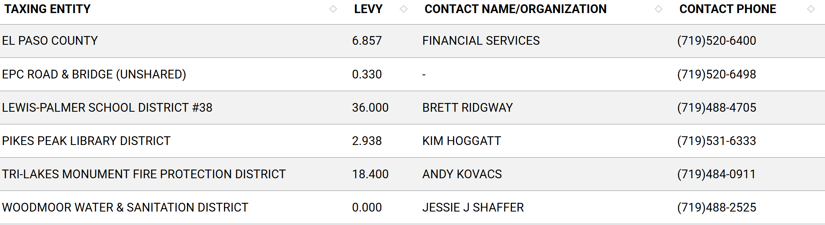
Road Impact Fees:
DPW to discuss

Proposed source of water |  |  | Proposed method of wastewater disposal
☒ | Central System |  | ☒ | Central System
District Name: |  | Woodmoor | District Name: |  | Woodmoor

Fire District:
Tri-Lakes Monument Fire Protection District
https://www.monumentfire.org/
719-484-0911
Contact Page

Fire District Design Concerns/Emergency Services Issues:
Parcel is in a Moderate Intensity Wildland Urban Interface area. A Wildland Fire and Hazard Mitigation Plan may be required if the Fire District requests one.

Commissioner District: 1 – Holly Williams

Parks and trails:
The 2022 El Paso County Parks Master Plan shows no impacts to existing or proposed parks, trails, or open space. As such no trail easement dedications will be necessary for this project. Regional park fees will be assessed upon review of the forthcoming platting actions.
It is not necessary for EPC Parks staff to attend this early assistance meeting.
Thank you!
Ashlyn Mathy
Parks Planner
Park Planning Division
El Paso County Parks Department
Office 719.520.6978
(Parks staff may be confusing this with a standard plat rather than a condo plat. You may call to confirm whether parks fees will be required for a site development plan and condo plat)

Annexations/Intergovernmental/ Jurisdictional Access issues:
Town of Monument Planning Department was invited to attend this meeting as the parcel is
within 3 miles of their jurisdiction. They sent a response on 8/19 however, the comments were
not visible. A request for them to resubmit their comments was sent on 8/24.
A resubmittal of comments has not been received as of the date of this meeting.
You may reach out if you want, however they will also be invited to review the submitted
Site Development Plan and may return comments in that process. planning@tomgov.org

Next Steps
The following documents will be requested for submittal with this Site Development Plan application. (I have provided links where we have them available for specific forms and checklists. Some documents will need to obtained from specific agencies or certified professionals.)
- Application/Petition Form
- Elevation Plans
- Floor Plans
- Landscape Plan Drawings
- Letter of Intent
- Lighting Plan
- Road Impact Fee Acknowledgement Form
- Site Development Plan
- PCM Applicability Form
- Drainage Letter

Process
- A submittal request will be sent for the documents listed above.
- Once all documents are received and accepted, a payment request will be sent for $1723.
- Once payment is made, a 14-day review cycle will commence in which all documents will be sent to agencies for review
- Review comments will filter in over the 14-day period and on the 14th day, county staff will return their comments along with a resubmittal request for documents that need to be revised and resubmitted.
- Once we receive the resubmittal, a 2nd review cycle of 7 to 14 days will initiate and the process will repeat until all comments are resolved.
- Once all comments are resolved, you will receive all stamped, signed, approved plan set which you will use to submit to PPRBD for building permits.
- You will schedule a Pre-Con meeting with our inspections team
- Once the structure is built, contact us to set up the Condo Plat project in EDARP
- The Condo Plat project will ask for the following documents.
- Application/Petition Form
- Legal Description
- Letter of Intent
- Title Commitment (Current within 1 year of submittal)
- Plat Drawing
- Codes, Covenants, Condo Declarations, Common Space Restrictions
- Condo Association Bylaws
- The review fee for the Condo Plat will be $1070.
- Once the review of the Condo Plat is complete, we will schedule a recording date for you to come in with the plat drawings on mylar, a zero tax certificate, current Title Commitment, Deeds conveying shared space to the HOA

Helpful Links

Planning Website: https://planningdevelopment.elpasoco.com/

El Paso County Master Plan: https://planningdevelopment.elpasoco.com/#1510603950097-f5d985dc-35b2
Parks, Mineral and Water Master Plan: https://planningdevelopment.elpasoco.com/resources-and-references/#1516982531779-52cc0e87-01af

Forms and Templates: https://planningdevelopment.elpasoco.com/planning-development-forms/#1510677560407-ff8cfff5-69b2716b-00f9cbba-0c21

Land Development Code: https://library.municode.com/co/el_paso_county/codes/land_development_code

EDARP: https://epcdevplanreview.com/

Public GIS: https://elpasoco.maps.arcgis.com/apps/View/index.html?appid=5be6431018594c67b035ad0aad3e7e8a

Wrap Up
-If subdivision is proposed, recording fees, park and school fees and road impact fees may apply.

-Fees are subject to change. The fees at the time of application apply.

-Road Impact Fees
Please see the following website for information on the EPC Road Impact Fee Project. https://publicworks.elpasoco.com/road-impact-fees/ to include fee schedule.
As of December 15, 2016, per Resolution 16-454, on and after January 1, 2020, property in the unincorporated area of the county that receives a Land Use Approval either in a public hearing or administratively, is subject to the payment of Road Impact Fees. After December 31, 2024, in accordance with BoCC Resolution 24-377 the fee is paid for new residential and non-residential uses and structures and expansions of non-residential uses and structures. Road Impact fees are typically paid at time of building permit. If no building permit is being obtained for a particular Land Use application, then Road Impact Fees must be paid at the time of Site Development Plan or Special Use approval. If there are questions about EPC Road Impact program or fees, please contact DPW Development Review Services and the Engineer of the Day.

- Engineering Criteria Manual (ECM) Deviations.
The fee for any additional ECM deviation requests (more than two per land use application) - $1483.00 each per current Fee Schedule. Please note ECM deviation requests may result in additional processing and project review time. ECM Deviations should be submitted prior to the initial Site Development Plan or Final Plat submittal to preclude changes having to be made to engineering plans and documents if the deviation is not approved. Submission of an ECM deviation request does not imply or guarantee that the deviation will be approved. An ECM Deviation form must be submitted to include complete exhibits and justification excluding cost with supporting engineering criteria. If there are questions about ECM Deviation requests, please contact DPW Development Review Services and the Engineer of the Day.

-The fee for any additional waiver/deviation requests (more than two) - $550.00 each. Please note that requests for waivers and/or deviations may result in additional processing/review delay.

-All items requested must accompany the submittal for it to be complete, prior to payment request or the submittal will not be complete and ready for review agencies.

-A temporary use permit shall be applied for and approved for any staging area associated with development, such as a sales office, construction trailer, or contractor's equipment yard, prior to scheduling of the pre-construction meeting with El Paso County Planning and Community Development. If a Planned Unit Development is proposed, the temporary staging area should be shown on the development guideline and phasing plan.

-All prospective timelines for review are subject to departmental staffing and workload.

-Early Assistance is valid for 12 months from submittal of the EA application. If a project submittal is not received within 12 months, a new EA meeting may be required. An audio/video copy of the meeting is available in EDARP within the EA folder.

- Applications scheduled for public hearings may be heard as a regular item at the request of staff or a hearing body member.

- Any comments or commitments made by any member of the County Staff during this early assistance meeting are only preliminary in nature and should not be relied upon by the applicant. All prospective applicants should be informed that formal comments cannot be made by staff until after the application is submitted.

