Early Assistance Meeting Number: EA2490
Project Name: Dellacroce Ranch PUD
Project Location: Baptist Road and Old Denver Road/Woodcarver Road, El Paso County
Project Parcel Nos. 7100000427
Project Description: N.E.S. Inc, on behalf of Classic Homes, requests an Early Assistance Meeting to discuss a proposed project on the approximately 75-acre site (part of the larger 711-acre Dellacroce Ranch) located north and south of Baptist Road between Old Denver Road and the Union Pacific Railroad. The site is currently owned by Dellacroce Ranch, LLC and is being purchased by Classic Homes. The project proposes to rezone the A-35 zoned property to PUD and to include 228 single-family lots.
Meeting Date: September 4, 2024

El Paso County Planning & Community Development Planning Checklist

Request – Map Provided by Applicant
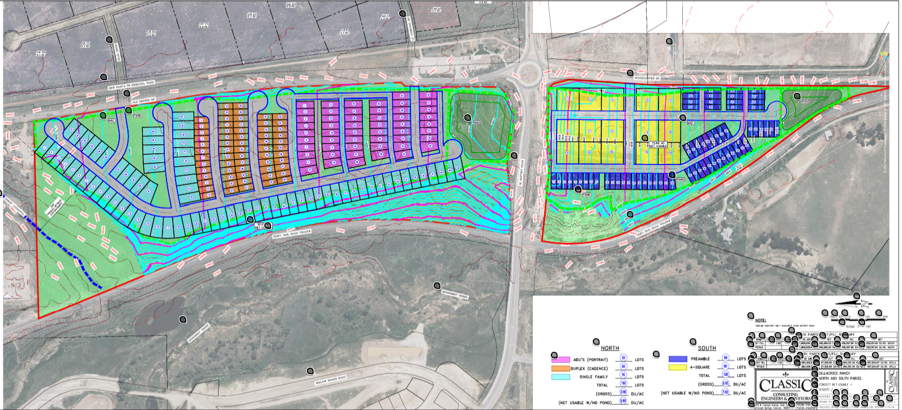

Zoning
Existing Zone(s)
Zone |  | Name
A-35 |  | Agricultural
Proposed Zone(s)
Zone |  | Name
PUD |  | Planned Unit Development

Zone Map (existing conditions of approval)
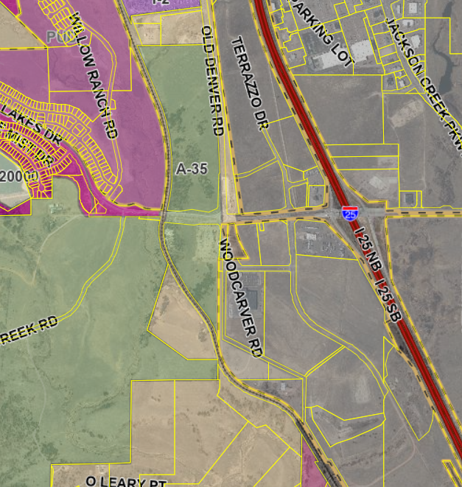

Zoning Analysis
Rezone to PUD for 228 single family lots on 75 acres

All PUD specifications can be found in section 4.2.6 of the LDC

Zoning District Requirements (density, lot size, lot design standards, building setbacks)
The use, dimensional, and development standards for a PUD district shall be set forth in the approved PUD development plan and/or development guide and shall include, but may not be limited to: uses, density, lot area, lot width, lot depth, building height, building elevations, coverage, parking, access, screening, landscaping, open space, accessory buildings, signs, lighting, project phasing or scheduling, management associations, and other standards necessary to the administer the plan.

Application Type(s) Hearing: Required/ Optional/ No
PUDSP | Required
Final Plat | Optional (water dependent)

Approval Criteria:
• The proposed PUD District zoning advances the stated purposes set forth in this Section;
• The application is in general conformity with the Master Plan;
• The proposed development is in compliance with the requirements of this Code and all applicable statutory provisions and will not otherwise be detrimental to the health, safety, or welfare of the present or future inhabitants of El Paso County;
• The subject property is suitable for the intended uses and the use is compatible with both the existing and allowed land uses on the neighboring properties, will be in harmony and responsive with the character of the surrounding area and natural environment; and will not have a negative impact upon the existing and future development of the surrounding area;
• The proposed development provides adequate consideration for any potentially detrimental use to use relationships (e.g. commercial use adjacent to single family use) and provides an appropriate transition or buffering between uses of differing intensities both on-site and off-site which may include innovative treatments of use to use relationships;
• The allowed uses, bulk requirements and required landscaping and buffering are appropriate to and compatible with the type of development, the surrounding neighborhood or area and the community;
• Areas with unique or significant historical, cultural, recreational, aesthetic or natural features are preserved and incorporated into the design of the project;
• Open spaces and trails are integrated into the development plan to serve as amenities to residents and provide a reasonable walking and biking opportunities;
• The proposed development will not overburden the capacities of existing or planned roads, utilities and other public facilities (e.g., fire protection, police protection, emergency services, and water and sanitation), and the required public services and facilities will be provided to support the development when needed;
• The proposed development would be a benefit through the provision of interconnected open space, conservation of environmental features, aesthetic features and harmonious design, and energy efficient site design;
• The proposed land use does not permit the use of any area containing a commercial mineral deposit in a manner which would unreasonably interfere with the present or future extraction of such deposit unless acknowledged by the mineral rights owner;
• Any proposed exception or deviation from the requirements of the zoning resolution or the subdivision regulations is warranted by virtue of the design and amenities incorporated in the development plan and development guide; and
• The owner has authorized the application.

Processing Issues and Options

Relevant Past History:

Design and Landscaping

Site Design/Layout (Lot pattern, circulation/road design, open space, preservation of natural features, compatibility internally and with adjacent land uses)

Landscaping
☐ | Expressway, Principal arterial area depth – 25’-Trees required 1 per 20’
☐ | Urban interchange/Intersection area depth – 25’- N/A
☐ | Minor arterial area depth 20’ – Trees required 1 per 25’
☐ | Non-arterial area depth 10’ – Trees required 1 per 30’
☐ | Parking lot landscaping required
☐ | Buffer between non-residential and residential districts separated by a non-arterial road or public alley

PUD Zoning District Open Space Requirement. The amount and type of open space provided in a PUD district shall be proportional to the intensity of the applicable base zoning districts identified in the PUD district and uses specified in the application. In no case, however, shall the open space provided be less than 10% of the gross site area.

Open Space Requirements in Residential PUD Districts
Unless otherwise modified by the BoCC, a minimum of 10% of the gross PUD development area shall be set aside as open space. Individual phases within the PUD are not required to provide 10% open space within each phased area where a planned network of open space is provided in the overall PUD development plan.

Usable Residential Open Space. Open space shall be concentrated in large usable areas. No less than 25% of the gross land area of open space shall be contiguous and usable.

Signage:

Parking Requirements:

Lighting:
Photometric Plan Required | ☐

Site Characteristics\ Constraints\ Environmental Standards:

☒ | 30% or greater slope | Topography: | 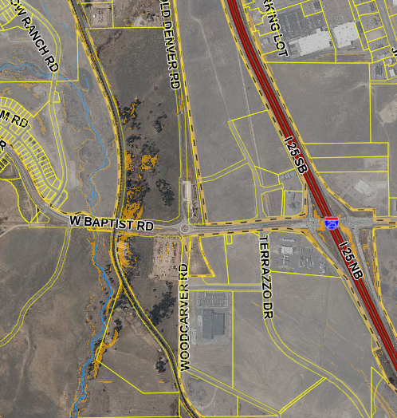
☒ | CGS review required (separate fee to CGS) | Soils/geology:
☐ | Floodplain | Floodplain comment:
☐ | Noise mitigation required | Noise comment:
☒ | Preble’s mouse | 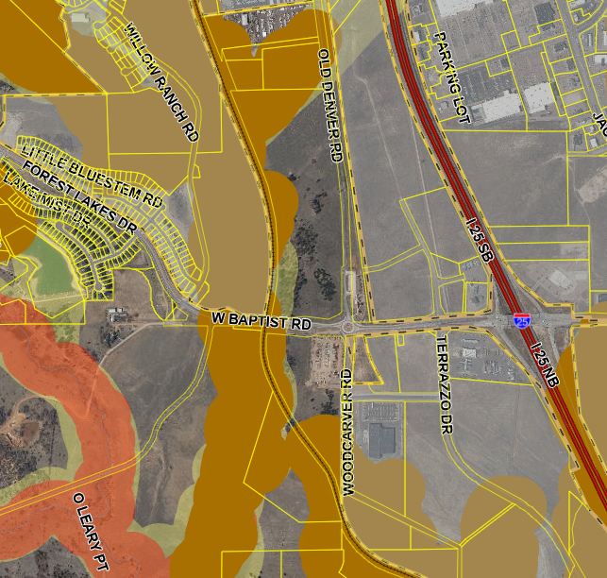

Air/Visual Quality:

Districts

Taxing Entities
El Paso County
EPC Road & Bridge
Lewis-Palmer School District #38
Pikes Peak Library District
Tri-Lakes Monument Fire Protection
El Paso County Conservation District

Proposed source of water |  |  | Proposed method of waste water disposal
☒ | Central System |  | ☒ | Central System
District Name: |  |  | District Name:

Water/wastewater comments
Dwelling, Two Family Use requires central water and wastewater services.

Fire District:
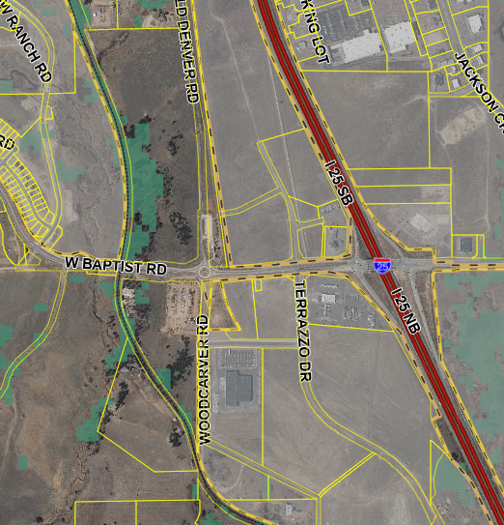

Emergency Services Issues:

Commissioner District:

Code Waivers:

Parks and trails:

Annexations/Intergovernmental/ Jurisdictional Access issues:
Adjacent to the Town of Monument

Road Impact Fee Program (PID Inclusion):

Your El Paso Master Plan

Placetype:
Character:

Recommended Land Uses:

Goals, Objectives, Strategies:

Area of Change Designation:
Description:

Goals, Objectives, Strategies:

Key Area:

Goals, Objectives, Strategies:

Water Master Plan Area:

Recommendations:

Wildlife impact

Parks Master Plan:

Helpful Links

Planning Website: https://planningdevelopment.elpasoco.com/

El Paso County Master Plan: https://planningdevelopment.elpasoco.com/#1510603950097-f5d985dc-35b2
Parks, Mineral and Water Master Plan: https://planningdevelopment.elpasoco.com/resources-and-references/#1516982531779-52cc0e87-01af

Forms and Templates: https://planningdevelopment.elpasoco.com/planning-development-forms/#1510677560407-ff8cfff5-69b2716b-00f9cbba-0c21

Land Development Code: https://library.municode.com/co/el_paso_county/codes/land_development_code

EDARP: https://epcdevplanreview.com/

Public GIS: https://elpasoco.maps.arcgis.com/apps/View/index.html?appid=5be6431018594c67b035ad0aad3e7e8a

Wrap Up
-If subdivision is proposed, recording fees, park and school fees and road impact fees apply.
-Fees are subject to change. The fees at the time of application apply.
-Pursuant to the adopted El Paso County Road Impact Fee Program (Resolution No. 12-382), a transportation impact fee, calculated on a per trip basis, may be due at the time of building permit issuance. Starting January 1, 2020 the transportation impact fee will be due for all new construction (Resolution No. 19-471).
-The fee for any additional waiver/deviation requests (more than two) - $550.00 each. Please note that requests for waivers and/or deviations may result in additional processing/review delay.
-All items requested must accompany the submittal for it to be complete, prior to payment request or the submittal will not be complete and ready for review agencies.
-A temporary use permit shall be applied for and approved for any staging area associated with development, such as a sales office, construction trailer, or contractor's equipment yard, prior to scheduling of the pre-construction meeting with El Paso County Planning and Community Development. If a Planned Unit Development is proposed, the temporary staging area should be shown on the development guideline and phasing plan.
-All prospective timelines for review are subject to departmental staffing and workload.
-Early Assistance is valid for 12 months from submittal of the EA application. If a project submittal is not received within 12 months, a new EA meeting may be required. An audio/video copy of the meeting is available in EDARP within the EA folder.

- Applications scheduled for public hearings may be heard as a regular item at the request of staff or a hearing body member.

- Any comments or commitments made by any member of the County Staff during this early assistance meeting are only preliminary in nature and should not be relied upon by the applicant. All prospective applicants should be informed that formal comments cannot be made by staff until after the application is submitted.

