

FALCON FIRE PROTECTION DISTRICT
Fire Prevention Division
7030 Old Meridian Road
Falcon, Colorado 80831
Business Number: 719-495-4050 Business Fax: 719-495-3112



Lieutenant/Fire Marshal Curtis L. Kauffman
Email: ckauffman@falconfirepd.org Cell #: 719-641-2139

Date: July 2, 2026

To: EDARP
C/O: Joe Letke
Planning & Community Development
2882 International Circle, Suite 110
Colorado Springs, CO 80910
Phone: 719-520-7964
Email: joeletke@elpasoco.com

Project Name: Triple H Ranch Preliminary Plan
File Prefix: SP-Preliminary Plan
Parcel/s: 3300000168 and 3300000388
Zone:
File Number: SP254

This letter serves as comments on the preliminary plan. You are responsible for complying with all sections, codes and references with the fire code based on the 2021 International Fire Code and local amendments. This project lies within two fire protection districts (Ellicott Fire Protection District and Falcon Fire Protection District). This comment letter covers both fire districts.

RED: Local Amendments
Blue: Fire Department Comments

PLEASE READ THIS ENTIRE DOCUMENT, YOU ARE RESPONSIBLE FOR EVERYTHING CONTAINED HERIN!

The following are ACTION ITEMS that need to be completed.

503.1 Where required. Fire apparatus access roads shall be provided and maintained in accordance with Sections 503.1.1 through 503.1.3 and Appendix D.

503.2 Specifications. Fire apparatus access roads shall be installed and arranged in accordance with Sections 503.2.1 through 503.2.8 and Appendix D.

503.2.1 Dimensions. Fire apparatus access roads shall have an unobstructed width of not less than 20 feet (6096 mm), exclusive of shoulders, except for approved security gates in accordance with Section 503.6, and an unobstructed vertical clearance of not less than 13 feet 6 inches (4115 mm). modifications to the required access widths where they are inadequate for fire or rescue operations or where necessary to meet the public safety objectives of the jurisdiction.

503.2.2 Authority. The fire code official shall have the authority to require or permit modifications to the required access widths where they are inadequate for fire or rescue operations or where necessary to meet the public safety objectives of the jurisdiction.

Section 503.2.3 Surface. Fire apparatus access roads shall be designed and maintained to support the imposed loads of fire apparatus and shall be surfaced so as to provide all-weather driving capabilities.

503.2.4 Turning radius. The required turning radius of a fire apparatus access road shall be determined by the fire code official. 33’ inside and 53’ outside radius.

503.2.5 Dead ends. Dead-end fire apparatus access roads in excess of 150 feet in length shall be provided with an approved area for turning around fire apparatus.

503.2.7 Grade. The grade of the fire apparatus access road shall be within the limits established by the fire code official based on the fire department’s apparatus. 10% maximum.

503.2.8 Angles of approach and departure. The angles of approach and departure for fire apparatus access roads shall be within the limits established by the fire code official based on the fire department’s apparatus. Less than 8° degrees (not % percent).

Section 505.1. Address Identification. New and existing buildings shall have approved address numbers, building numbers or approved building identification placed in a position that is plainly legible and visible from the street or road fronting the property. These numbers shall contrast with their background. Address numbers shall be Arabic numbers or alphabetical letters. Numbers shall be a minimum of five (5) inches (127 mm) high with a minimum stroke width of one half (0.5) inch (12.7 mm). Where access is by means of a private road and the building cannot be viewed from the public way, a monument, pole or other means of signage shall be used to identify the structure.” Address numbers shall be visible from the street side and in both directions of road travel for each new home.

507.1 Required water supply. An approved water supply capable of supplying the required fire flow for fire protection shall be provided to premises on which facilities, buildings or portions of buildings are hereafter constructed or moved into or within the jurisdiction. We, Ellicott Fire Protection District and Falcon Fire Portent District are on the understanding that this project will have central water system for fire hydrants.

507.2 Type of water supply. A water supply shall consist of reservoirs, pressure tanks, elevated tanks, water mains or other fixed systems capable of providing the required fire flow.

507.2.1 Private fire service mains. Private fire service mains and appurtenances shall be installed in accordance with NFPA 24.

Section 507.3 Fire Flow. Amend Section 507.3 to read as follows:
507.3 Fire Flow. Fire flow requirements for buildings or portion of buildings and facilities shall be determined by an approved method as outlined in Appendix B of this code. A fire flow report shall be provided to both the fire districts as each phase of fire hydrants are installed.

507.4 Water supply test. The fire code official shall be notified prior to the water supply test. Water supply tests shall be witnessed by the fire code official or approved documentation of the test shall be provided to the fire code official prior to final approval of the water supply system.

Section 507.5 Fire hydrant systems. Amend Section 507.5 to read as follows:
507.5 Fire hydrant systems. Fire hydrant systems shall comply with Sections 507.5.1 through 507.5.6, NFPA 24, and Appendix C.

Section 507.5.1 Where required. Amend Section 507.5.1 to read as follows.
507.5.1 Where required. Where a portion of the facility of building hereafter constructed or moved into or within the jurisdiction is more than 400 300 feet from a hydrant on a fire apparatus access road, as measured by an approved route around the exterior of the facility or building, on-site fire hydrants and mains shall be provided where required by the fire code official.
Exceptions:
1. For Group R3 and Group U occupancies, the distance requirement shall be 600 500 feet.
2. For buildings equipped throughout with an approved automatic sprinkler system installed in accordance with Section 903.3.1.1 or 903.3.1.2, the distance requirement shall be 600 500 feet.
3. Use of alternative water supply per NFPA 1142 or the International Wildland-Urban Interface Code as authorized by the fire code official.

507.5.2 Inspection, testing and maintenance. Fire hydrant systems shall be subject to periodic tests as required by the fire code official. Fire hydrant systems shall be maintained in an operative condition at all times and shall be repaired where defective. Additions, repairs, alterations and servicing shall comply with approved standards. Records of tests and required
maintenance shall be maintained. Annual fire hydrant testing shall be performed and the report shall be provided to both fire districts.

507.5.3 Private fire service mains and water tanks. Private fire service mains and water tanks shall be periodically inspected, tested and maintained in accordance with NFPA 25 at the following intervals:
1. Private fire hydrants of all types: Inspection annually and after each operation; flow test and maintenance annually.
2. Fire service main piping: Inspection of exposed, annually; flow test every 5 years.
3. Fire service main piping strainers: Inspection and maintenance after each use.

Records of inspections, testing and maintenance shall be maintained.

507.5.4 Obstruction. Unobstructed access to fire hydrants shall be maintained at all times. The fire department shall not be deterred or hindered from gaining immediate access to fire protection equipment or fire hydrants.

507.5.5 Clear space around hydrants. A 3-foot (914 mm) clear space shall be maintained around the circumference of fire hydrants, except as otherwise required or approved.

507.5.6 Physical protection. Where fire hydrants are subject to impact by a motor vehicle, guard posts or other approved means shall comply with Section 312.

APPENDIX B FIRE-FLOW REQUIREMENTS FOR BUILDINGS
User note:
About this appendix: Appendix B provides a tool for the use of jurisdictions in establishing a policy for determining fire-flow requirements in accordance with Section 507.3. The determination of required fire flow is not an exact science, but having some level of information provides a consistent way of choosing the appropriate fire flow for buildings throughout a jurisdiction. The primary tool used in this appendix is a table that presents fire flow based on construction type and building area based on the correlation of the Insurance Services Office (ISO) method and the construction types used in the International Building Code®.

B101.1 Scope. The procedure for determining fire-flow requirements for buildings or portions of buildings hereafter constructed shall be in accordance with this appendix. This appendix does not apply to structures other than buildings.

B105.1 One- and two-family dwellings, Group R-3 and R-4 buildings and townhouses. The minimum fire-flow and flow duration requirements for one- and two-family dwellings, Group R-3 and R-4 buildings and townhouses shall be as specified in Tables B105.1(1) and B105.1(2).

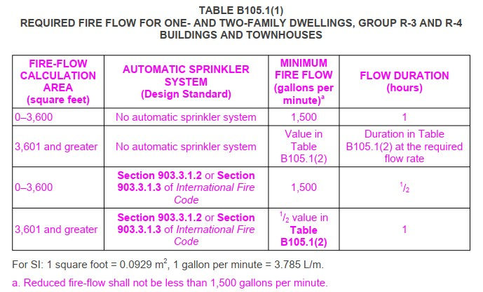

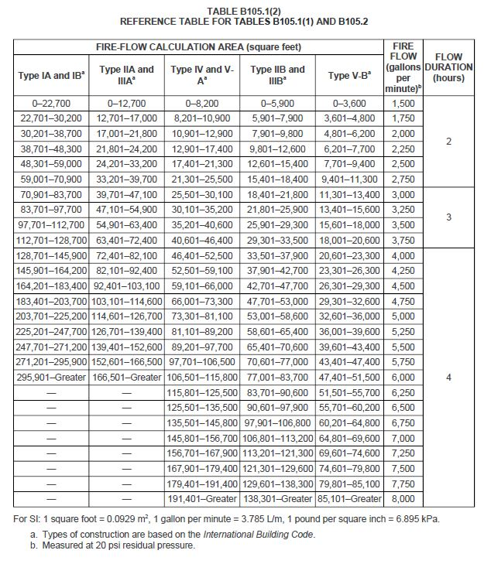

B105.4 Simultaneous flows. Any hydrant must produce a minimum flow of 1,500 gallons per minute at 20 psi of residual pressure when flowing individually, or a minimum of 750 gallons per minute at 20 psi residual pressure when flowing simultaneously to be considered by Table C102.1 or by Table C102.1’s footnotes as one of the minimum hydrants required to protect any structure, hazard, or potential hazard.

APPENDIX C FIRE HYDRANT LOCATIONS AND DISTRIBUTION
User note:
About this appendix: Appendix C focuses on the location and spacing of fire hydrants, which is important to the success of fire-fighting operations. The difficulty with determining the spacing of fire hydrants is that every situation is unique and has unique challenges. Finding one methodology for determining hydrant spacing is difficult. This particular appendix gives one methodology based on the required fire flow that fire departments can work with to set a policy for hydrant distribution around new buildings and facilities in conjunction with Section 507.5.

C101.1 Scope. In addition to the requirements of Section 507.5.1, fire hydrants shall be provided in accordance with this appendix for the protection of buildings, or portions of buildings, hereafter constructed or moved into the jurisdiction.

C102.1 Minimum number of fire hydrants for a building. The number of fire hydrants available to a building shall be not less than the minimum specified in Table C102.1.

C103.1 Hydrant spacing. Fire apparatus access roads and public streets providing required access to buildings in accordance with Section 503 shall be provided with one or more fire hydrants, as determined by Section C102.1. Where more than one fire hydrant is required, the distance between required fire hydrants shall be in accordance with Sections C103.2 and C103.3.

C103.2 Average spacing. The average spacing between fire hydrants shall be in accordance with Table C102.1.
Exception: The average spacing shall be permitted to be increased by 10 percent where existing fire hydrants provide all or a portion of the required number of fire hydrants.

Section C106.1 Public hydrants. Add a new Section C106.1 to read as follows:
C106.1 Public hydrants. All barrels are to be chrome yellow except in cases where another color has already been adopted by the water district.

Section C106.2 Tops and nozzle caps. Add a new Section C106.2 to read as follows:
C106.2 Tops and nozzle caps. The tops and nozzle caps should be painted with the capacity-indicating color scheme shown in Table C106.2 (1) to provide simplicity and consistency with colors used in signal work for safety, danger, and intermediate condition.

Table C106.2 (1). Add a new Table C106.2 to read as follows:

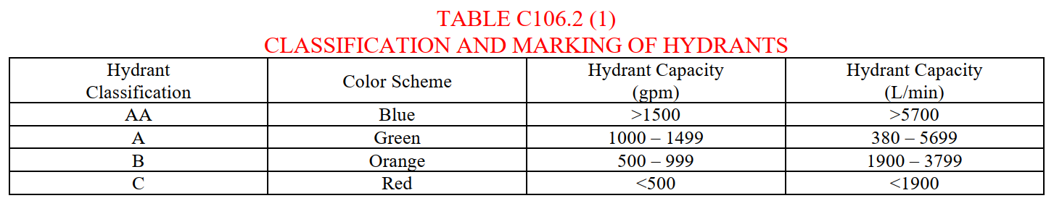

Section C106.3 Hydrants less than 20 psi. Add a new Section C106.3 to read as follows:
C106.3 Hydrants less than 20 psi. Hydrants rated at less than 20 psi (1.4 bar) should have the rated pressure stenciled in black on the hydrant top.

Section C106.7 Recommended paint. Add Section C106.7 to read as follows:
C106.7 Recommended paint. Rust-Oleum, High Performance 7400 System DTM Alkyd Enamel (450) meets USDA requirements for incidental food contact; accepted for use in federally registered food facilities; <450 VOCs. High-gloss finish; one-cost coverage; dries tack free in 2-4 hours. Resists chipping, fading, and weathering. Protects against mild chemicals; ideal for moderate to slightly severe industrial environments. Two-year rust-proof guarantee by Rust-Oleum, maximum corrosion protection. Color codes are as follows:
1. Yellow; 944402 (safety yellow)
2. Red; 964402 (safety red)
3. Blue; 925402 (safety blue)
4. Green; 933402 (safety green)
5. Orange; 956402 (safety orange)
6. Black; 634402 (high glass black)

APPENDIX D FIRE APPARATUS ACCESS ROADS
User note:
About this appendix: Appendix D contains more detailed elements for use with the basic access requirements found in Section 503, which gives some minimum criteria, such as a maximum length of 150 feet and a minimum width of 20 feet, but in many cases does not state specific criteria. This appendix, like Appendices B and C, is a tool for jurisdictions looking for guidance in establishing access requirements and includes criteria for multiple-family residential developments, large one and two-family subdivisions, specific examples for various types of turnarounds for fire department apparatus and parking regulatory signage.

D101.1 Scope. Fire apparatus access roads shall be in accordance with this appendix and all other applicable requirements of the International Fire Code.

Section D102.1 Access and loading. Amend Section D102.1 to read as follows:
D102.1 Access and loading. Facilities, buildings, or portions of buildings hereafter constructed shall be accessible to fire department apparatus by way of an approved fire apparatus access road with asphalt, concrete, or other approved driving surface capable of supporting the imposed load of fire apparatus weighing up to 75,000 pounds with a minimum single axle weight of 27,000 pounds. Alternative methods such as brick pavers, road, base, and gravel as approved by the fire code official.

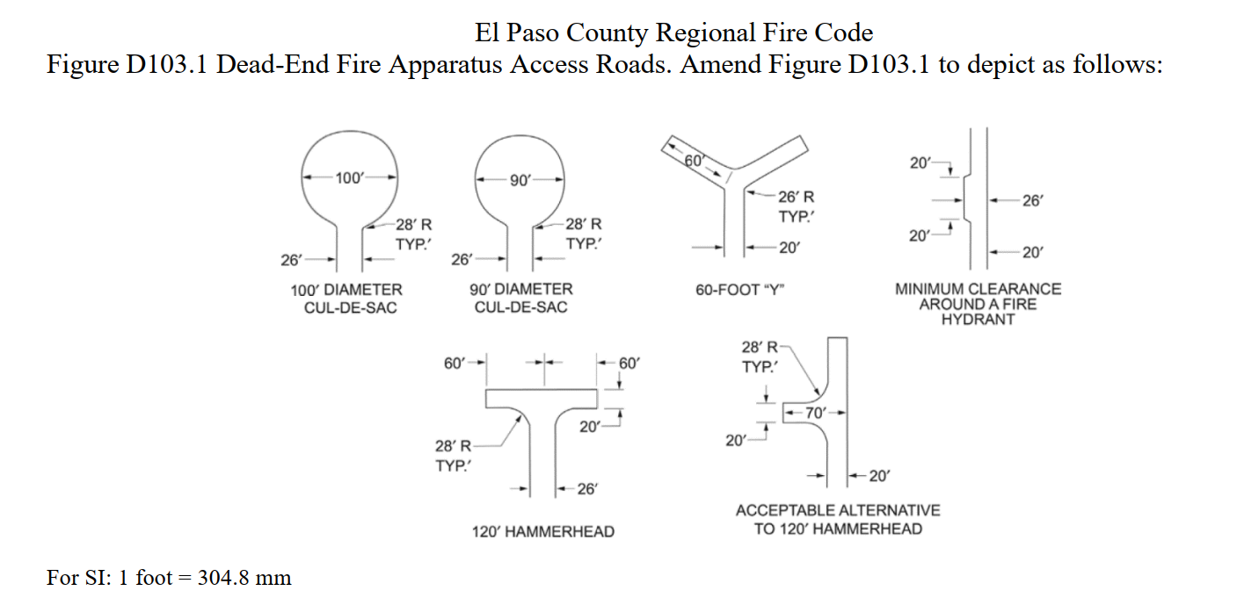

D103.3 Turning radius. The minimum turning radius shall be determined by the fire code official.

D103.4 Dead Ends. Dead-end fire apparatus access roads in excess of 150 feet (45 720 mm) shall be provided with width and turnaround provisions in accordance with Table D103.4.

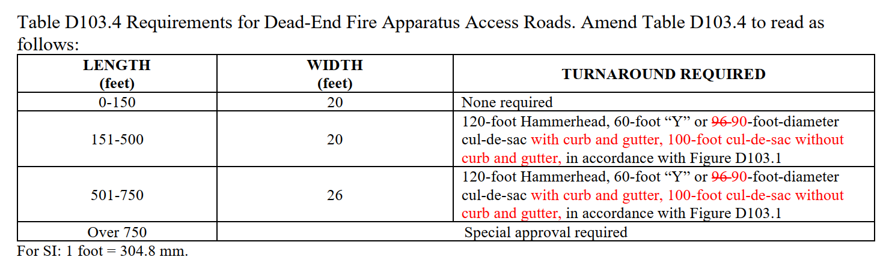

D103.6 Signs. Where required by the fire code official, fire apparatus access roads shall be marked with permanent NO PARKING—FIRE LANE signs approved by the fire code official and comply with the most current Manual on Uniform Traffic Control Devices (MUTCD) for Streets and Highways. Signs shall have a minimum dimension of 12 inches wide by 18 inches high and have red letters on a white reflective background. Signs shall be posted on one or both sides of the fire apparatus road as required by Section D103.6.1, D103.6.2, or D103.6.3, and indicate the extent of the no parking zone.

D103.6.1 Roads less than 28 feet in width. Fire lane signs as specified in Section D103.6 shall be posted on both sides of fire apparatus access road(s).

D103.6.2 Roads 28 feet to less than 34 feet in width. Fire lane signs as specified in Section D103.6 shall be posted on one side of fire apparatus access road(s).

D103.6.3 Roads 34 feet and greater. Fire lane signs are not required on either side of fire apparatus access road(s).

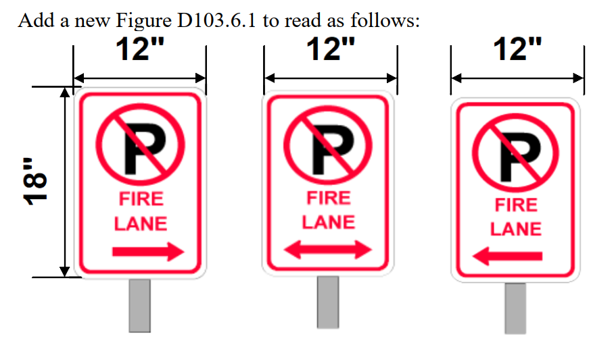

D105.1 Where required. Where the vertical distance between the grade plane and the highest roof surface exceeds 30 feet (9144 mm), approved aerial fire apparatus access roads shall be provided. For purposes of this section, the highest roof surface shall be determined by measurement to the eave of a pitched roof, the intersection of the roof to the exterior wall, or the top of parapet walls, whichever is greater.
Exception: Where approved by the fire code official, buildings of Type IA, Type IB or Type IIA construction equipped throughout with an automatic sprinkler system in accordance with Section 903.3.1.1 and having fire fighter access through an enclosed stairway with a Class I standpipe from the lowest level of fire department vehicle access to all roof surfaces.

D105.2 Width. Aerial fire apparatus access roads shall have a minimum unobstructed width of 26 feet (7925 mm), exclusive of shoulders, in the immediate vicinity of the building or portion thereof.

D105.3 Proximity to building. One or more of the required access routes meeting this condition shall be located not less than 15 feet (4572 mm) and not greater than 30 feet (9144 mm) from the building and shall be positioned parallel to one entire side of the building. The side of the building on which the aerial fire apparatus access road is positioned shall be approved by the fire code official.
D105.4 Obstructions. Overhead utility and power lines shall not be located over the aerial fire apparatus access road or between the aerial fire apparatus road and the building. Other obstructions shall be permitted to be placed with the approval of the fire code
official.

Section D107.1 One- or two-family dwelling residential developments. Amend D107.1 to read as follows:
D107.1 One- or two-family dwelling residential developments. Developments of one- or two-family dwellings where the number of dwelling units exceeds 30 shall be provided with two separate and approved fire apparatus access roads.
Exceptions:
1. Where there are more than 30 dwelling units on accessed from a single public or private fire apparatus access road and all dwelling units are equipped throughout with an approved automatic. sprinkler system in accordance with Section 903.3.1.1, 903.3.1.2 or 903.3.1.3, access from two directions shall not be required.
2. The number of dwelling units on accessed from a single fire apparatus access road shall not be increased unless fire apparatus access roads will connect with future development, as determined by the fire code official.
3. The fire code official is authorized to modify the requirement of two separate and approved fire apparatus access roads, when they are not possible due to location on property, topography, waterways, non-negotiable grades, or similar.

Section D107.2. Amend Section D107.2 to read as follows:
D107.2 Remoteness. Where two fire apparatus access roads are required, they shall be placed a distance apart equal to not less than one-half of the length of the maximum overall diagonal dimension of the property or area to be served, measured in a straight line between accesses.
Exception: The fire code official is authorized to modify this requirement when the required remoteness is not possible due to the location on property, topography, waterways, non-negotiable grades or similar.

The following are ATTENTION ITEMS that apply to this review.

Section 1402.1 Temporary Fire Access Road. Temporary access roads shall be an all-weather surface comprised of either the first lift of asphalt or concrete/compacted gravel to a thickness capable of supporting the imposed loads of fire department apparatus. A 20-foot minimum width shall be maintained unless the permanent road is designed less than 20 feet, in which case the temporary road shall be the intended width of the permanent road. Adequate street signs and fire lane signs shall be installed where applicable. Temporary access roads must be maintained in accordance with this section. Temporary roads serving as fire lanes shall not be in place more than 6 months without special approval from the fire department.”

TIMING OF INSTALLATION: Fire department access roads shall be made serviceable prior to and during the time of construction except when approved alternative methods of protection are provided.

ACCESS FOR FIREFIGHTING: Approved vehicle access for firefighting shall be provided to all construction/demolition sites. Vehicle access shall be provided by either temporary or permanent roads capable of supporting vehicle loading under all weather conditions. Vehicle access shall be maintained until permanent fire apparatus access roads are available.

Attention Contractor/Applicant:

YOU ARE RESPONSIBLE TO COMPLETE THE FOLLOWING ITEMS.

Please complete the following items:

- Permits – Ensure all applicable permits are obtained from the Pikes Peak Regional Building Department (PPRBD).
- Follow the Colorado State Forest Service for all mitigation guidelines; csfs.colostate.edu
- Review of the comment letter from Falcon Fire Protection District. You are responsible for complying with the entire fire code as amended and any applicable NFPA’s referenced.
- Ensure all Action Items have been addressed.
- Plan review comments (this letter) shall be on site and available to the fire inspector.

Please let me know if there are any questions and/or concerns. You may contact me via email at the top of the letter.

Sincerely, Sincerely,

Curtis L. Kauffman

Curtis L. Kauffman Roland Peterson
Fire Prevention Division
Lieutenant/Fire Marshal

