Early Assistance (EA) Meeting Number: EA2555 (EDARP Link)
Project Name: Office & RV Storage Development
Project Location: 2713 Akers Dr Colorado Springs, CO 80922
Project Parcel No.: 5332414004 (Assessor’s Link) (LOT 2 SEDER SUB)
Project Description: The proposed RV Storage Facility at 2713 Akers Dr, Colorado Springs, CO will provide secure, uncovered storage for recreational vehicles (RVs) and trailers. The facility will also include an office for on-site management and parking for 3 cars. This facility will offer a long-term storage solution for RVs and large vehicles, an on-site office for customer service, and convenient parking for customers, meeting the growing demand in the area.
EA Meeting Date: 05/15/2025 at 3:00 P.M.
Planning and Community Development: Miranda Benson (mirandabenson2@elpasoco.com)

El Paso County Planning & Community Development Planning Checklist

Request -
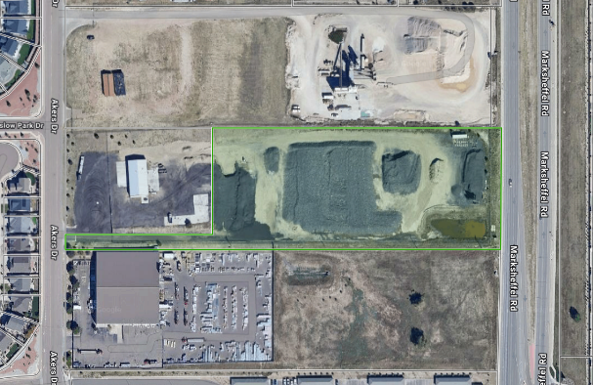
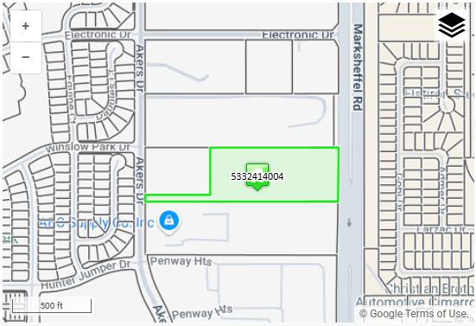
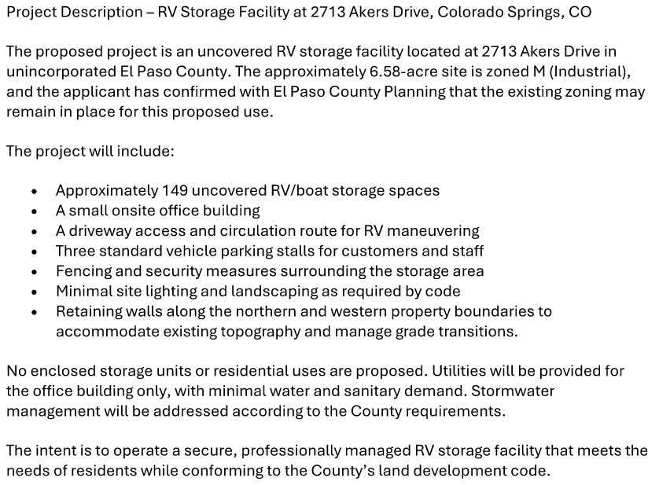
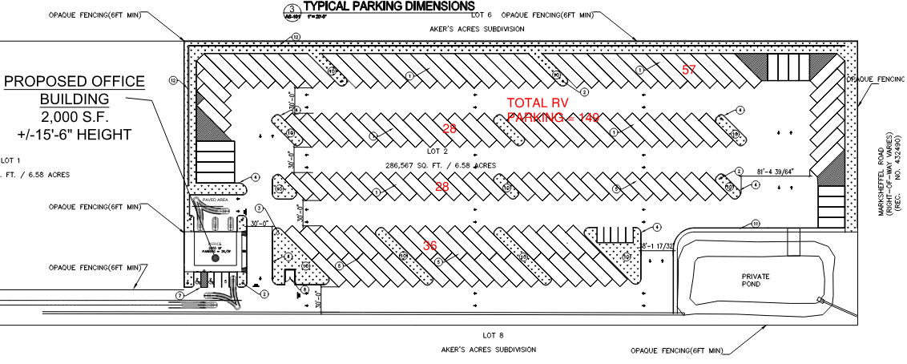

Existing Zoning
District |  | Name
M |  | Industrial (obsolete)
CAD-O (ANAV) |  | Commercial Airport Overlay District

Zoning Analysis
4.1.3. Overlay Zoning Districts - As the name implies, overlay districts work in combination with base zoning districts to impose additional requirements and standards on specific property or to modify the standards associated with the base zoning district. These additional standards only apply within the limits of the overlay district. Overlay zoning districts are established and amended in accordance with the rezoning procedures applicable to any other zoning district, except as otherwise provided within this Code.

4.3.1. CAD-O, Commercial Airport Overlay District (Link to LDC 4.3.1)
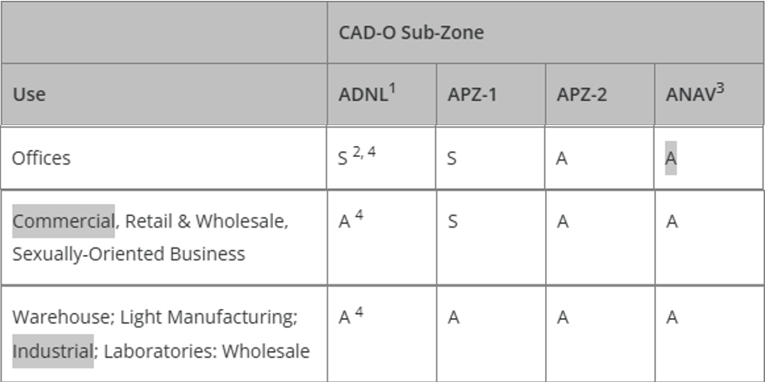
³ Airport Activity Notice and Disclosure or equivalent required, if not already recorded, in order to secure a building permit or development permit.

4.1.4. Obsolete Zoning Districts - The C-1, C-2, M, and R-4 zoning districts have been declared to be obsolete pursuant to BoCC Resolution No. 91-59, Land Use 10 as replaced by Resolution 92-46, Land Use-9. No land will be rezoned to an Obsolete Zoning district. The BoCC may modify the allowed uses, special uses, and development standards within these zoning districts.
Landowners are encouraged to rezone land from an Obsolete Zoning district classification. The BoCC may offer incentives, such as modified application fees in order to accomplish this goal.
4.4.3. M, Industrial (Obsolete)
(A) Purpose. This district is established for the purpose of providing for general industrial and manufacturing activities.
(B) Allowed, Special, Accessory, and Temporary Uses. The allowed, special, accessory, and temporary uses in the M district are shown in the Use Table in Chapter 5.
(C) Use and Dimensional Standards. All uses and development in the M district are subject to the use and dimensional standards in Chapter 5.
(D) General Development Standards. All uses and development in the M district are subject to the general development standards in Chapter 6.
(E) Development Standards for Junkyards and Related Uses. All salvage yards, automobile recycling centers, scrap and waste recycling facilities, junk yards or other similarly classified uses shall comply with the standards of Chapter 6.
(F) Maintenance Plan. A maintenance plan conforming to the requirements of Chapter 6 shall be approved by the PCD Director prior to the issuance of any building permit.
(G) Site Development Plan. Site Development Plan approval is required for all development prior to authorization of a building permit.
(H) Platting. No building permits shall be granted on any portion of property which is currently zoned M until the property is platted in accordance with this Code, unless otherwise exempted by State Statute.
If a property, at the time of its creation, was established in accordance with all applicable subdivision regulations, platting of the property is not required for issuance of a building permit. It shall be the responsibility of the person seeking a building permit to submit the necessary documentation to the PCD to substantiate the legal creation of the property.
(I) Discontinuance of Zoning or Rezoning. No land shall be zoned or rezoned to M on or subsequent to May 1, 1991. All land zoned M on or before May 1, 1991, shall remain zoned M and shall be subject to all the provisions of the M district until such time as the land is either rezoned or annexed.

Automobile and Boat Storage Yard — A lot, parcel, or structure used for temporary storage of operable automobiles, trucks under 5 tons rated capacity, campers, recreational vehicles, trailers, or boats, not owned by the property owner, where typically the storage occurs when they are not in use and for a fee. The term shall not include scrap metal processing yards, vehicle dismantling yards, or salvage yards.

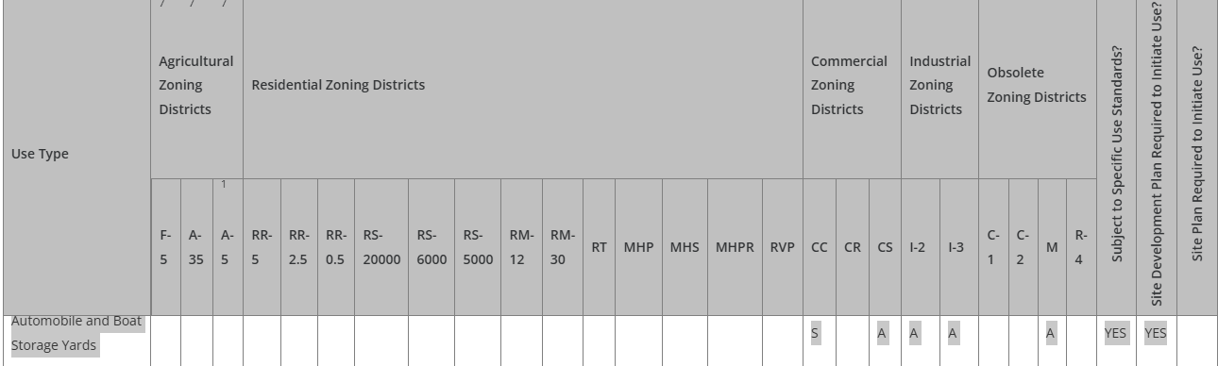
(LDC Table 5-1, Principal Uses Link)

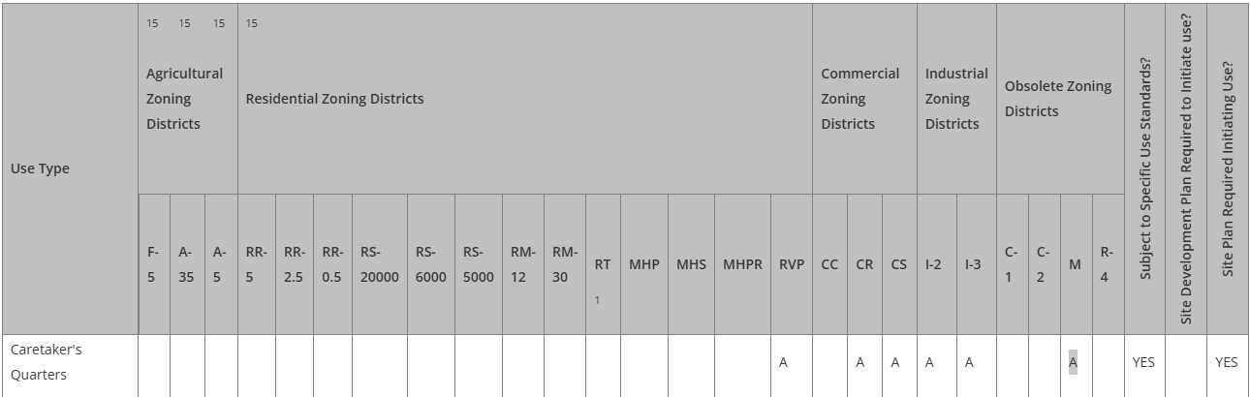

(LDC Table 5-2, Accessory Uses Link)

5.2.9. Automobile and Boat Storage Yards - Automobile and boat storage yards shall comply with the outdoor storage standards of this Chapter.

5.2.40. Outside Storage
(A) Applicability. All outside storage is subject to the requirements of this Section.
(B) Outside Storage Standards. Outside storage shall meet the following standards.
- Materials to be Stored and Principal Use Required. Outside storage may include vehicles, raw materials, supplies, finished or semi-finished products or equipment used in conjunction with, and specifically accessory to, an allowed principal use conducted on the premises unless listed as a principal use. Outside storage of inoperable vehicles or equipment in a location other than the salvage yard is only permitted to the extent allowed in the Parking, Storage and Repair of Vehicles and Machines, Personal Section of Chapter 5 of this Code, provided the standards of that section are met. Employee or customer parking or outdoor sales and display areas shall not be considered outside storage.
- Materials Screened by Solid Fence or Vegetation. Outside storage shall be enclosed and concealed by a solid fence or wall at least 6 feet in height or any combination of berming, shrubs, trees fencing or walls which will provide at maturity a minimum of 6 feet of height and 100% opaque screening for the area utilized for outside storage.
- Outside Storage Not to Exceed Height of Screening. Outside storage or stacked materials shall not exceed the height of the screening fence except for operable vehicles, trailers, or other equipment designed to be towed or lifted as a single component.
- Storage of Equipment and Vehicles Exceeding Height of Fence. All equipment and vehicles exceeding the height of the fence shall be stored on the rear ⅓ of the property except when adjacent to a residential zoning district, in which case the equipment or vehicles shall be a minimum 50 feet from the residential zoning district boundary.
- Storage Adjacent to Road. Outside storage is allowed within the required setback area from a road provided that the storage area does not occupy more than 50% of the lineal frontage at the right-of-way.
- No Storage in Required Landscape Area. Outside storage shall not be allowed within any required landscaped area.
- Screening Fence Waived Between Adjacent Storage Areas. When outside storage areas abut each other and are not visible from public areas, administrative relief may be sought from the requirement for a solid fence between the outdoor storage areas.
- Salvage Yards and Solid Waste Landfills. Salvage yards and solid waste landfills are not regarded as outside storage, but salvage yards are required to meet the screening standards of this Section.
- Temporary Storage. Administrative relief from the outside storage standards may be sought in association with approved temporary uses.
- Landscaping Requirements to be Met. Outside storage shall comply with the landscaping requirements in this Chapter.
(C) Relationship to Site Development Plan. Outside storage areas shall be so identified on the site development plan prior to the establishment of the outside storage use.

5.2.14. Caretaker's Quarters
(A) Number of Caretaker's Quarters. One caretaker's quarters is allowed per ownership.
(B) Type of Structure. A caretaker's quarters may be a detached single-family dwelling, manufactured home, apartment-type unit within the principal structure, or where a post-1976 mobile home is allowed as a principal use in the zoning district, a post-1976 mobile home, or as a tiny house meeting the use specific standards found in Chapter 5 may be used as a caretaker's quarters.
(C) Occupancy Limited. A caretaker's quarters may be occupied only by a caretaker and their immediate family.
(D) Other Applicable Standards. A caretaker's quarters shall meet all standards for a principal dwelling unit of the same type and the accessory dwelling standards in this Chapter unless specifically modified by this Section.

Zoning District Requirements (density, lot size, lot design standards, building setbacks)
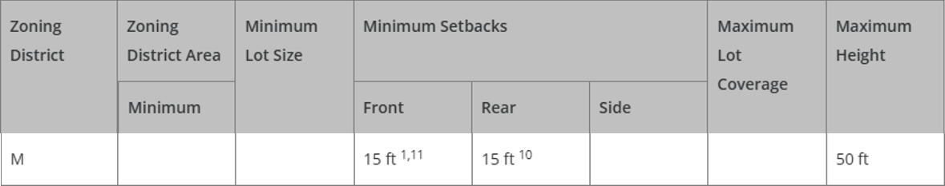
¹ Gasoline pumps and canopies shall be at least 15 feet from the front property line or public right-of-way, except where the landscaping regulations require a greater setback.
¹⁰ The setback for stables and corrals is 50 feet.
¹¹ If the building is established as or converted to condominium units in accordance with Chapter 7 of this Code, the building and lot shall meet the minimum lot area and setbacks, but the individual units are not required to meet the minimum lot area, maximum lot coverage, or setback requirements.
(LDC Table 5-4, Density and Dimensional Standards Link)

5.4.3. Measurements and Exceptions
(D) Setback Measurement
(6) Flag Lot Setbacks. The required front, side and rear yard setbacks shall be established by determining the front, side and rear lot lines based on the following criteria.
(a) Front Lot Line. The property line most parallel and nearest to the road from which access from the road is gained is the front lot line.
(b) Rear Lot Line. The property line that is most opposite or parallel to the front lot line is the rear lot line.
(c) Side Lot Line. Property lines that are not considered front or rear property lines are side lot lines.

Zoning Map – 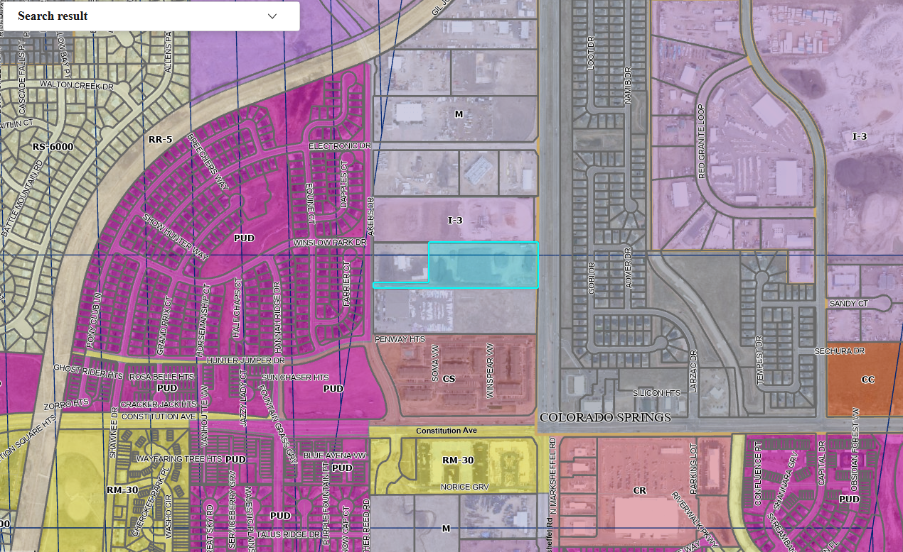

Map of Platted Lot/ Tract (check plat notes & conditions of approval):

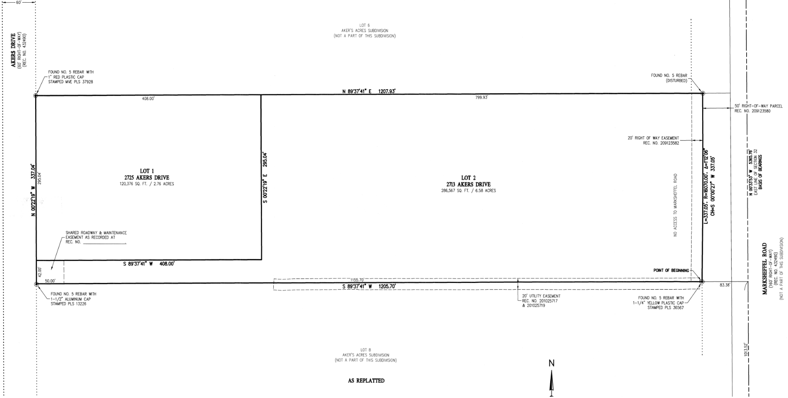
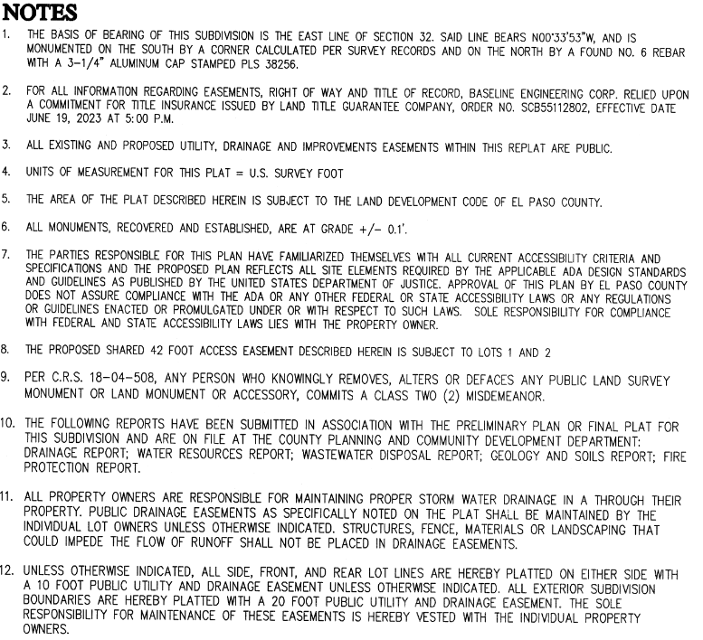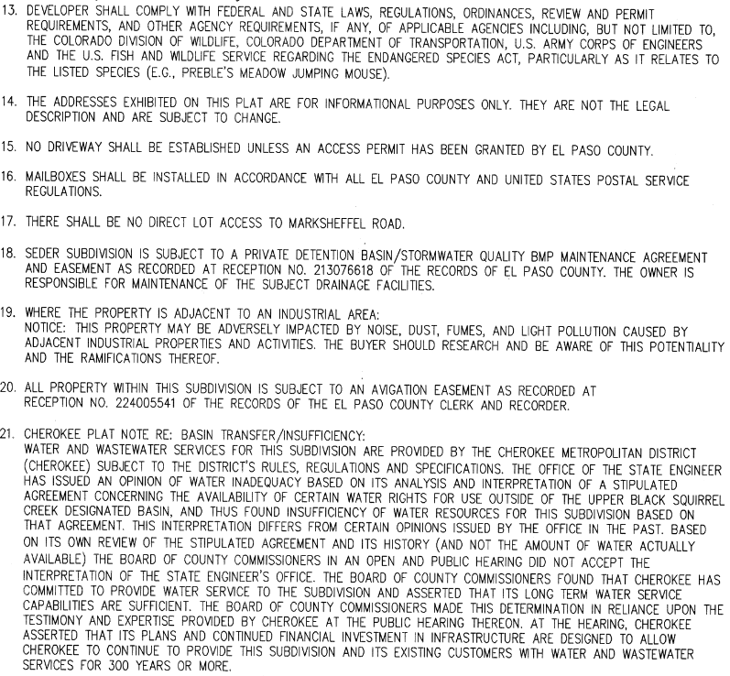
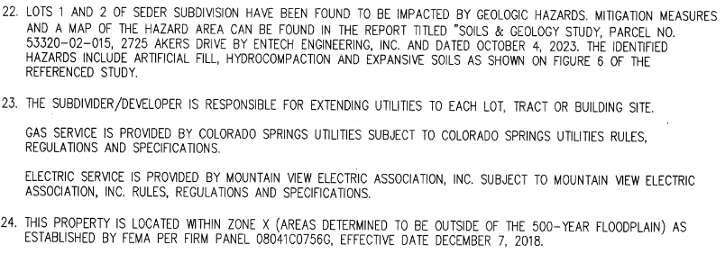
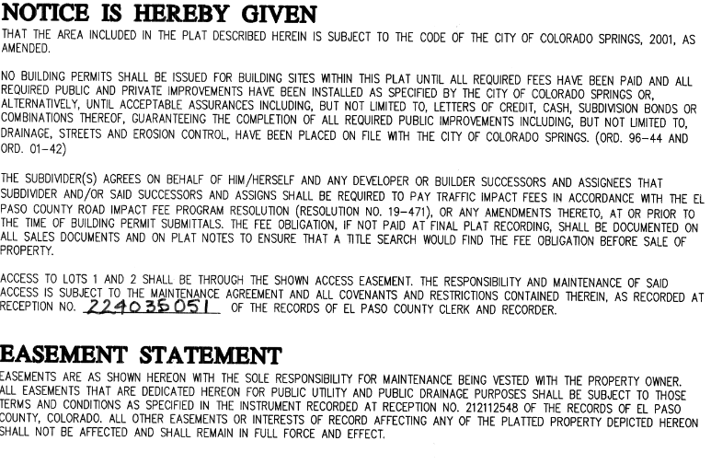
Application Type(s) Hearing: Required/ Optional/ NO
Site Development Plan (PPR-)

Processing Issues and Options
-- No major issues were identified for Land Development Code requirements (Planning Department).
-- Communicate with the City of Colorado Springs regarding City Code compliance & fees.
-- Reduce visual impacts to adjacent residential (east): landscaping, berms, fencing/walls, etc. (existing and proposed) to mitigate impacts.

Relevant Past History:
RECENT:
Plat No. 15321 – VR2319 Seder Subdivision – “Recorded Plat - 224715321”
– EA for this Vacation and Replat is found under EDARP File No. EA2355.
PAST:
EDARP File No. PPR1312
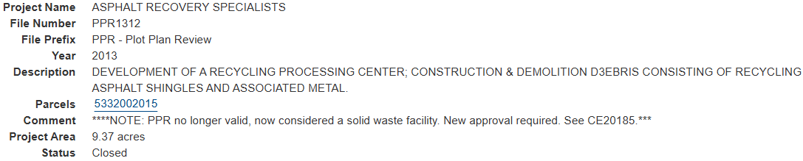
Design and Landscaping. A Site Development Plan identifying compliance with all aspects of Chapter 6 of the Land Development Code will be required.

Show the site design/layout (lot pattern, circulation/road design, open space, preservation of natural features, compatibility internally and with adjacent land uses).

(Chapter 6 Link)
6.1.3. Americans with Disabilities Act (ADA) Site Accessibility
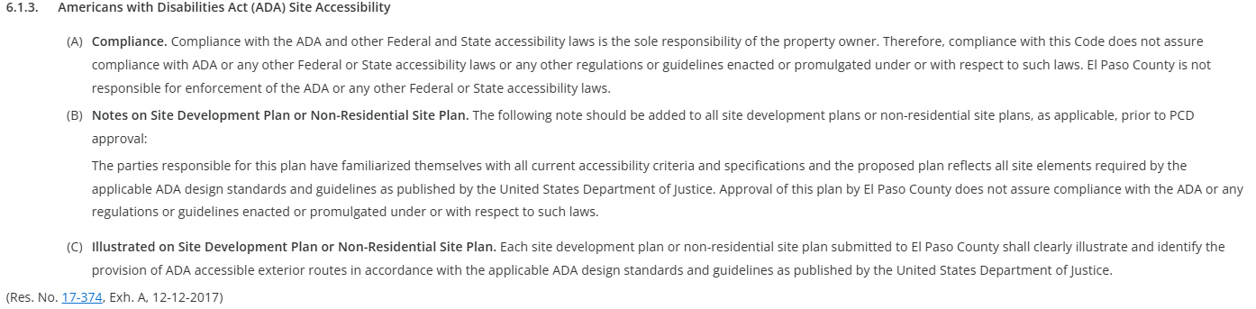

Fencing: (if proposed, follow these development standards)

(Chapter 6 Link) 6.2.1. Fences, Walls, and Hedges
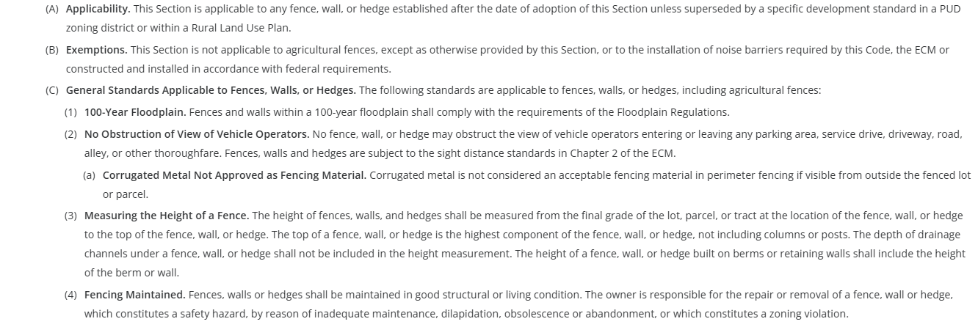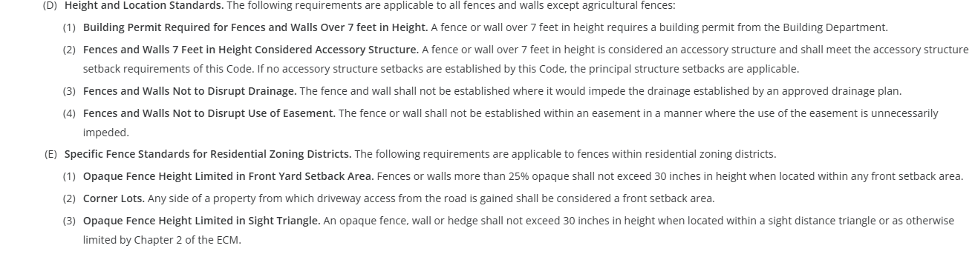

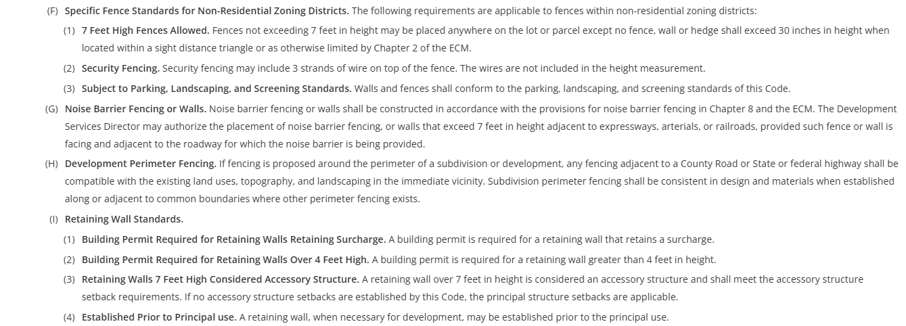

Landscaping: (required)

Check one:
☐ | Expressway, Principal Arterial - required depth 25’ - Trees required: 1 per 20’
☐ | Urban Interchange/Intersection - required depth 25’- Trees required: 1 per 20’
☒ | Minor arterial (EAST) - required depth 20’ - Trees required: 1 per 25’
☐ | Non-arterial (WEST) - required depth 10’ 15’ - Trees required: 1 per 30’ 15’ and min 50% evergreen. (Table 6-1 and footnote)
Also required:
☒ | Parking lot landscaping required (trees, landscape islands, screening)
☐ | Buffer between non-residential and residential districts separated by a non-arterial road or public alley
☒ | Zone Boundary Buffer  - 15’ when adjacent to residential zones (this may overlap within roadway landscaping along east)  - clustering is ok, utilizing existing vegetation towards count is ok – identify any of these in your Site Dev Plan & LOI

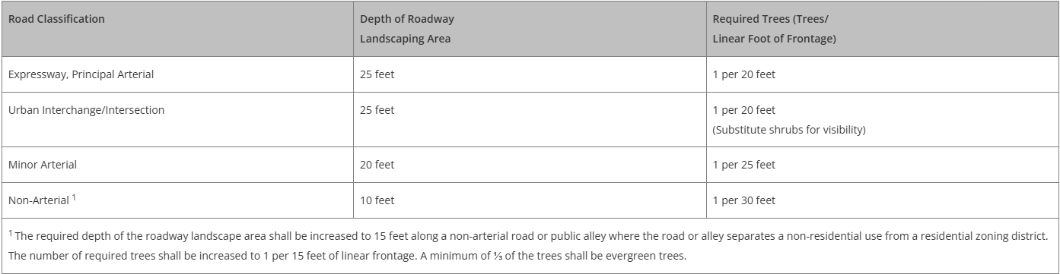

(Table 6-1)

(Chapter 6 Link) 6.2.2. Landscape Requirements
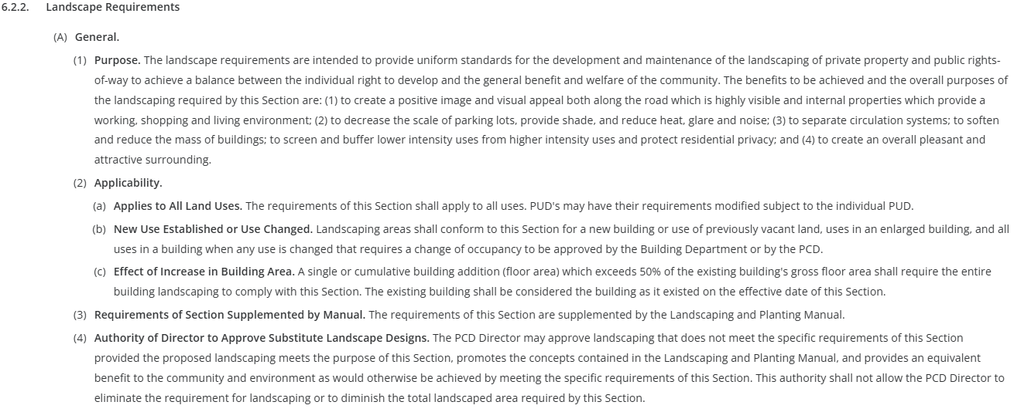
(B) Roadway Landscaping Requirements
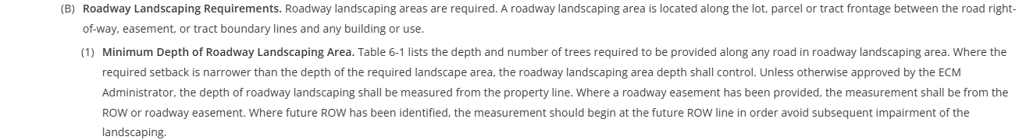
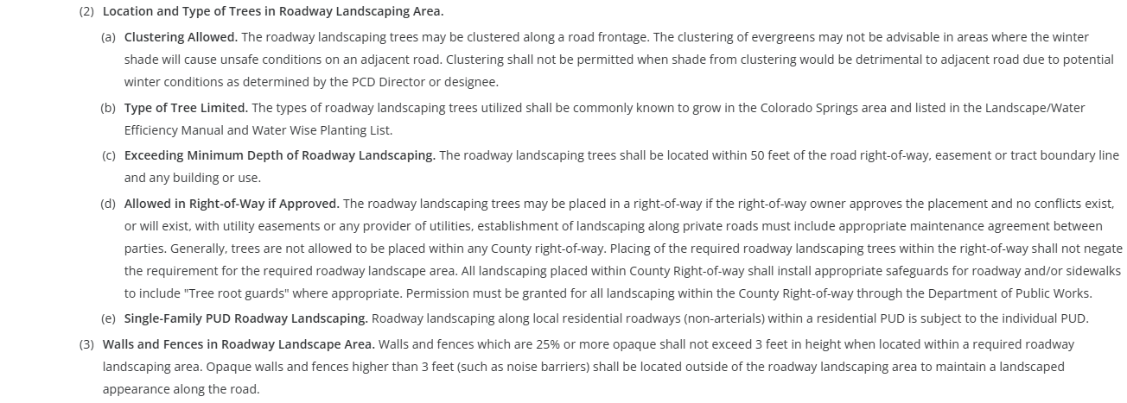
(C) Parking Lot Landscape Requirements
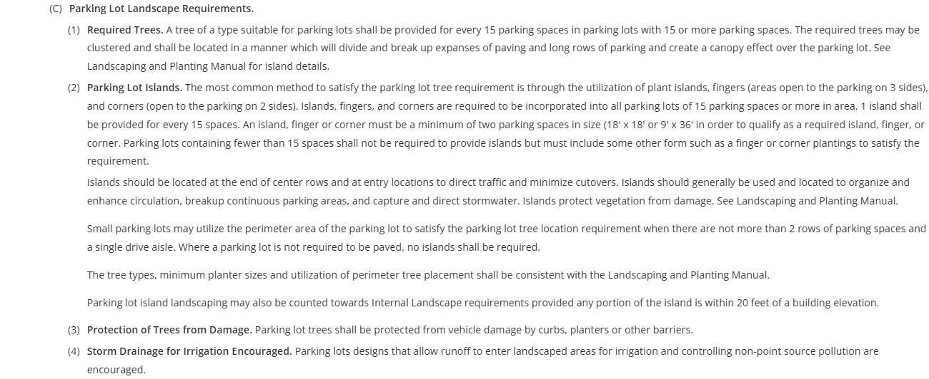
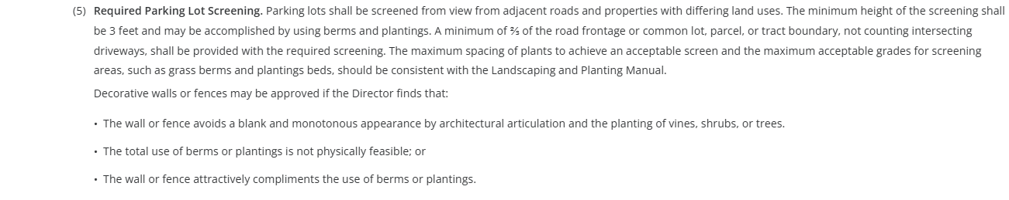

(D) Required Buffer and Screen Areas
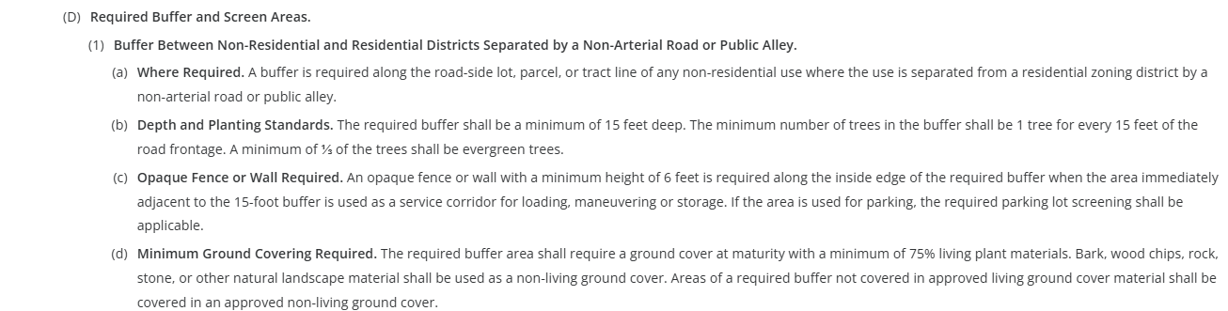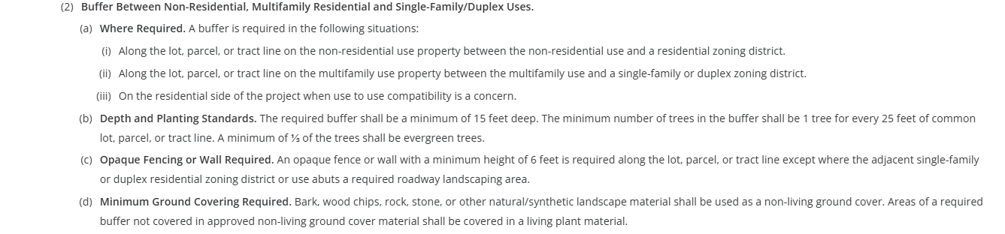
(E) Internal Landscaping required
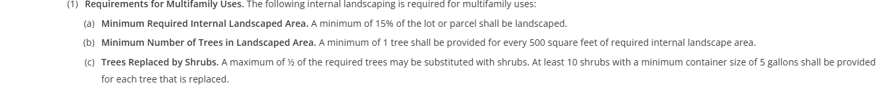
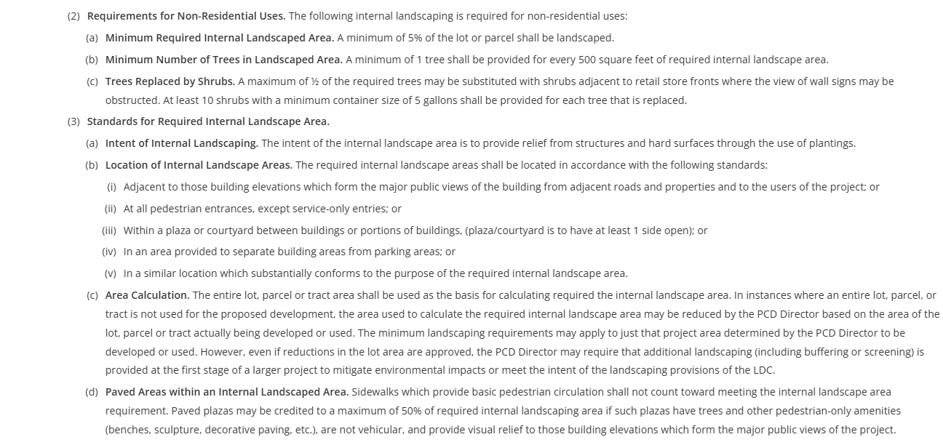
(F) Minimum Plant Sizes and Percentage of Live Ground Cover
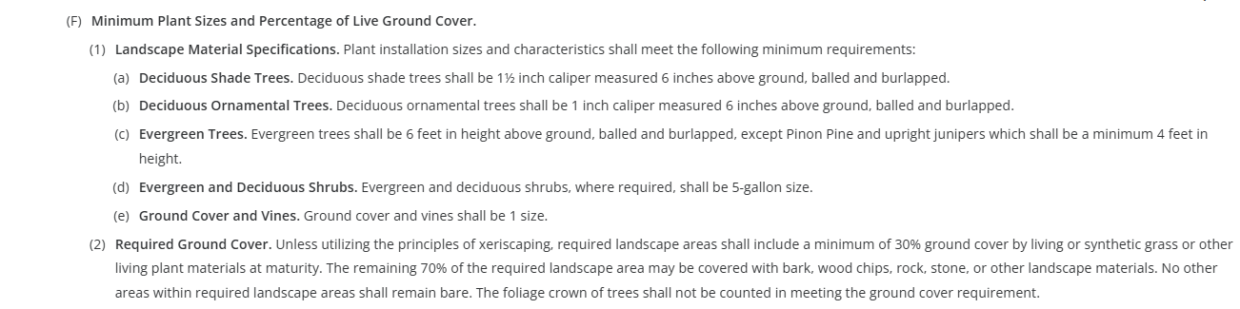
(G) Other Required Landscape Areas
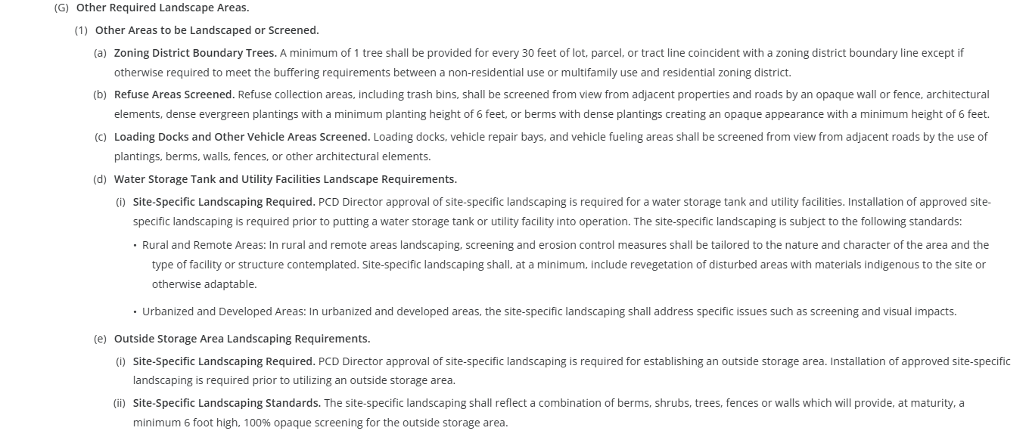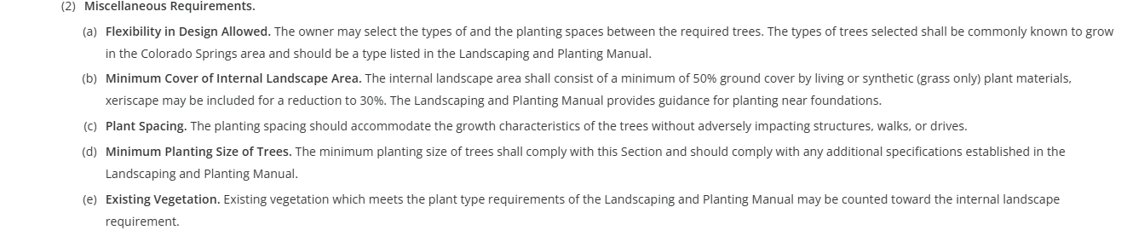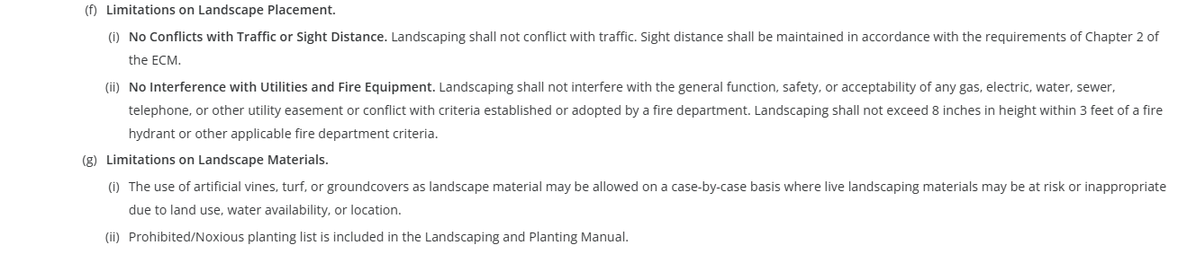
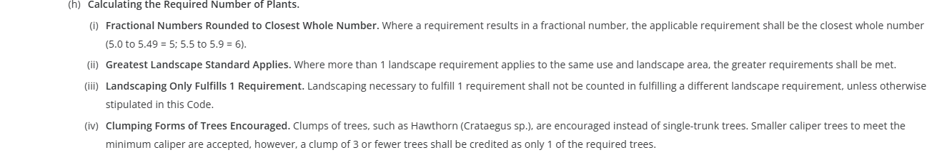
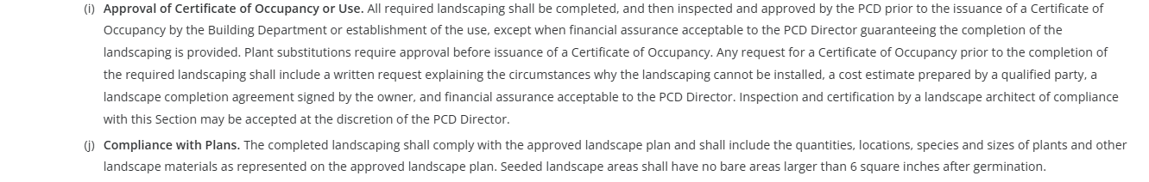
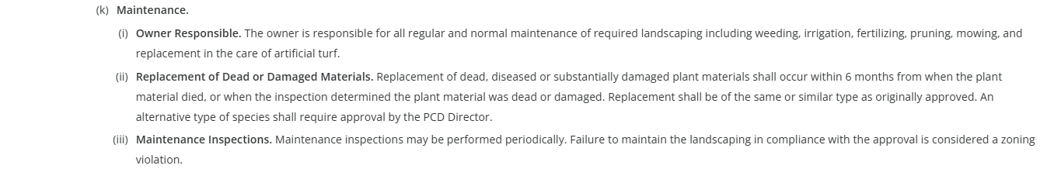
Appendix D (Link) – Landscaping and Planting Manual
Parking: (required)

(Chapter 6 Link) 6.2.5 Parking, Loading, and Maneuvering Standards

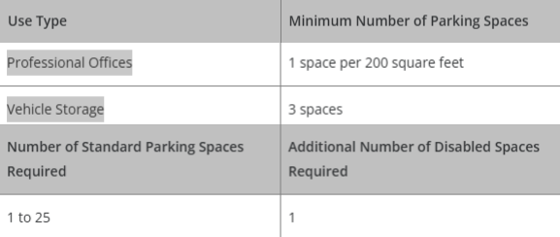(Table 6-2)

There is no minimum requirement for RV parking spaces for the business. The minimum parking standards only apply to the structure and the use.

The minimum parking requirement for a 2,000 sq ft office and vehicle storage (RV/boat storage) use would total 13 standard spaces. Using this number, an additional 1 ADA space will be required. This use is not considered “Commercial Center”. TOTAL REQUIRED = 14 spaces. If an additional ~150 spaces are proposed for the business, that would not be considered as part of a parking requirement calculation. You will, however, need to meet parking lot development standards of the Code (below). There is no need for administrative relief to reduce the number of required parking spaces.

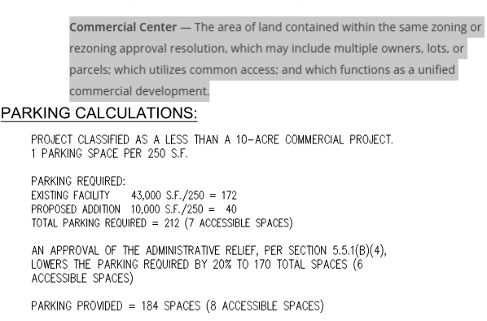
(A) General.
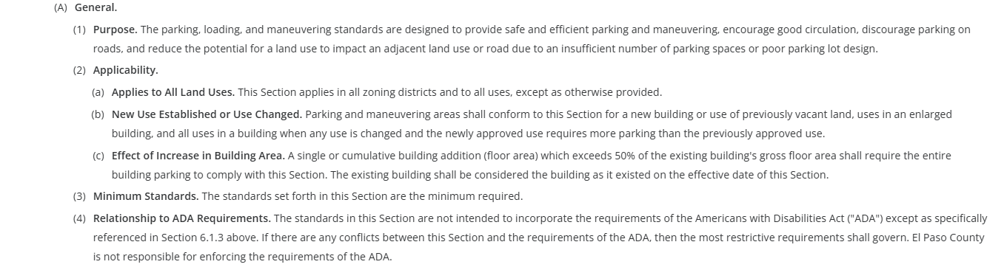

(B) General Parking Standards.
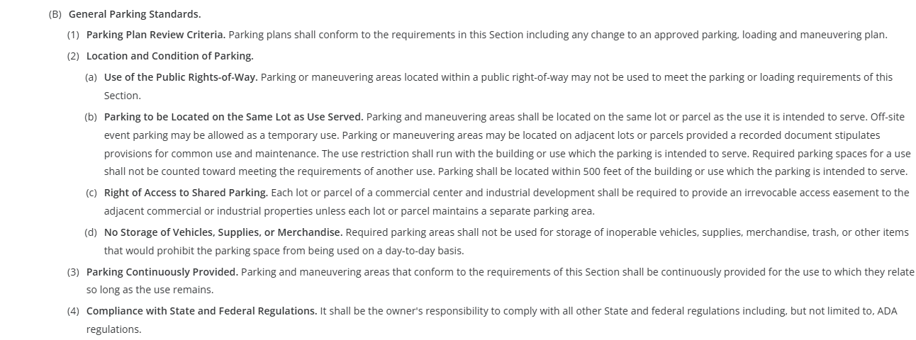
(C) Parking Design Standards.
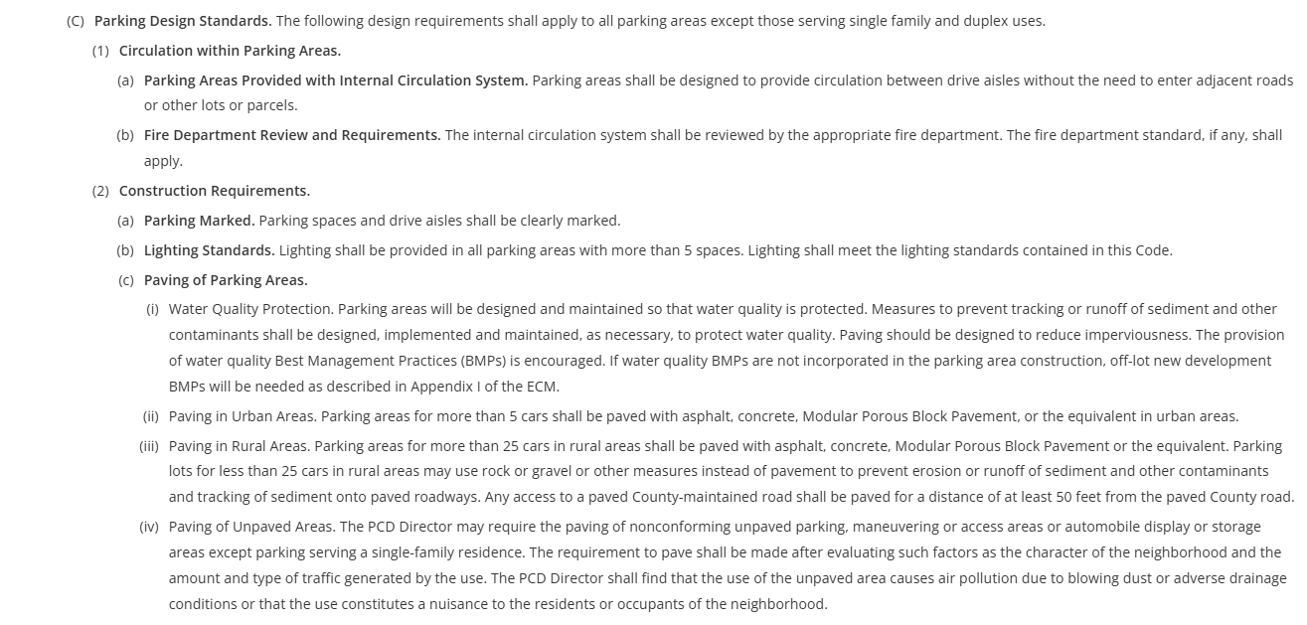
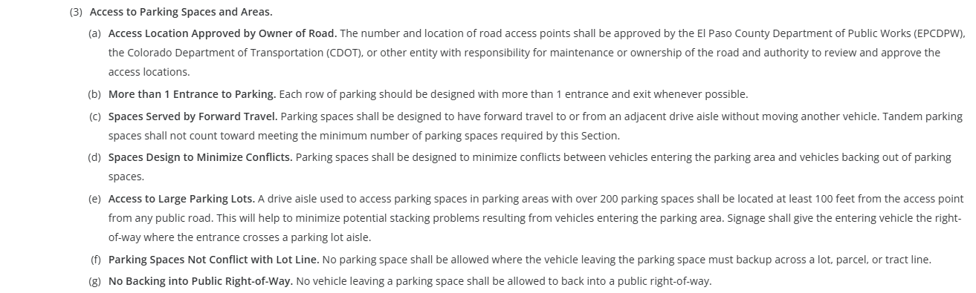
(D) Parking Space Requirements (Table 6-2 above)
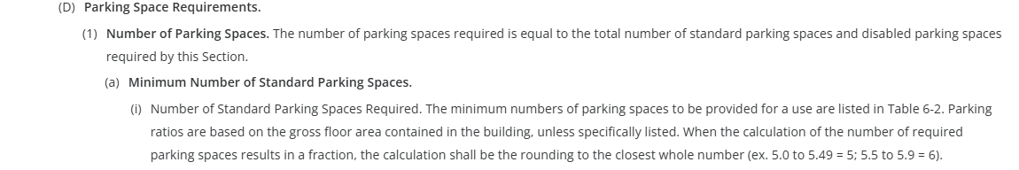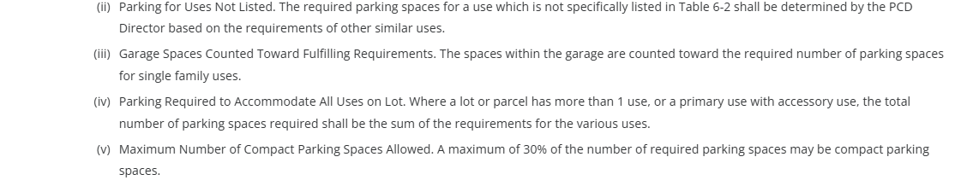
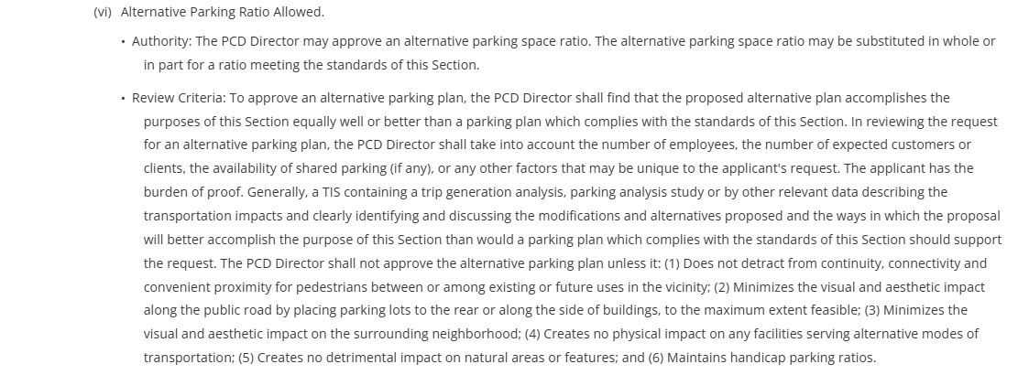

Refer to Table 6-4 for Parking Space Dimensional Requirements
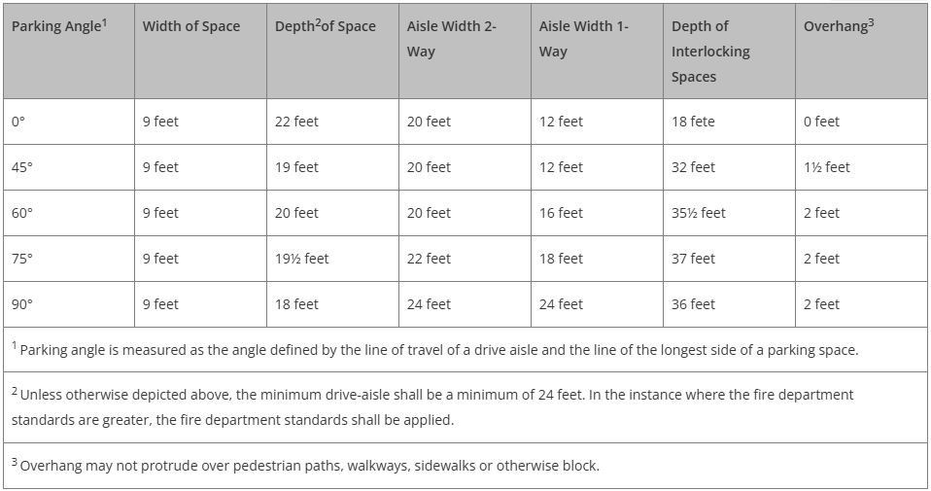
Refer to Table 6-5 for Dimensional Requirements for Compact Spaces
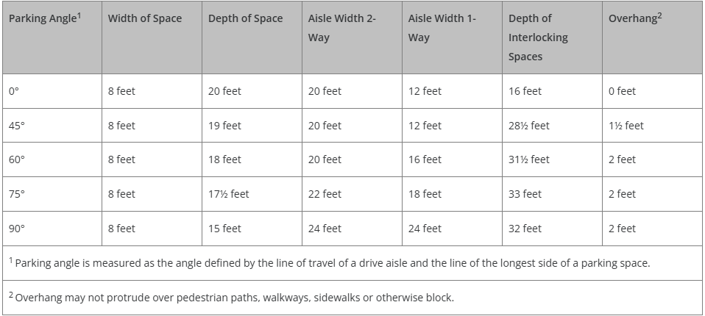
Refer to Table 6-3 for Disabled Parking Space Requirements
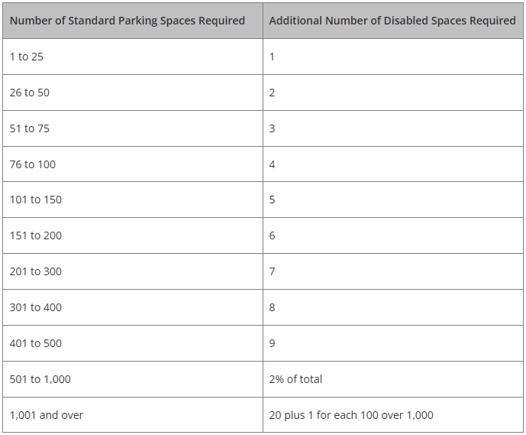
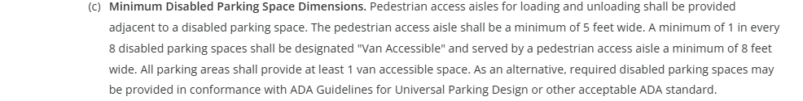
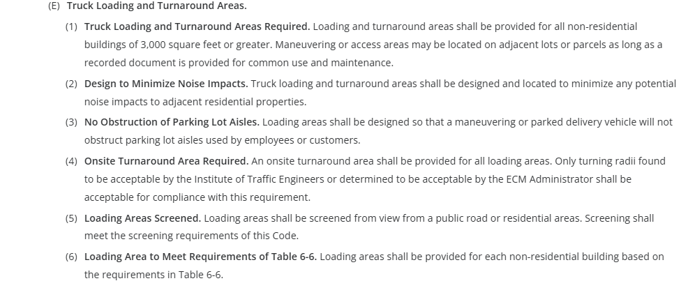
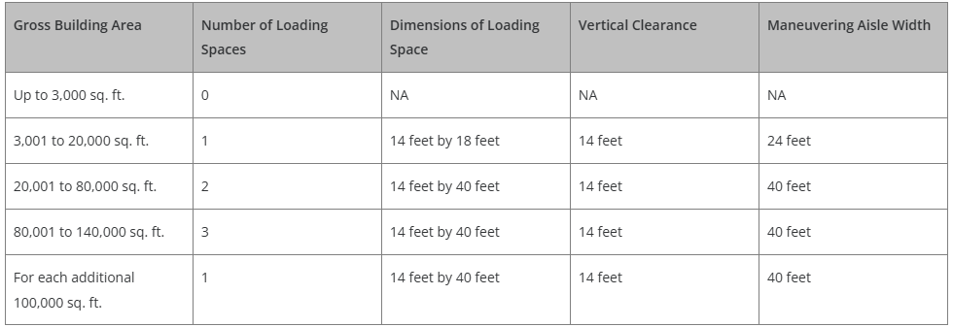
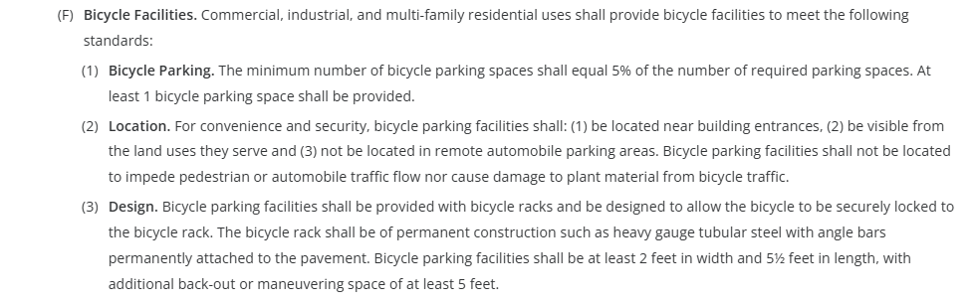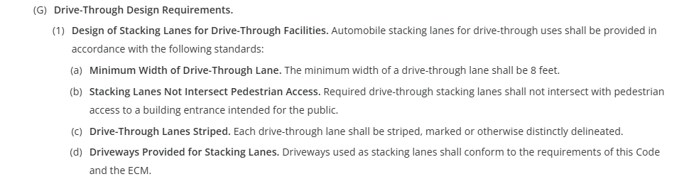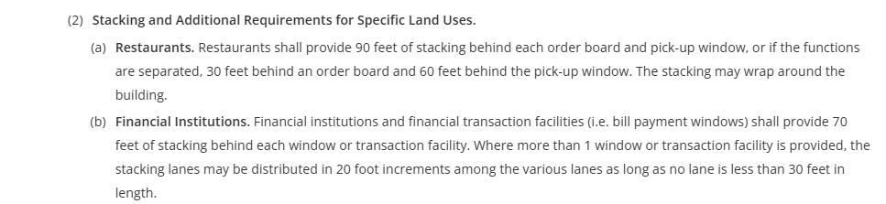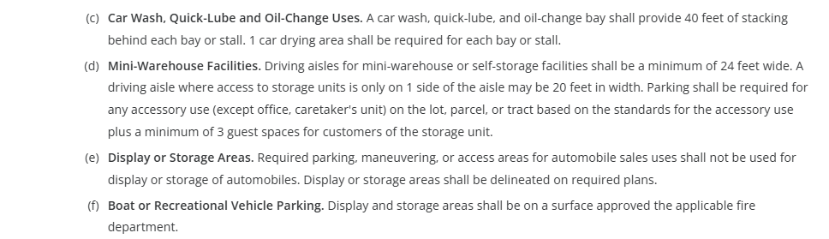

Lighting: (required)

(Chapter 6 Link) 6.2.3 Lighting
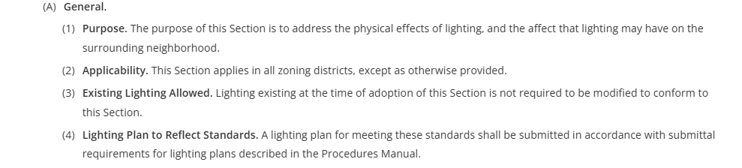

(B) Design Standards and Requirements
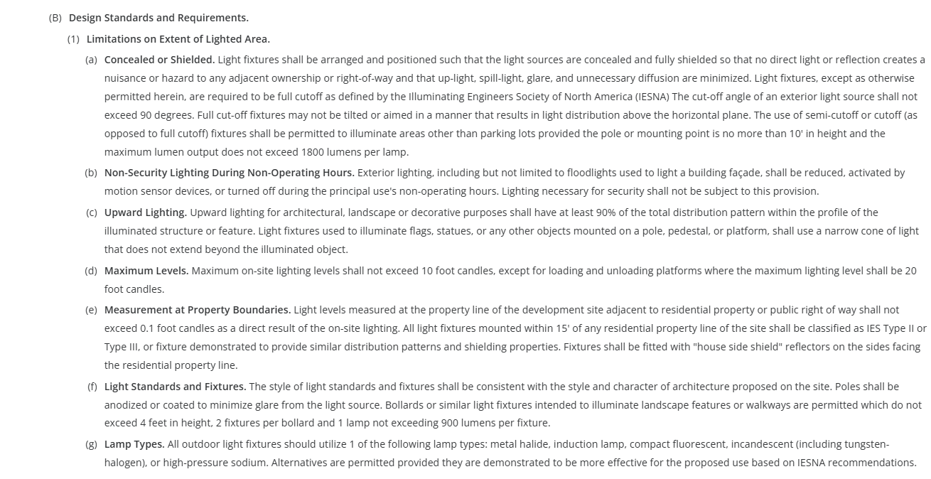
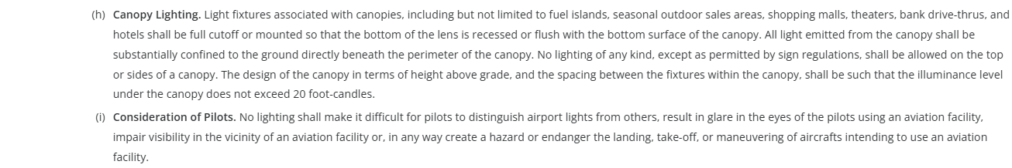
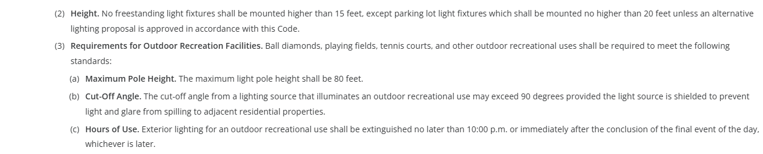
(C) Prohibited Lighting
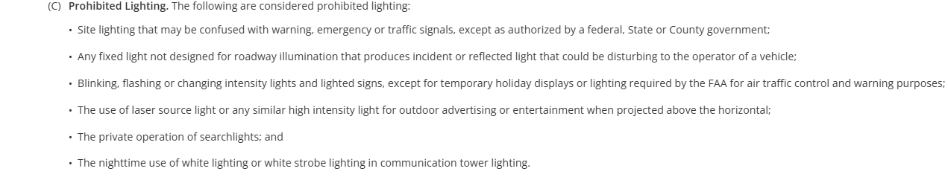
(D) Exemptions
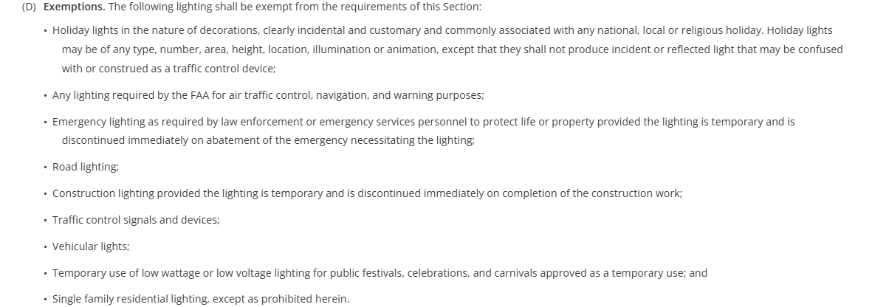
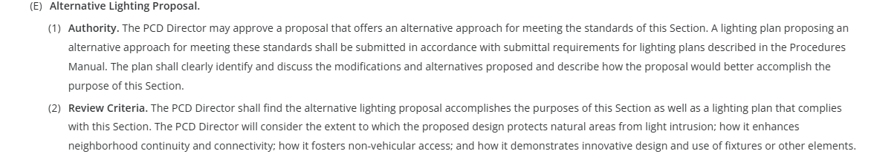
☒ Photometric Plan Required Example: Lighting Plan under Review Docs of EDARP File No. PPR2413

(Chapter 6 Link) General Development Standards
6.2.6. Pre-Subdivision Site Grading
6.2.7. Operational Standards (Dust and Debris Control, Noise, etc.)
6.2.8. Maintenance Plans

(Chapter 6.3 Link) Environmental Standards**
6.3.1. Air Quality Standards
6.3.2. Drainage and Floodplain
6.3.3. Fire Protection and Wildfire Mitigation
6.3.4. Forestry
6.3.5. Grading and Erosion Control
6.3.7. Noxious Weeds
6.3.8. Wetlands
6.3.9. Wildlife

☐ | 30% or greater slope | Comments: | N/A – not on this lot
☐ | CGS review previous concerns discussed |  | N/A
☐ | Floodplain |  | N/A – not on this lot
☐ | Noise mitigation required |  | N/A
☐ | Preble’s mouse |  | N/A – w/in block clearance

Signage: (if proposed, follow these development standards)

(Chapter 6 Link)
6.2.9. Signs, Off-Premise
6.2.10. Signs, On-Premise
PERMITS REQUIRED (separate sign application, SC-, required after Site Dev Plan).
This type of project is self-initiated on the EDARP home page.

**Existing Billboard on site! 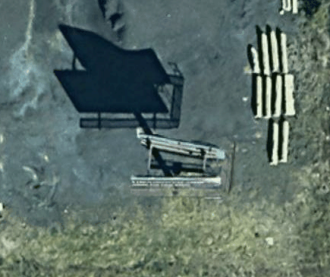 EDARP File No. AL154 and SC1517

Districts/Taxing Entities:
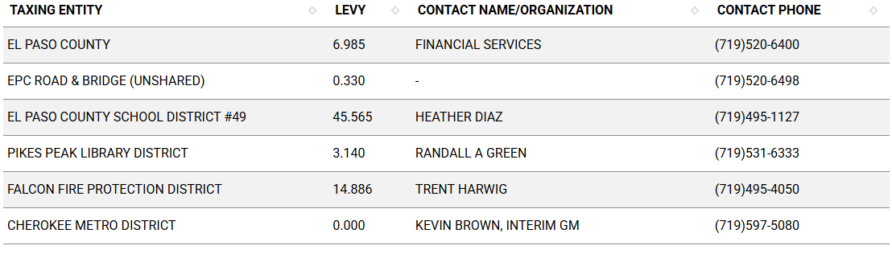

Road Impact Fees:
BOCC Res. No. 24-377 – fee is applied at the time of building permit
The Engineering team will provide the $ amount during review of the Site Dev Plan.

Proposed source of water |  |  | Proposed method of wastewater disposal
☐ | Central System |  | ☐ | Central System
District Name: |  | Cherokee Metro | District Name: |  | Cherokee Metro

Fire District: (Concerns/Emergency Service Issues, etc.)
Falcon Fire Protection District

The FPD will be a reviewing agency – all returned comments will be made available to the applicant in EDARP.

Commissioner District: 2

Alternative Design Discussion:
(landscaping)
(parking)
(lighting)

Parks and Trails:
No County parks or trails were identified on the property.

Review Comment entered on EA Meeting request:
“El Paso County Parks and Community Services Department. The 2022 El Paso County Parks Master Plan shows no impacts to existing or proposed parks, trails, or open space. As such, no trail easement dedications will be necessary for this project. As this is a commercial development, no regional park fees are applicable, although changes to the El Paso County Land Development Code over the next year or so may or may not change this guideline. It is not necessary for EPC Parks staff to attend this early assistance meeting. Thank you!”

Annexations/Intergovernmental/ Jurisdictional Access Issues:
N/A, enclave

Moving Forward:
Access EDARP project to begin submitting documents for Site Development Plan Review:

Required docs for Site Development Plan (Application Packets here)
- Application/Petition Form
- Letter of Intent
- Site Development Plan
- Floor Plans
- Elevation Plans
- Landscape Plan
- Lighting Plan
- Parking Plan
- Erosion and Stormwater Quality Control Permit (ESQCP)
- Grading & Erosion Control (GEC) Checklist
- Grading & Erosion Control (GEC) Plan
- Financial Assurance Forms
- PBMP Applicability Form
- Storm Water Management Plan (SWMP)
- SWMP Checklist
- Drainage Letter
- Traffic Impact Study/Memo
- Driveway Access Permit

Notes for Follow-Up Email:

Helpful Links

Planning Website

El Paso County Master Plan
Parks, Mineral and Water Master Plan

Forms and Templates

Land Development Code

EDARP

Public GIS

Wrap Up
-If subdivision is proposed, recording fees, park and school fees and road impact fees apply.
-Fees are subject to change. The fees at the time of application apply.
-Pursuant to the adopted El Paso County Road Impact Fee Program (Res. No. 12-382), a transportation impact fee, calculated on a per trip basis, may be due at the time of building permit issuance. Starting January 1, 2020, the transportation impact fee will be due for all new construction (Res. No. 19-471) (Res. No. 24-377).
-The fee for any additional waiver/deviation requests (more than two) - $550.00 each. Please note that requests for waivers and/or deviations may result in additional processing/review delay.
-All items requested must accompany the submittal for it to be complete, prior to payment request or the submittal will not be complete and ready for review agencies.
-A temporary use permit shall be applied for and approved for any staging area associated with development, such as a sales office, construction trailer, or contractor's equipment yard, prior to scheduling of the pre-construction meeting with El Paso County Planning and Community Development. If a Planned Unit Development is proposed, the temporary staging area should be shown on the development guidelines and phasing plan.
-All prospective timelines for review are subject to departmental staffing and workload.
-EA is valid for 12 months from submitting the EA application. If a project submittal is not received within 12 months, a new EA meeting may be required. An audio/video copy of the meeting is available in EDARP within the EA folder.
- Applications scheduled for public hearing may be heard as a regular item at staff or Board discretion.
- Any comments or commitments made by any member of the County Staff during this EA meeting are only preliminary in nature and should not be relied upon by the applicant. All prospective applicants should be informed that formal comments cannot be made by staff until after the application is submitted.

