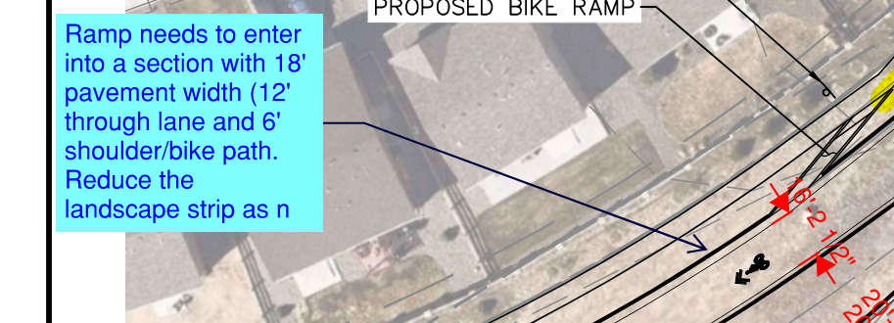
There are no dedicated bike facilities west of the roundabout and there is potential for both driver and bicyclist expectations will be subverted, when the lane configuration changes to a 2-lane section (with 2-12 lanes and no bike facility) approximately 200’ to the west. The lane assignment confusion at this location presents potential safety concerns. We recommend not widening to 18’ at this point and providing a bike lane/shoulder.
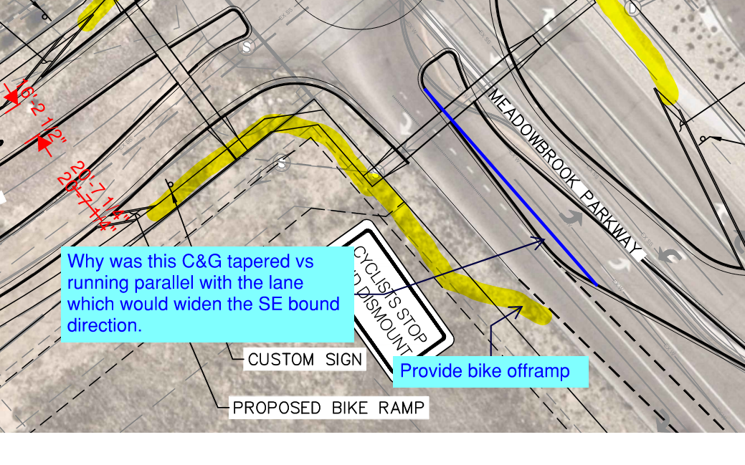
Proposed curb at this location is taper to restrict the exit geometry to 1 lane. A 19’ width is required at the exit of the roundabout to accommodate the design vehicle. The taper of the curb line is included to restrict the width of the exit pavement reducing the appearance of a 2 lane section. This treatment is intended to reduce the potential for EB right turns to attempt to treat their maneuver as a free right, and reduce the potential for drivers in the circulatory roadway to attempt to accelerate around other vehicles.
The indicated location for a bike ramp is at a significant decision point, where 3 additional lanes are opening for a driver. Additionally, there are no dedicated bike facilities on this leg of the roundabout. We recommend not including a bike ramp to reduce the number of conflict points a driver will need to be aware of on approach to the intersection at US-24.
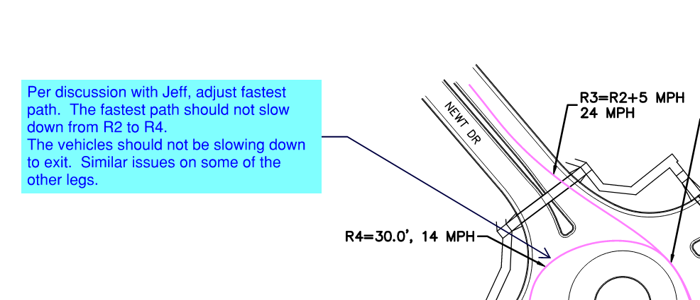
In general, R4 speeds are slower than R2 speeds. R4 measures the speed of a vehicle circulating the roundabout to make a left turn maneuver, and does not represent the speed of a vehicle exiting the roundabout. Exiting speeds are represented by R3 values. We have adjusted the linework and annotation of the R4 values to more accurately represent the left turn maneuver. See below snip from the Wisconsin DOT FDM 11-26:
