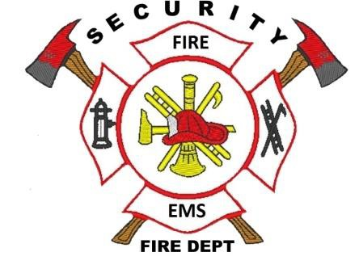

Security Fire Protection District
Fire Chief ~ David Girardin

Date: 10-7-2019
To Whom It May Concern:
This letter is being written to serve as Fire Protection Report, per Section 6.3.3.(B)(1) of the LDC, "The Fire Protection Report is required for any subdivision request and shall include the fire department's capabilities, including existing and proposed equipment, facilities, services, and response time to provide fire protection for the proposed subdivision."
The Security Fire Protection District serves an estimated population of 44,000 people in the Security and Widefield area located in the unincorporated area of El Paso County. To serve this area we have three fire station strategically placed throughout the district to provide an average response time of less than five minutes. The three fire stations are manned 24/7 out of our 35 paid career firefighters/EMS, and 25 volunteer personnel. The Security Fire Protection District has 5 fire engines, 1 ladder truck, 2 mini pumpers, 2 brush truck, 1 utility truck, 5 ambulance, and 2 Chiefs vehicle; all capable of providing fire, medical, and emergency services.
In addition the Security Fire Protection District provides 3 dedicated ambulances to the Security and Widefield Area. All 3 ambulances are staffed 24/7. This has enabled us to provide Advanced Life Support to the entire community in less than 5 minutes of receiving an EMS call.
If you have any questions please feel free to contact me.

Brandon Sullivan
Fire Marshal
Security Fire Protection District

400 Security Boulevard ~ Security, Colorado 80911 ~ (719) 392-3271 ~ securityfiredept.org

