Owner - Tobin Allen, 214 263 4276, tobin@allen-builder.com
Property address-- 10890 Salbeck Lane, Black forest, CO 80908
Property tax schedule - (5223004001)
Current zoning--10.3 Acres RR-5 zoning
Proposed variance: Requesting a variance in the limitation of size of agricultural accessory structures to twice the principal structure size. Our principle dwelling is 2100sf which limits an agricultural accessory structure to 4200 SF on our 10.3 acre property. 4200SF is to small of an area to safely ride in and exercise horses. Typical arenas for most disciplines are 100x200 plus the building structure. We house 6 horses on our property and value the horses wellbeing at the same time we also value the native prairie and pasture grasses on our property. During the winter we are unable to exercise our horses due to frozen ground in our outdoor arena and we do not want to let our horses overgraze the pasture we have during the winter; turning the area into weeds and dirt due to overgrazing form excessive turnout. To rectify this, we want to build a covered indoor arena overtop our existing outdoor arena to be able to exercise our horses on unfrozen ground and preserving the natural grass and trees on our property by keeping the horses off the land during the winter.
This is not outside the norm as there are multiple properties throughout black forest that have buildings that are over twice the size of the primary residence, many of which are used for riding arenas. This limitation is written for RR-2.5 / RR-5 but not RR-35. Our property at 10.3 acres falls between these two sizes. This riding arena would not overwhelm the property as if approved there would be 7.5% total coverage for this lot where 25% is allowed. As far as we can tell there is no logical way to divide the property into two five acre tracts in the future so this will always be a 10.3 acres lot and thus the coverage of this lot would not increase no matter what happens in the future. We understand that some limitations are written for general land use based on the different zoning to make sure that our community can uphold the standards we all want to live in and around while also not stopping legal use of the land. In this case a single building used as a personal horse-riding arena (not a stable but location for riding) with aesthetics that match the standards of the area and a total coverage of less than a third the allowable still follows those same standards better than many multiple accessory use buildings that are allowed such as a large house and garage and accessory structures that are allowed in RR-5 zoning up to 25% of coverage of the lot. At the time we built our property we clearly called this future indoor arena off in our PPRBD permit application in 2009 for our house and barn which we only point out to show how long we have been planning this unaware of this rule. We don’t know if this was a code at the time we bought and built my property or if we were just unaware of it, but we have invested over 15 years saving to have our dream of an indoor to go along with our 6 horses we live with.
Noncombustible construction (metal, concrete foundation, and dirt floor). The lot is surrounded by trees and is not clearly visible from other neighbors due to the mature trees and the fact that we are at the end of a dead-end private road. The location is 100ft from the property line which is 4 times the minimum requirement.
The slope of the lot would remain the same as it is going where the outdoor is already located with no floodplains on the property and immediate slope into the existing drainage swell in the center of our property not impacting our neighbors.
The rendering below shows that the material will maintain the same aesthetics as our house. (metal green roof, brown Wainscott to match the house and beige walls to match the stucco and siding of the home with a soffit same as the house)
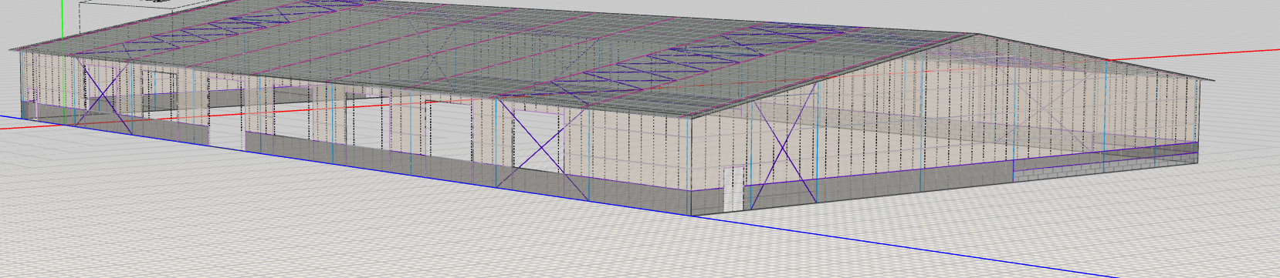
Please consider this for a permanent one-time variance of SF limit of a single agricultural accessory on our property.

Respectfully;
//Signed//
Tobin Allen
11/22/25

