Early Assistance Meeting Number: EA2660
Project Name: WHMD RWRF Stormwater Improvements
Project Location: 9503 Meridian Ranch Blvd
Project Parcel No. 4230312001
Project Description: The Woodmen Hills Regional Water Reclamation Facility (WHMD RWRF) has no on-site stormwater infrastructure to capture and deliver surface water off site during storm events. Stormwater floods the building during each storm event. There are existing culverts in the southeast corner of the site connecting to storm infrastructure that carries flow to Bennett Ranch Regional Detention Pond. The purpose of this project is to design, permit, and construct on-site stormwater infrastructure to mitigate building flooding that will carry flows to the existing culvert.
Meeting Date: 05/18/26
Planner: Joe Letke JoeLetke@elpasoco.com 719-520-7964

El Paso County Planning & Community Development Planning Checklist

Request – Map Provided by Applicant
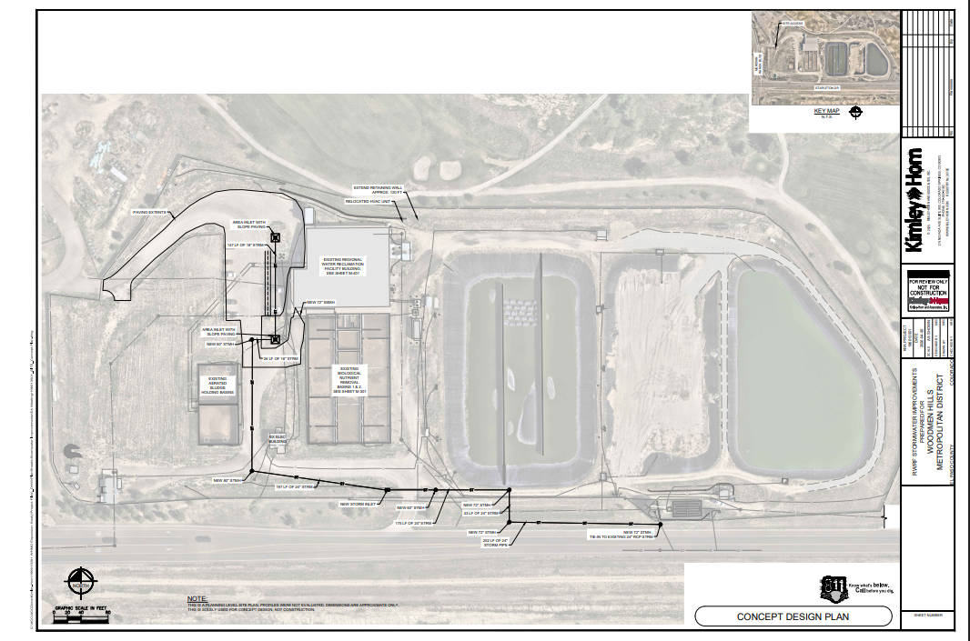

Zoning (check conditions of approval)
Existing Zone(s)
Zone |  | Name
PUD |  | Planned Unit Development

Zoning Analysis/Application Type Narrative
EDARP Project File PPR2520 Woodmen Hills Metro – Wastewater Storage Facility Site Development Plan was approved October 9, 2025. https://epcdevplanreview.com/Public/ProjectDetails/197954

This request is largely a stormwater/engineering item so there are minimal planning discussion points. If you have specific LDC questions I am available to assist.

Will any of the changes affect parking or landscaping? If so, a commercial over the counter site plan (COM) will be required to ensure compliance with the LDC. If not, the application will be processed as construction drawings (CDR) project type.

Application Type(s) Hearing: Required/ Optional/ No
CDR (Construction Drawings) | No

Processing Issues and Options

Relevant Past History:

Design and Landscaping

Site Design/Layout (Lot pattern, circulation/road design, open space, preservation of natural features, compatibility internally and with adjacent land uses)

Landscaping
☐ | Expressway, Principal arterial area depth – 25’-Trees required 1 per 20’
☐ | Urban interchange/Intersection area depth – 25’- N/A
☐ | Minor arterial area depth 20’ – Trees required 1 per 25’
☐ | Non-arterial area depth 10’ – Trees required 1 per 30’
☐ | Parking lot landscaping required
☐ | Buffer between non-residential and residential districts separated by a non-arterial road or public alley  Zone Boundary Buffer

Signage:

Parking Requirements:

Lighting:
Photometric Plan Required | ☐

Site Characteristics\ Constraints\ Environmental Standards:

☐ | 30% or greater slope | Topography:
☐ | CGS review previous concerns discussed | Soils/geology:
☐ | Floodplain | Floodplain comment:
☐ | Noise mitigation required | Noise comment:
☐ | Preble’s mouse

Air/Visual Quality:

Districts

Taxing Entities

Road Impact Fees:

Proposed source of water |  |  | Proposed method of wastewater disposal
☐ | Central System |  | ☐ | Central System
District Name: |  |  | District Name:

Fire District:

Fire District Design Concerns/Emergency Services Issues:

Commissioner District:

Alternate Design:

Parks and trails:

Annexations/Intergovernmental/ Jurisdictional Access issues:

Helpful Links

Planning Website: https://planningdevelopment.elpasoco.com/

El Paso County Master Plan: https://planningdevelopment.elpasoco.com/#1510603950097-f5d985dc-35b2
Parks, Mineral and Water Master Plan: https://planningdevelopment.elpasoco.com/resources-and-references/#1516982531779-52cc0e87-01af

Forms and Templates: https://planningdevelopment.elpasoco.com/planning-development-forms/#1510677560407-ff8cfff5-69b2716b-00f9cbba-0c21

Land Development Code: https://library.municode.com/co/el_paso_county/codes/land_development_code

EDARP: https://epcdevplanreview.com/

Public GIS: https://elpasoco.maps.arcgis.com/apps/View/index.html?appid=5be6431018594c67b035ad0aad3e7e8a

Wrap Up
-If subdivision is proposed, recording fees, park and school fees and road impact fees may apply.

-Fees are subject to change. The fees at the time of application apply.

-Road Impact Fees
Please see the following website for information on the EPC Road Impact Fee Project. https://publicworks.elpasoco.com/road-impact-fees/ to include fee schedule.
As of December 15, 2016, per Resolution 16-454, on and after January 1, 2020, property in the unincorporated area of the county that receives a Land Use Approval either in a public hearing or administratively, is subject to the payment of Road Impact Fees. After December 31, 2024, in accordance with BoCC Resolution 24-377 the fee is paid for new residential and non-residential uses and structures and expansions of non-residential uses and structures. Road Impact fees are typically paid at time of building permit. If no building permit is being obtained for a particular Land Use application, then Road Impact Fees must be paid at the time of Site Development Plan or Special Use approval. If there are questions about EPC Road Impact program or fees, please contact DPW Development Review Services and the Engineer of the Day.

- Engineering Criteria Manual (ECM) Deviations.
The fee for any additional ECM deviation requests (more than two per land use application) - $1483.00 each per current Fee Schedule. Please note ECM deviation requests may result in additional processing and project review time. ECM Deviations should be submitted prior to the initial Site Development Plan or Final Plat submittal to preclude changes having to be made to engineering plans and documents if the deviation is not approved. Submission of an ECM deviation request does not imply or guarantee that the deviation will be approved. An ECM Deviation form must be submitted to include complete exhibits and justification excluding cost with supporting engineering criteria. If there are questions about ECM Deviation requests, please contact DPW Development Review Services and the Engineer of the Day.

-The fee for any additional waiver/deviation requests (more than two) - $550.00 each. Please note that requests for waivers and/or deviations may result in additional processing/review delay.

-All items requested must accompany the submittal for it to be complete, prior to payment request or the submittal will not be complete and ready for review agencies.

-A temporary use permit shall be applied for and approved for any staging area associated with development, such as a sales office, construction trailer, or contractor's equipment yard, prior to scheduling of the pre-construction meeting with El Paso County Planning and Community Development. If a Planned Unit Development is proposed, the temporary staging area should be shown on the development guideline and phasing plan.

-All prospective timelines for review are subject to departmental staffing and workload.

-Early Assistance is valid for 12 months from submittal of the EA application. If a project submittal is not received within 12 months, a new EA meeting may be required. An audio/video copy of the meeting is available in EDARP within the EA folder.

- Applications scheduled for public hearings may be heard as a regular item at the request of staff or a hearing body member.

- Any comments or commitments made by any member of the County Staff during this early assistance meeting are only preliminary in nature and should not be relied upon by the applicant. All prospective applicants should be informed that formal comments cannot be made by staff until after the application is submitted.

