COLORADO GEOLOGICAL SURVEY

Land Use Review Program
1801 19th Street
Golden, Colorado 80401
303-384-2655
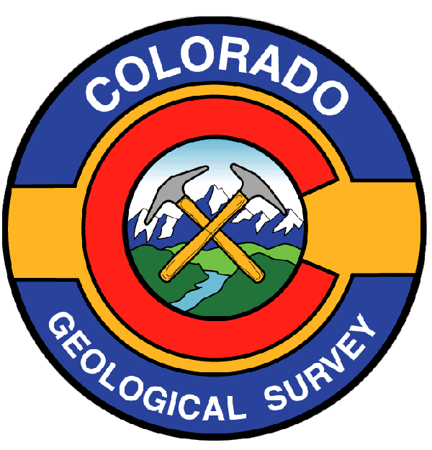

Karen Berry
State Geologist

R E C E I P T

Receipt acknowledging payment for land use review to be performed by the Colorado Geological Survey.

Applicant: N.E.S. Inc.

Project Name: Flying Horse North

Colorado Geological Survey Unique No. EP-16-0021

Payment received: $2,500.00

Payee: JBS Family Enterprises LLLP

Date: April 26, 2016

Should you have questions regarding this receipt, please contact:

Debbie Cockburn
Program Assistant
Colorado Geological Survey
303-384-2647
dcockbur@mines.edu

cc: DSDComments@elpasoco.com

