December 22, 2025

To: Glen Smith, Interim Town Administrator, gsmith@palmer-lake.org
County File: ANX257 – North Tree Annexation into Calhan
Planning Division
Process comments:
- The project proposes to annex 39.5 acres of land from unincorporated County to the Town of Palmer Lake. An Annexation Impact Report meeting Chapter 10.1.4. Annexation Impact Report has been submitted to the Board of County Commissioners.

- Please note this request for Annexation will be presented to the Board of County Commissioners; please provide the expected date the application will be heard by the Palmer Lake Board of Trustees.

Development Plan Comments:
- The proposed annexation would result in creating County enclaves within the Town of Palmer Lake which may have little or no possibility of future annexation. To avoid this while still proceeding with the annexation, it is recommended that Parcel Nos. 7109000055, 7109013009, 7109000095, 7109000098, 7109014003, and 7109014004 be included in the annexation.
- To avoid the two existing parcels being split between the two jurisdictions, we require the in-process El Paso County Final Plat No. SF2513 be approved and recorded before the annexation process is completed.
- The Your El Paso County Master Plan identifies this parcel within the Suburban Residential Placetype.
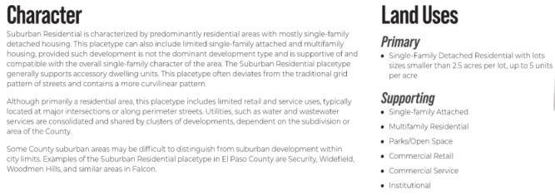
Placetype Map
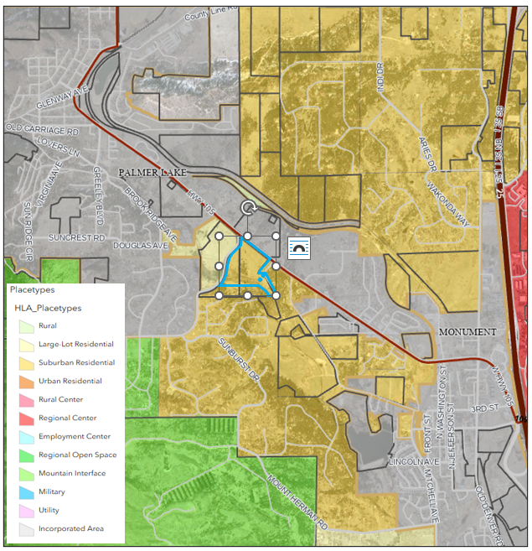
- Additionally, the Plan identifies this area as an Area of Change: Minimal Change: Developed
These areas have undergone development and have an established character. Developed areas of minimal change are largely built out but may include isolated pockets of vacant or underutilized land. These key sites are likely to see more intense infill development with a mix of uses and scale of redevelopment that will significantly impact the character of an area. For example, a large amount of vacant land in a suburban division adjacent to a more urban neighborhood may be developed and change to match the urban character and intensity so as to accommodate a greater population. The inverse is also possible where an undeveloped portion of an denser neighborhood could redevelop to a less intense suburban scale. Regardless of the development that may occur, if these areas evolve to a new development pattern of differing intensity, their overall character can be maintained.
Area of Change Map
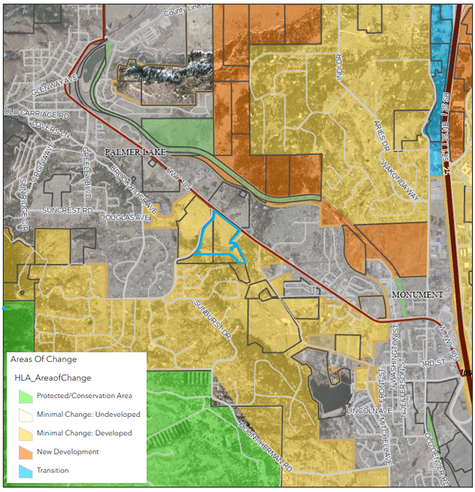
- The site is within the Key Area: Tri-Lakes Area
Tri-Lakes is the northern gateway into the County along Interstate 25 and Highway 83. It is situated between Pike National Forest, the United States Air Force Academy, and Black Forest. With significant suburban development and some mixed-use development, this Key Area supports the commercial needs of many of the residents in northern El Paso County. Tri-Lakes also serves as a place of residence for many who commute to work in the Denver Metropolitan Area. It is also an activity and entertainment center with the three lakes (Monument Lake, Woodmoor Lake, and Palmer Lake) that comprise its namesake and direct access to the national forest. Tri-Lakes is the most well-established community in the northern part of the County with a mixture of housing options, easy access to necessary commercial goods and services, and a variety of entertainment opportunities. Future development in this area should align with the existing character and strengthen the residential, commercial, employment, and entertainment opportunities in the adjacent communities of Monument, Palmer Lake, and Woodmoor.
Key Area Map
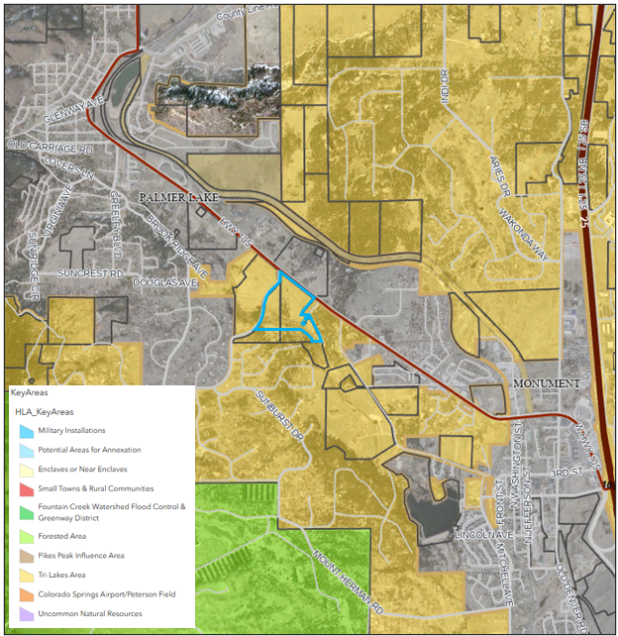
- County Planning and DPW staff would like the opportunity to review the future zoning and subdivision entitlements submitted to Town of Palmer Lake, not limited to, the drainage and traffic reports.

Reviewed by:
Lisa Elgin
Senior Planner
719-520-6449
lisaelgin@elpasoco.com

Department of Public Works Engineering and Stormwater Divisions
EPC Engineering
Review 1:
Traffic/Transportation:
1. An El Paso County access permit, appropriate roadway and drainage improvements, and a CDOT access permit will be required. Red Rocks Ranch Drive will be required to be annexed from Highway 105 to the point of access for the subdivision. EPC will also require the entirety of Rockbrook Road to be included in the annexation.
2. A traffic study meeting EPC requirements and addressing all offsite development responsibilities, including design and construction of any improvements to Highway 105, will be required prior to site development. If necessary, a development agreement between the developer, the County, and the Town can be drafted.
3. Construction drawings will need to be reviewed and approved by EPC for improvements on Red Rocks Ranch Drive that remain under County jurisdiction.
4. Work-in-the-right-of-way permits are required for construction in the County right-of-way.
Drainage:
1. Improvements to drainage infrastructure in or along County roads may be required. A final drainage report will need to be submitted for EPC review prior to development.
Reviewed by:
Bret Dilts, PE
719-520-6864
bretdilts@elpasoco.com
EPC Stormwater
Review 1:
MS4 Permit compliance will be required with the Town of Palmer Lake's MS4 Permit once annexed. If the planned project continues progress, provide the County with the Preliminary and Final Drainage Reports for the project so any stormwater impacts to County jurisdiction can be assessed.
Reviewed by:
Mikayla Hartford, P.E.
Engineer – Stormwater
719.339.5053
MikaylaHartford@elpasoco.com
EPC Parks Department
The 2022 El Paso County Parks Master Plan does not show impacts to any county-owned parks, trails, or open space. EPC Parks has no objections to this annexation.
Thank you!
Ashlyn Mathy
Parks Planner
Office 719.520.6999

_____________________________________________________________________________________________________________
Please contact me if you have any questions or comments
Lisa Elgin
El Paso County Planning and Community Development
2880 International Circle, Colorado Springs, CO, 80910
(719) 520-6449

