COLORADO GEOLOGICAL SURVEY

Land Use Review Program
1801 19th Street
Golden, Colorado 80401
303-384-2655
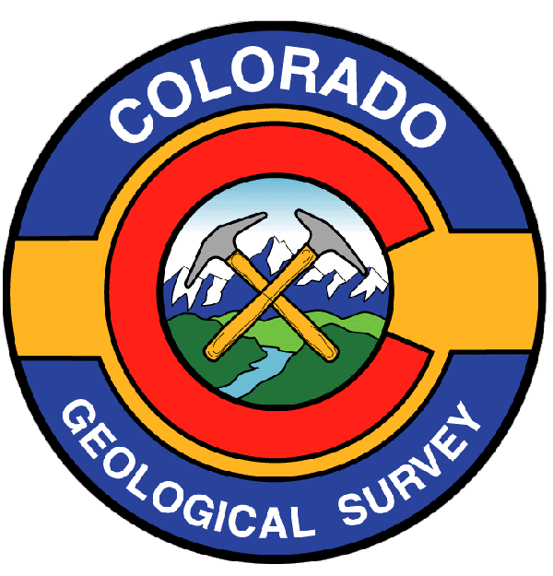

Karen Berry
State Geologist

R E C E I P T

Receipt acknowledging payment for land use review to be performed by the Colorado Geological Survey.

Applicant: N.E.S. Inc.

Project Name: The Ranch

Colorado Geological Survey Unique No. EP-19-0051

Payment received: $2,500.00

Payee: N.E.S. Inc.

Date: October 9, 2018

Should you have questions regarding this receipt, please contact:

Debbie Cockburn
Program Assistant
Colorado Geological Survey
303-384-2647
dcockbur@mines.edu

cc: DSDComments@elpasoco.com

